Provider Enrollment Manual
Table of Contents
Before Starting an Application 1
Provider Enrollment Manual Overview 2
Provider Type, Enrollment Type and Enrollment Requirements 2
Enrollment Types 2
Additional Required Information 4
Accessing the Provider Enrollment Portal 7
Completing the Application 10
Welcome Panel 13
Request Information Panel 14
Change of Ownership Panel 19
Specialties Panel 21
Addresses Panel 27
Provider Identification Panel 33
Network Participation Panel 41
Languages and Primary Employer/Owner Panel 44
Electronic Funds Transfer (EFT) Enrollment Panel 48
Other Information Panel 56
Addendums Panel 68
Disclosures Panel 69
Fingerprinting Panel 79
Attachments and Fees Panel 82
Agreement Panel 87
Summary Panel 90
After the Application Is Submitted 91
Resume Enrollment 91
Enrollment Status 92
Site Visits 93
Provider Enrollment Notifications 93
Forms 94

Before Starting an Application
Ensure the latest version of one of the following browsers is installed to navigate through the enrollment application in the Provider Web Portal.
- Microsoft Edge
- Mozilla Firefox
- Safari
- Google Chrome

More Information on a Field
An asterisk (*) next to a field indicates the field could either be required or optional if the user begins entering data.
Additional information is available in certain fields by hovering the cursor over the ! symbol. Hovering over this symbol opens a box that gives more information about the field. The information box disappears when the cursor is moved.
!

Help Feature on Each Panel
A question mark  symbol appears toward the top right corner of each panel. Clicking this symbol opens a dialog help window specific to the current screen.
This example displays the Specialties Help panel. The screen may look similar to the following:
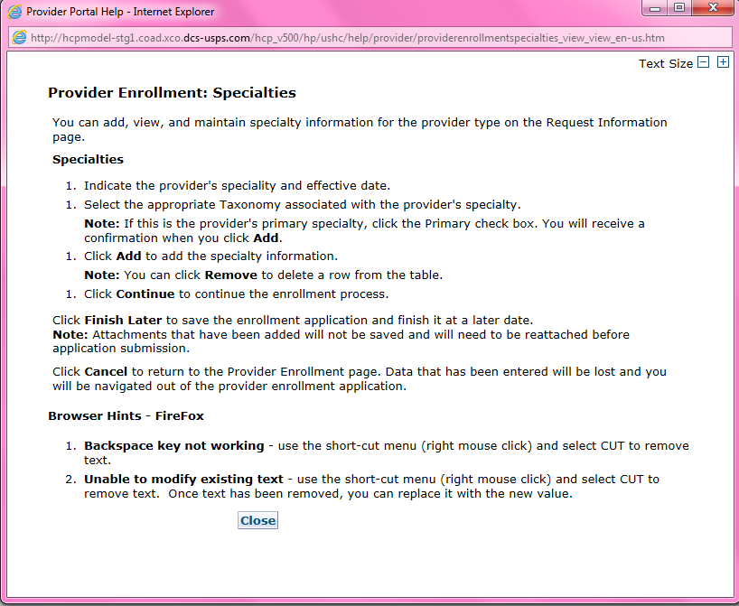

Provider Enrollment Manual Overview

Provider Type, Enrollment Type and Enrollment Requirements
Enrollment requirements vary depending on the provider type and enrollment type. Having the required enrollment information for the provider and enrollment type prior to beginning the application expedites the enrollment process.
Visit the Information by Provider Type web page to view additional enrollment requirements for the provider type. Visit the Enrollment Types web page to view the allowable provider types for each enrollment type. The following section list the enrollment requirements for each enrollment type.

Enrollment Types

Individual Within a Group
This enrollment type is for an individual that renders services but does not bill Colorado Medicaid directly. These providers must be associated with a Group that submits claims on their behalf.
- Social Security Number (SSN) will be pre-selected as the Tax ID Type.
- Must associate to at least one (1) Group provider enrollment type.
- The group to which the individual affiliates must have an approved enrollment before the individual can enroll.

Group
This enrollment type is a clinic or practice that submits claims on behalf of one (1) or more practitioners enrolled as an Individual Within a Group. Income is reported to the Internal Revenue Service (IRS) under the business Employer Identification Number (EIN).
- EIN will be pre-selected as the Tax ID Type
- Billing/direct pay entity
- Must have at least one (1) enrolled Individual Within a Group practitioner associated. (This association is indicated on the Individual Within a Group application). Associations may be added, removed, or changed after enrollment by logging in to the Provider Web Portal.

Billing Individual
This enrollment type is for an individual who receives direct payment for services rendered and submits claims for his/her own services. Income is reported to the Internal Revenue Service (IRS) under the individual’s SSN.
- SSN will be pre-selected as the Tax ID Type
- Billing/direct pay entity

Individual Who Wants to Use EIN for Enrollment
This is a common scenario for individuals, such as physicians that own their own practice. Even if the individual is the only practitioner, if using an EIN for billing, this is a business. A group enrollment type application must be completed to enroll the business. In this example, a Group enrollment type application would need to be completed as a Provider Type 16 – Clinic Practitioner Group. The EIN must be used as the Tax ID Type and the group EIN Tax ID entered.
The physician must submit a second application as an Individual Within a Group with a provider type of Physician for themselves as the rendering practitioner after the application for their business has been submitted and approved for enrollment. The physician must indicate they are affiliated to the group that was enrolled for the business while completing the Individual Within a Group application. SSN will be pre-selected as the Tax ID Type and the individual must enter an SSN Tax ID.
This allows the individual physician to bill under their business EIN and render services to members via the SSN enrollment.

Facility
This enrollment type is for an entity that submits claims for services rendered. An associated Individual Within a Group provider enrollment type is not required.
- EIN will be pre-selected as the Tax ID Type
- Billing/direct pay entity

Atypical
This enrollment type renders non-medical services. These providers may include but are not limited to Home and Community-Based Waiver Services (HCBS) providers, Managed Care Organizations (MCOs) and Regional Accountable Entities (RAEs).
- Enrollment requirements vary. Visit the Information by Provider Type web page to view enrollment requirements.
- The SSN or EIN Tax ID type may be used depending on provider type requirements.

Ordering, Prescribing and Referring (OPR)
This enrollment type is for individuals that only order, prescribe or refer items or services covered by Health First Colorado (Colorado’s Medicaid program) for Health First Colorado members. These physicians and other professionals are not enrolled as an Individual Within a Group or a Billing Individual and do not submit claims for payment of services rendered.
- SSN will be pre-selected as the Tax ID Type

Program of All-Inclusive Care for the Elderly (PACE)-Only Subcontractor
This enrollment type is for an entity or individual that has a valid contract with a participating PACE organization. the associated PACE organization may submit PACE encounter claims listing the subcontractor’s provider number and information once the PACE-Only Subcontractor is enrolled.
- The SSN or EIN Tax ID type may be used depending on the provider type requirements.
- The PACE Subcontractor Participation Attestation Form is required for this enrollment type.
- PACE-Only Subcontractors are exempt from the following enrollment requirements:
  - Electronic Funds Transfer (EFT) Enrollment
  - Addendums
  - Disclosures
  - Fingerprinting
  - Submission of licensure, certification, or insurance
  - Application fee
  - Provider Participation Agreement
  - Site Visits
- PACE-Only Subcontractors cannot register for the Provider Web Portal and must contact the Provider Services Call Center to update provider information or disenroll.

Fiscal Intermediary
This enrollment type is for a private company or another type of business entity that is currently contracted with the Department to manage financial transactions, ensure compliance with program regulations, and provide oversight to prevent fraud and misuse of funds.
- EIN will be pre-selected as the Tax ID Type
  - Fiscal Intermediaries are exempt from risk based screening requirements.

Additional Required Information

National Provider Identifier (NPI)
The NPI is a Health Insurance Portability and Accountability Act (HIPAA) Administrative Simplification Standard that is a 10-digit unique identification number for covered healthcare providers. Visit the National Plan & Provider Enumeration System (NPPES) website to apply for an NPI.
- Not all provider types require an NPI. Visit the Information by Provider Type web page to determine if an NPI is required.
- Refer to the list below to verify which type of NPI is required based on the enrollment type.
Enrollment Type | Requirement
Group | Organizational NPI and associated zip code +4
Facility | Organizational NPI and associated zip code +4
Individual Within a group | Individual NPI and associated zip code +4
Billing Individual | Individual NPI and associated zip code +4
Ordering-Prescribing-Referring | Individual NPI and associated zip code +4
Atypical Provider | *NPI may or may not be required.
PACE-Only Subcontractor | *NPI may or may not be required.
Fiscal Intermediary | *NPI is optional.
*Not all Atypical providers require an NPI. Visit the Information by Provider Type web page or HCBS Provider Enrollment Information web page to determine whether an individual or organizational NPI is needed for the selected Atypical enrollment.

Provider Taxonomy Codes
The Healthcare Provider Taxonomy Code Set is a hierarchical code set that consists of codes, descriptions, and definitions designed to categorize the type, classification and/or specialization of health care providers.
Use the Search NPI Records Tool to see the taxonomy codes used when originally applying for the NPI.

Address Information
Service Address – This is the location where services are rendered. This address is searchable on the Health First Colorado Find a Doctor web page. The email address associated with the service location is used to send provider communications such as newsletters and bulletins.
Note: Each service address for an organization requires a separate application and unique NPI.
Mailing Address – This address is where paper Prior Authorization Request (PAR) letters are sent if the provider is not receiving PAR letters electronically.
Billing Address – This address is where paper checks and Remittance Advice (RA) statements are sent if the provider is not receiving them electronically.

Federal Employer Identification Number (EIN) vs Social Security Number (SSN)
An EIN is used to identify a business entity; an SSN is used for individuals.

Provider License Number (if applicable)
This is the identification number assigned by licensing agencies.

Completed W-9 Form
This form must be signed and dated within the last six (6) months.
Enrollment Type | Requirement
Group | W-9 with EIN
Facility | W-9 with EIN
Atypical Provider | W-9 with EIN or SSN (as applicable)
Billing Individual | W-9 with SSN
Individual Within a group | Not required
Ordering-Prescribing-Referring | Not required
PACE-Only Subcontractor | Not required
Fiscal Intermediary | Not required

Malpractice and Liability Insurance Information
Insurance information must be entered on the application by all provider types. A copy of the current insurance face sheet is required for Nursing Facilities. All other provider types are not required to attach a copy.

Banking Information
Electronic Fund Transfers (EFTs) are required for payments. A copy of a voided check or a bank letter that is signed and dated within six (6) months of the application submission must be uploaded to the application on the Attachments and Fees panel.
- Voided checks must be pre-printed. Checks cannot be handwritten or temporary checks.
- The printed name on the voided check must match either the legal name or the Doing Business As (DBA) name entered in the application.
- The routing number on the voided check must match the routing number entered on the EFT panel.
- The bank account number listed on the voided check must match the bank account number entered on the EFT panel.
- Deposit slips are not acceptable.
If a bank letter is attached in lieu of a voided check:
- The bank letter must be printed on the bank’s letter head. It cannot be handwritten.
- The bank letter must be signed by a bank representative and dated within six (6) months of the application submission.
- The account holder name must match the legal or DBA name in the application.
- The routing number listed on the bank letter must match the routing number entered in the EFT panel.
- The bank account number listed on the bank letter must match the bank account number entered in the EFT panel.

Ownership/Controlling Interest and Conviction Disclosure Information
The following information is needed for each person or entity with an ownership or controlling interest of 5% or more in the enrolling provider (including a Board of Directors with 0% ownership):
- Name
- Address
- Federal Employer ID Number (EIN) or Social Security Number (SSN)
- Date of Birth (DOB) if an individual

Accessing the Provider Enrollment Portal
- Click Provider enrollment on the For Our Providers web page to navigate to the Provider Enrollment web page.
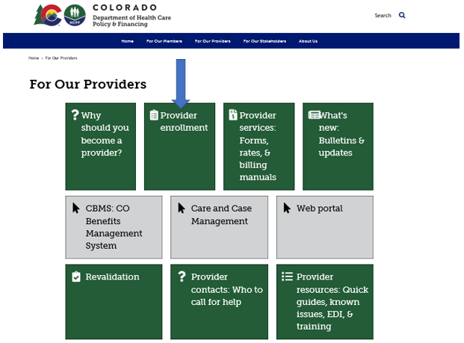
- Click the Enrollment Instructions & Application button. Read through the Common Reasons Enrollment Applications Are Returned to Providers instructions and review each step to determine the Provider Type and Enrollment Type.

- Click the Go to Application button at the bottom of the Enrollment Type web page.

The panel below displays after clicking Go to Application. Click the Enrollment Application link to begin the enrollment.
Provider Enrollment Home Panel

The additional links on this panel are:
Resume Enrollment: This allows the user to finish an enrollment application that was started earlier and saved or to open an application that has been returned for correction. The user needs the Tracking Number (ATN), the Tax ID enrolling on the application and the password that was set up when submitting or saving the application.
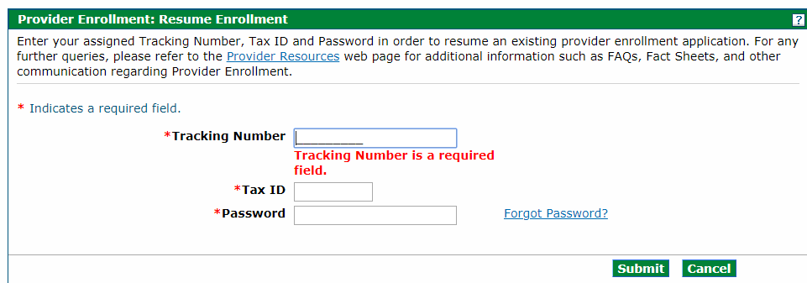
Enrollment Status: This allows the user to check the status of a previously submitted application and to view any comments left by reviewers. The user needs the ATN and the Tax ID entered on the application.
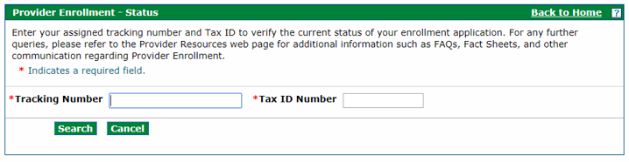
The status of the application and reviewer comments appear after a successful login.

Completing the Application
The Provider Web Portal autosaves entered data during the enrollment process. There are three (3) buttons available at the bottom of each panel while completing the application.
These buttons allow the user to:
Continue – Continues to the next panel of the enrollment application. The autosave process is initiated after entering data on each panel and clicking Continue.
Cancel – Cancels the application process. If an Application Tracking Number (ATN) has been generated, this button prompts the end of the application process without saving the data on the current panel (data entered on prior panels is already saved). This button prompts the end of the application process without saving the data if an ATN has not been generated. A Cancel Confirmation notification appears before the user is allowed to proceed.
If Yes is clicked, all data entered on this panel and any previous panels will be lost if an ATN has not been generated.
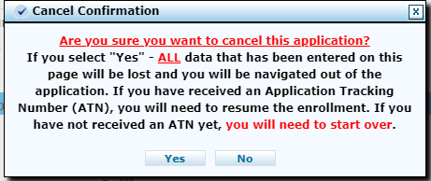
Finish Later – Saves the information and allows the user to return to the application later.
A Suspend Incomplete Application notification appears.

Suspend Incomplete Application Pop Up
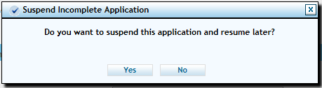
Clicking No returns users to the application process. Clicking Yes prompts the Provider Enrollment: Credentials panel to appear, as shown in the screen shot below.
Provider Enrollment: Credentials Panel
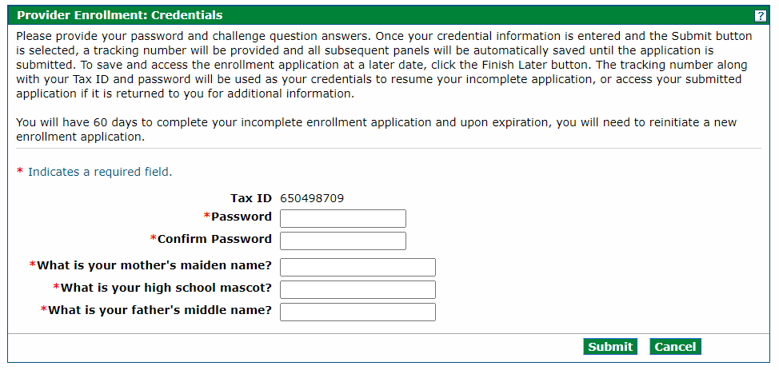
Password – Select a password between 8-20 alphanumeric characters to use for the enrollment process. This field is required for all providers saving their application.
Confirm Password – Confirm the password to use for the enrollment process. This field is required for all providers saving their application.
What is your mother’s maiden name? – Enter a maximum of 50 alphanumeric characters for the mother’s maiden name. This field is required for all providers saving their application.
What is your high school mascot? – Enter a maximum of 50 alphanumeric characters for a high school mascot. This field is required for all providers saving their application.
What is your father’s middle name? – Enter a maximum of 50 alphanumeric characters for the father’s middle name. This field is required for all providers saving their application.
Tip: It is important that users store the password somewhere they will not forget. The password cannot be reset for enrollment applications. The user will be unable to access the application and must begin a new enrollment application if the password and security question answers are lost.
Click Submit to save this information and proceed to the next panel. Click Cancel to stop this process and return to the Enrollment process.
Once the Submit button is clicked, the user is directed to the next panel that assigns the ATN that is required to resume the application. A Print Preview button is in the upper right corner of this panel which may be used to send a copy of this panel to a local or network printer connected to the computer.
Provider Enrollment: Tracking Information Panel
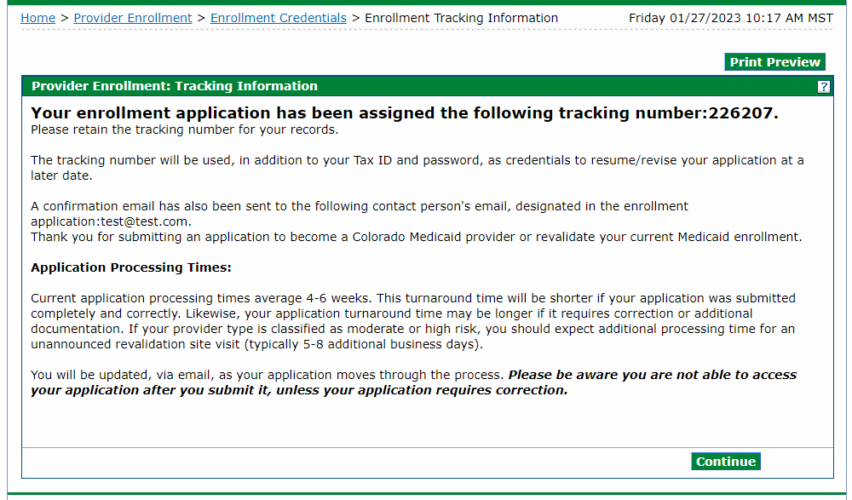
Click Continue to resume the enrollment process.
The bolded title on the upper left side of the panel indicates the panel that is currently open. Each panel becomes a clickable link as they are completed through the enrollment process, allowing users to access a previous panel if a change is needed.
Returning to a previous panel does not save the data entered. Click either the Continue or Finish Later button to save the data entered in an application.

Welcome Panel
The first panel to appear after the user clicks the Enrollment Application link is the Welcome panel.
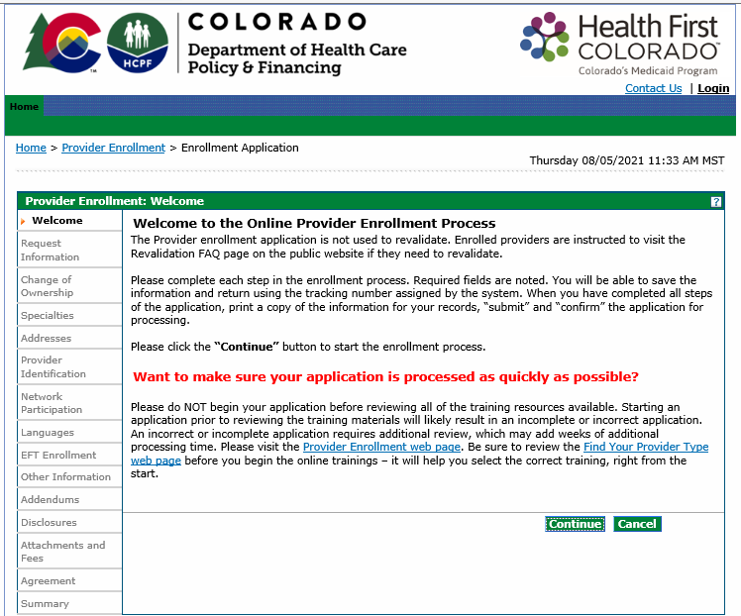
The Welcome panel gives some brief instructions. Click the Continue button to go to the next panel of the application.

Request Information Panel
The Request Information panel displays after clicking Continue on the Welcome panel.
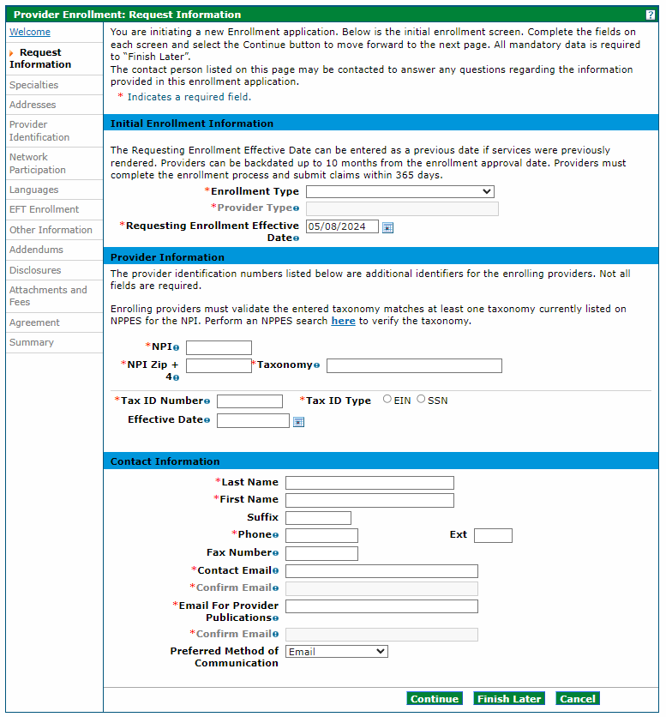
*The example below is for an Individual Within a Group enrollment type. The panel screen may appear similar to the following.
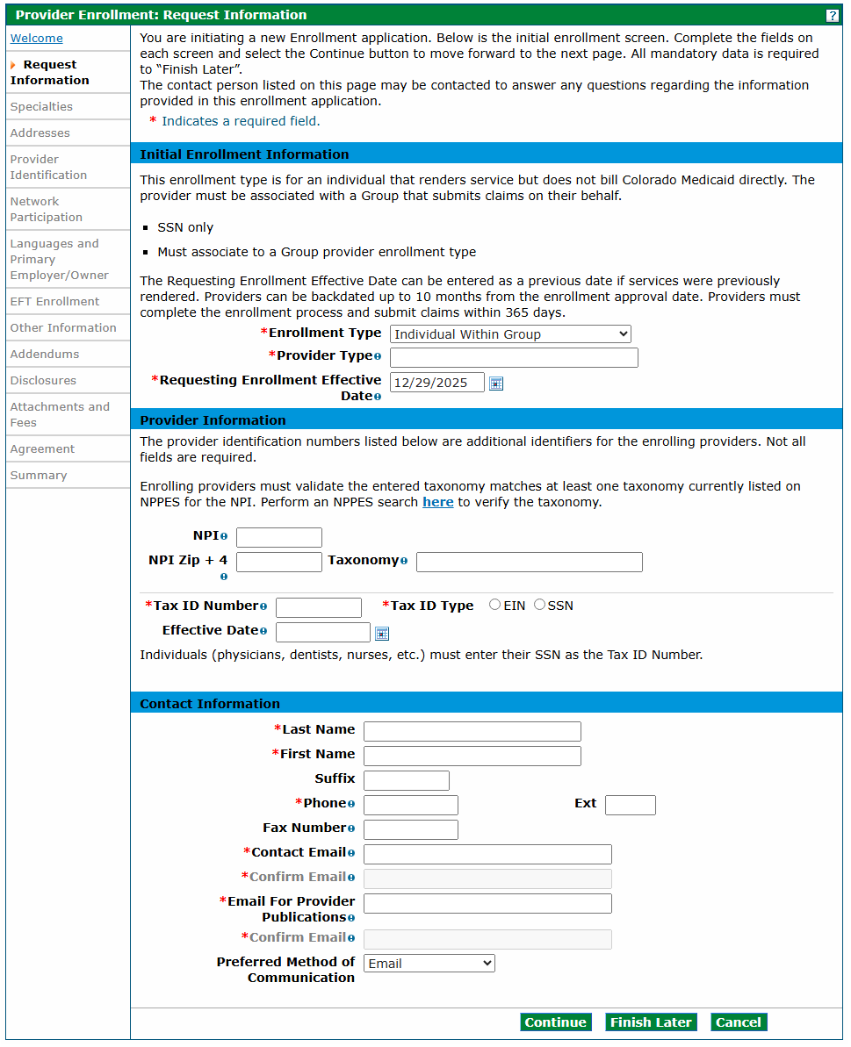
Initial Enrollment Information Section
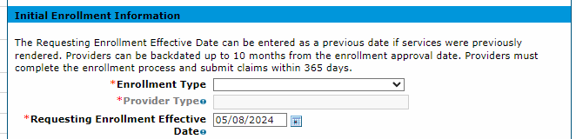

Enrollment Type
Select the enrollment type from the Enrollment Type drop-down list. Refer to the Provider Enrollment Manual Overview section above for explanations of the enrollment types.

Provider Type
Type two (2) asterisks (**) in this field to display all valid provider types specific to the enrollment type selected in the prior field. Type the first few characters of the word if the asterisks do not return the correct value.
Example: Type Phys and the panel returns items with Phys in the value, e.g., Physician and Physician Assistant.
Visit the Information by Provider Type web page to see all provider types supported in the Colorado interchange. These are the only provider types the system accepts.
We chose Physician for the purposes of this example.

Requesting Enrollment Effective Date
The Requesting Enrollment Effective Date field defaults to the current date for new enrollment applications. Users may enter a backdate up to 10 months prior to the current date. For applications in progress, the field populates with the date entered when the application was last saved. That date must be within 10 months prior to the current date.
A backdate (up to 10 months in the past) can be requested; however, the request is not a guarantee of approval. Additionally, any required licenses, certifications, insurance or specialties must be effective on the requested enrollment effective date.
Complete the remainder of the enrollment application. Providers receive a Welcome Letter which contains the provider’s backdated contract effective date if the enrollment and backdate request are approved.

Provider Information Section
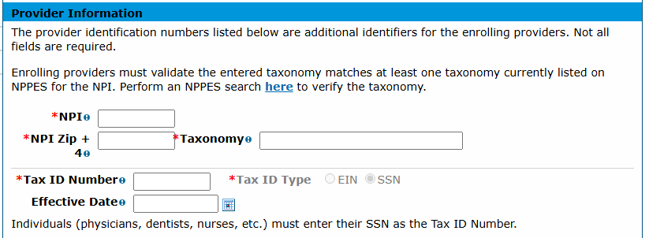
Enter the requested information within this section for the provider enrolling on the application, including the NPI number and the provider taxonomy and Tax ID.
Note: Not all provider types have an NPI number. For this example, the red asterisk indicating a required field is driven by the previous selection of Physician.
NPI – Enter the applicant’s 10-digit NPI. This information is required for most provider types. Some Atypical providers may not need an NPI.
NPI Zip + 4 – Enter the nine (9)-digit zip code associated with the service address, as listed in the NPPES NPI Registry. No entry is required in this field if an NPI is not required for the selected provider type.
Taxonomy Codes – Enter the 10-digit alphanumeric taxonomy code that classifies the enrolling provider as a healthcare provider according to the services offered. Entering two (2) or more characters to begin a search populates a drop-down list of applicable taxonomies from which the user may select. The taxonomy must match at least one (1) taxonomy listed in the NPPES NPI Registry. A popup notification appears after a taxonomy is selected that the application will be returned or possibly denied if the taxonomy does not match. The user must acknowledge the notification before continuing the application.
No entry is required in this field if the selected provider type does not require an NPI.
Refer to the Provider Taxonomy Codes under the Additional Required Information section of this manual for more taxonomy code information.
Tax ID Number – Enter the nine (9)-digit EIN or SSN associated with the enrolling provider in this required field. Individuals must enter their SSN as the Tax ID Number.
Tax ID Type – Organizations/businesses require an EIN while an individual (e.g., doctor, nurse, etc.) requires an SSN. The Tax ID Type will be automatically selected for most providers based on the chosen Provider Type. If the Tax ID Type is not automatically selected, select whether an EIN or SSN was entered in the Tax ID Number field as required for the provider type. Visit the Information by Provider Type web page to view enrollment requirements for the specific provider type.
Effective Date
- If an EIN was entered, the effective date for this field should be the date the corporation (entity) began doing business.
- If an SSN was entered, the effective date for this field should be the practitioner’s date of birth.

Contact Information Section
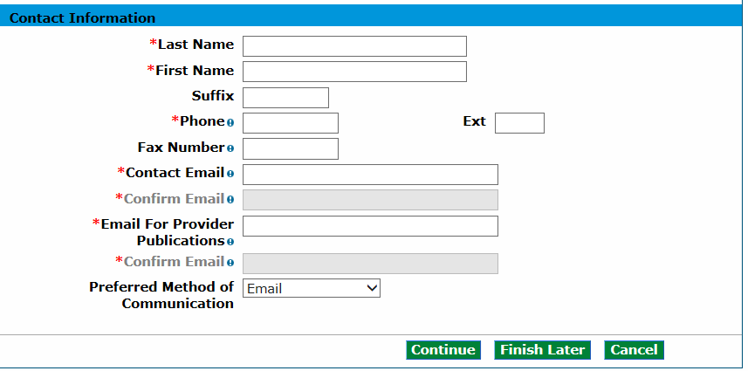
The information in this section is required for the practice or organization.
Last Name – Enter up to 50 alphanumeric characters in this required field for the last name of the individual who will receive correspondence regarding this enrollment.
First Name – Enter up to 25 alphanumeric characters in this required field for the first name of the individual who will receive correspondence regarding this enrollment.
Suffix – Enter up to 10 alphanumeric characters in this optional field for the suffix for the name of the individual who will receive correspondence regarding this enrollment, if applicable.
Phone – Enter 10 numeric characters in this required field using the 999-999-9999 format for the office phone number of the individual who will receive correspondence regarding this enrollment.
Ext – Enter the phone extension in this optional field of the individual who will receive correspondence regarding this enrollment, if applicable.
Fax Number – Enter 10 numeric characters in this optional field using the 999-999-9999 format for the fax number of the individual who will receive correspondence regarding this enrollment.
Contact Email – Use the name@domain format to enter a valid email address in this required field for the individual who will receive correspondence regarding this enrollment.
Confirm Email – Use the name@domain format to confirm the valid email address in this required field for the individual who will receive correspondence regarding this enrollment.
Email for Provider Publications – Use the name@domain format to enter a valid email address in this required field for the contact individual at the practice or organization to which Provider Publications should be sent.
Confirm Email – Use the name@domain format to confirm the valid email address for the contact individual at the practice or organization to which Provider Publications should be sent.
Preferred Method of Communication – Select Email to ensure more timely receipt of correspondence.

Change of Ownership Panel
After clicking Continue on the Request Information panel, entering credential information and generating an ATN, the Change of Ownership panel displays for certain facilities.
- Provider Type (PT) 01 – Hospital
- PT 02 – Mental Hospital
- PT 09 – Pharmacy
- PT 10 – Home Health
- PT 20 and 21 – Skilled Nursing Facility
- PT 50 – Hospice
- PT 62 – Indian Health Services (IHS) Pharmacy
Note: The Change of Ownership panel does not display for Individual Within a Group; Billing Individual; Ordering, Prescribing and Referring (OPR); Atypical; Group; Fiscal Intermediary; or PACE-Only Subcontractor provider enrollment types; or certain facilities.
The panel defaults to No for the Is this application due to a change of ownership where the EIN is changing? field.

Change of Ownership and EIN Section
Indicate if this enrollment is due to a change of ownership or federal EIN.
If No, click Continue to proceed to the next panel of the application.
If Yes, the Previous Ownership section displays.
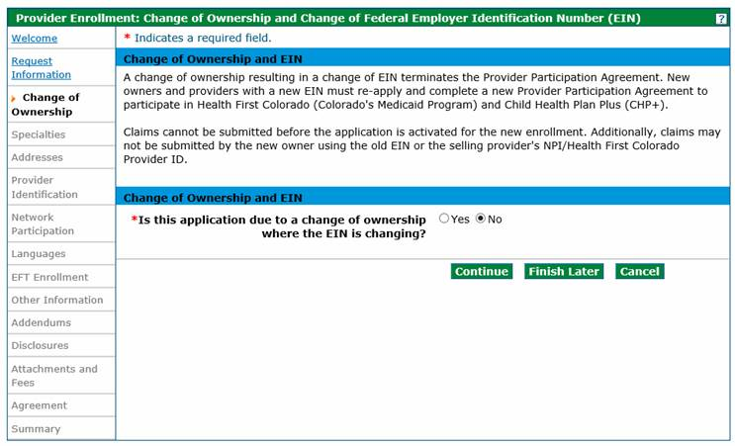
Note: Providers are reminded that new owners and providers with a new EIN must re-apply submitting a new enrollment application that includes the Selling Provider’s information and a new Provider Participation Agreement. Changes in ownership that do not result in an EIN change may continue to be submitted through the Disclosures panel of the Provider Maintenance or Revalidation applications. A change of ownership or change in EIN is not applicable to an individual (SSN) enrollment.
Visit the Provider Enrollment web page and click the Change of Ownership/Federal Employer Identification Number (EIN) drop-down for additional information.

Previous Ownership Section
Complete all required fields under the Previous Ownership section with the selling provider's information.
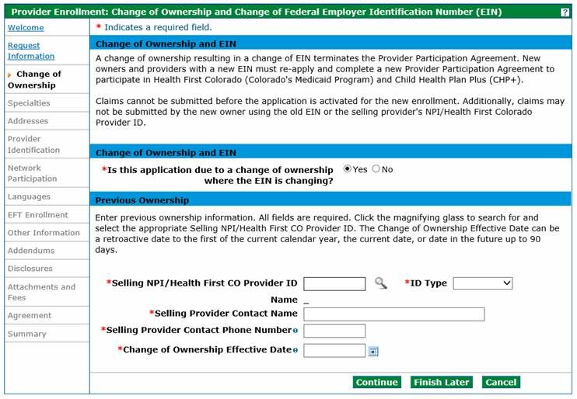
Selling NPI/Health First CO Provider ID – Enter the Medicaid number or NPI number of the selling provider or previous provider. Click the magnifying glass icon to search for a provider.
ID Type – Select the ID type from the drop-down list.
Name – This field populates with the NPI/Provider ID being entered.
Selling Provider Contact Name – Enter the selling provider’s first and last name.
Selling Provider Contact Phone Number – Enter 10 numeric characters using the 999-999-9999 format for the selling provider’s phone number in this required field.
Change of Ownership Effective Date – Enter the effective date of the change of ownership.
Click Continue, Finish Later or Cancel when all fields are completed.
Note: Upon receipt of a completed Change of Ownership enrollment application, the selling provider receives a notification from the Department with instructions on submitting a voluntary disenrollment application. The Change of Ownership enrollment application cannot be processed for approval until the selling provider completes and submits a voluntary disenrollment application through the Provider Web Portal.

Specialties Panel
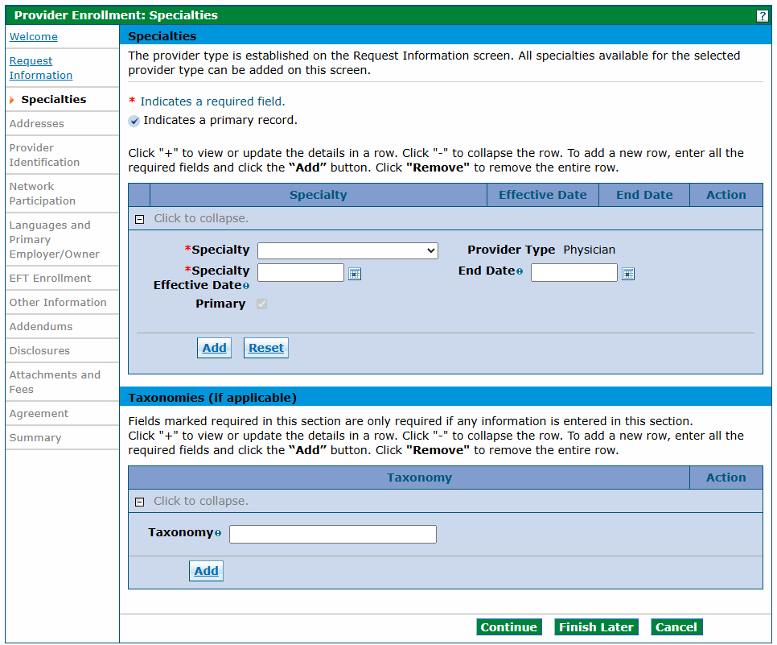
The specialties available on this panel are based on the Enrollment Type and Provider Type selection made on the Request Information panel. At least one (1) specialty is required. Some provider types allow for only one specialty, and some provider types allow for multiple specialties. However, only one specialty can be designated as the primary specialty. The system accepts only certain specialties.
Refer to the Provider Type, Enrollment Type and Enrollment Requirements section of this document for additional information on provider types, enrollment types and specialties.

Specialties Section
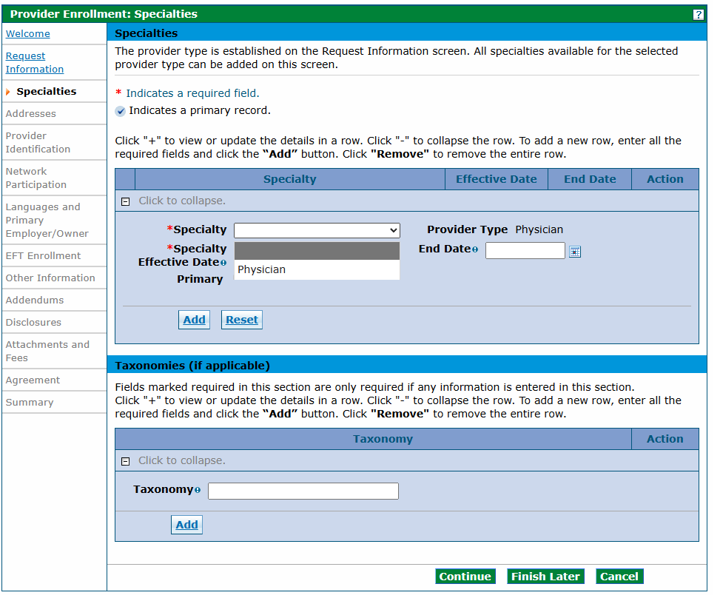
Specialty – Select the specialty from the drop-down list.
Note: There are many instances where the only Specialty option is the Provider Type selected. Select the only option available if this is the case.
Example: If the enrolling provider is a Pediatrician, select the only option shown (Physician) as the specialty.
Effective Date – Click the calendar icon next to this required field to enter the effective date of the specialty.
End Date – Click the calendar icon next to this optional field to enter the end date for the specialty, if applicable.

Specialties Section – Facility ID
Certain Home & Community Based Services (HCBS) specialties require a Facility ID, as indicated by a red asterisk. The Facility ID must be six (6) characters in length. HCBS providers can locate their assigned Facility ID on their issued Certificate & Transmittal (C&T) from the Colorado Department of Public Health and Environment (CDPHE). Only providers that are required to possess a C&T will have a Facility ID.
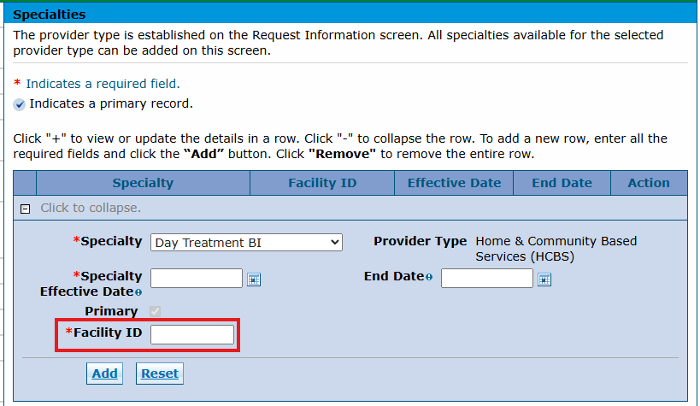
Certain HCBS specialties optionally allow a Facility ID. The Facility ID must be six (6) characters in length.
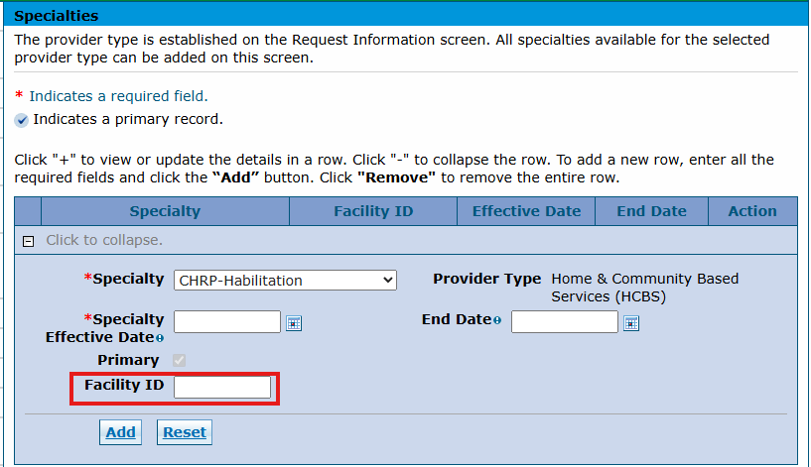
Certain HCBS specialties will not allow entry of a Facility ID.
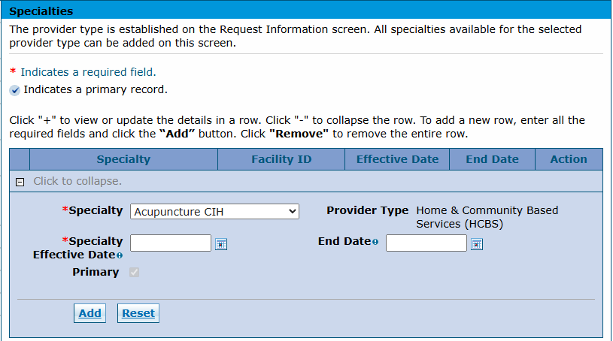
Do not forget to click the Add button.

Taxonomies Section
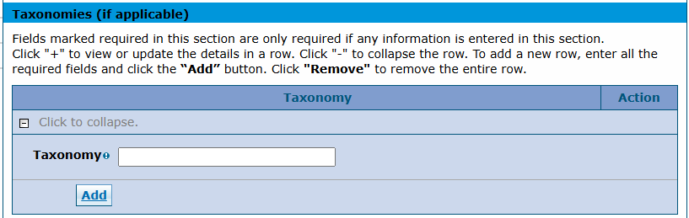
Additional taxonomies are not required. Click the Continue button if the user does not want to add additional taxonomy codes.
Taxonomy – Enter a taxonomy code, if applicable. This alphanumeric search field responds to characters entered and returns a list of valid taxonomy codes. Enter two (2) or more characters to begin a search, then select a code from the list.
This panel is complete. Click Continue, Finish Later or Cancel.

Addresses Panel
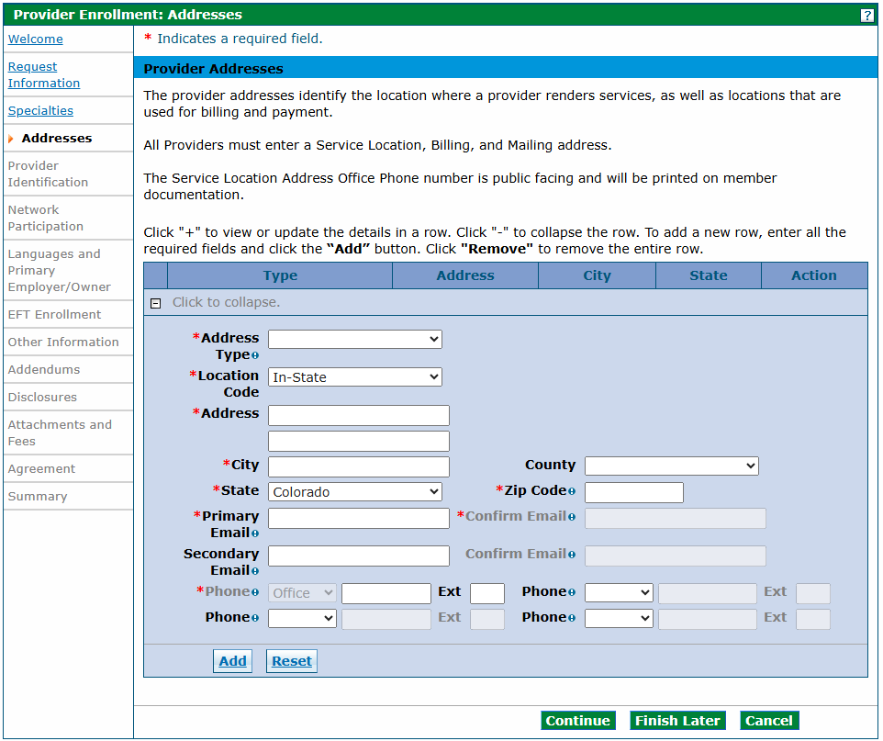
All providers regardless of enrollment type are required to enter three (3) different address types:
- Service Location
- Mailing
- Billing
There are slight differences in the information collected for each address type.
Refer to the Provider Type, Enrollment Type and Enrollment Requirements section of this document for additional information on these address types.
Note: Business entities enrolling with a federal Employer Identification Number (EIN) must complete a separate enrollment application for each service location address.
Individuals enrolling with a Social Security Number (SSN) are limited to one (1) enrollment only.

Provider Addresses Section
An additional section displays when Service Location is selected in the Address Type drop-down list. Refer to the example below.
Adding Service Location Address Information
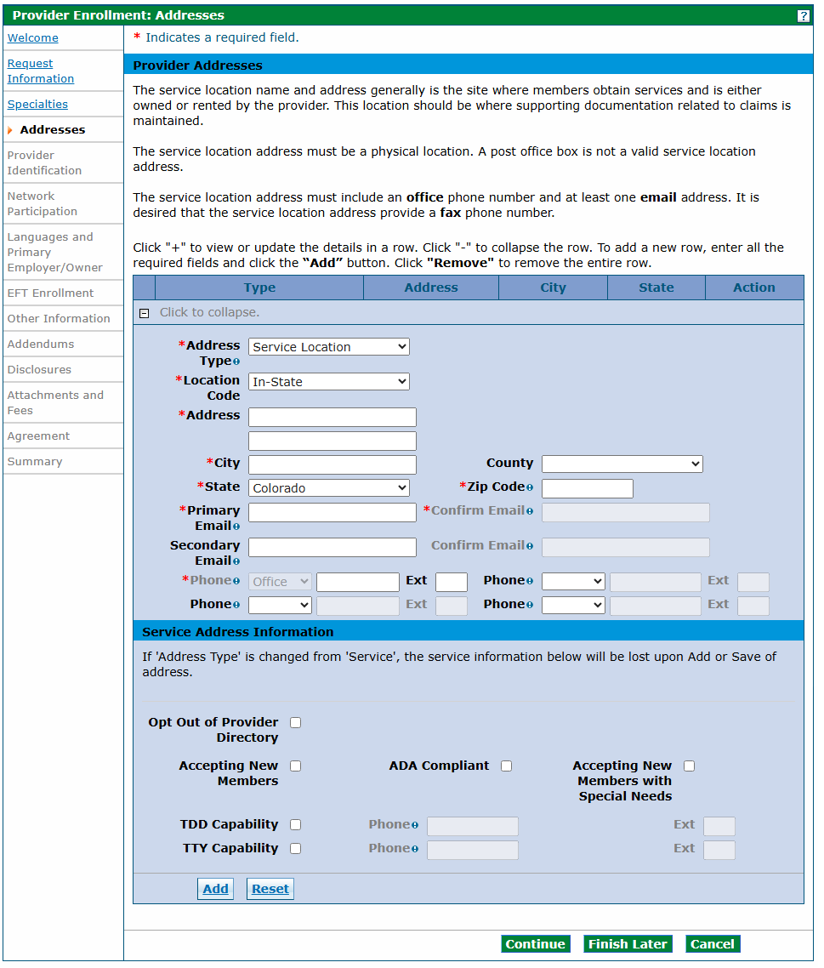
Address Type – Select the Service Location from this required drop-down list, which opens the Service Address Information panel at the bottom of the screen.
Location Code – Select the address location in relation to the State of Colorado in this required drop-down list. Possible selections are Border Provider, In-State and Out-of-State.
Note: Click the ? Help button on the upper right corner on this panel for a list of approved border providers.
- Refer to Appendix F: Border Towns located on the Billing Manuals web page under the Appendices drop-down for a list of approved border cities/town by bordering state.
- Visit the Information by Provider Type web page, select the appropriate provider type drop-down and refer to the BT Allowed? field in the table to determine if your provider type allows enrollment when the service location is in an approved border town.
Address – Enter up to 55 alphanumeric characters in this required field for the street address of the location. The Service Location must be a physical address and cannot be a PO Box. This address can be two (2) lines with suite, building or unit numbers on the second line.
City – Enter up to 30 alphanumeric characters in this required field for the appropriate city or town for the location.
County – Enter up to 30 alphanumeric characters in this optional field for the appropriate county for the location. Do not select State of Colorado as the County.
State – Select a valid state option for the location in this required drop-down list, which defaults to Colorado.
Zip Code – Enter the nine (9)-digit zip code for the location in this required field.
Primary Email – Use the name@domain format to enter up to 50 alphanumeric characters in this required field for the primary email address associated with the provider.
Confirm Primary Email – Use the name@domain format to re-enter up to 50 alphanumeric characters in this required field for the primary email address associated with the provider.
Secondary Email – Use the name@domain format to enter up to 50 alphanumeric characters in this optional field for the secondary email address associated with the provider.
Confirm Secondary Email – Use the name@domain format to re-enter up to 50 alphanumeric characters for the secondary email address associated with the provider. This field is required if the Secondary Email field is completed.
Phone (Type 1 of 4) – At least one (1) office number is required per location.
Phone (1 of 4) – Enter the 10-digit office phone number associated to the location in this required field. The service location address office phone number is public facing and is printed on member documentation.
Ext (1 to 4) – Enter the extension for the office phone number associated to the location in this optional field, if applicable.
Phone (Type 2 through 4) – Select the type of phone number from the optional drop-down list. Available selections are Cell, Fax, Office, Toll Free and Other.
Phone (2 through 4) – Enter additional 10-digit phone numbers associated to the location and phone type indicated in these optional fields, if applicable.
Ext (2 through 4) – Enter extensions applicable to the additional phone numbers entered in these optional fields.

Service Address Information
These fields display only on the Service Location Address panel.
Opt Out of Provider Directory – Select this optional checkbox if the service location should be omitted from the provider directory. Leaving this field blank will include the location in the provider directory.
Accepting New Members – Select this optional checkbox if the service location is accepting new patients. Leaving this field blank indicates the location is not accepting new patients.
ADA Compliant – Select this optional checkbox to indicate if the service location is compliant with the American Disabilities Act (ADA). Leaving this field blank indicates the location is not compliant.
Accepting New Members with Special Needs – Select this optional checkbox if the service location is accepting new patients with special needs. Leaving this field blank indicates the location is not accepting new patients with special needs.
TDD Capability – Select this optional checkbox if the service location provides a Telecommunications Device for the Deaf (TDD). Leaving this field blank indicates the location does not offer TDD capability.
Phone (TDD) – Enter the 10-digit phone number associated with the TDD capability. This field is required only if the TDD Capability checkbox is selected.
Ext (TDD) – Enter the four (4)-digit extension associated with the TDD in this optional field, if applicable.
TTY Capability – Select this optional checkbox if the service location provides a Teletypewriter (TTY) for the Deaf. Leaving this field blank indicates the location does not offer TTY capability.
Phone (TTY) – Enter the 10-digit phone number associated with the TTY capability. This field is required only if the TTY Capability checkbox is selected.
Ext (TTY) – Enter the four (4)-digit extension associated with the TTY in this optional field, if applicable.
Clicking the Add button after completing this panel stores the information in the application but does not save the information until either the Finish Later button is clicked, or the application is submitted at the end of the process. The panel updates to the version below after the Add button is clicked.
Provider Addresses Section – Service Location Added
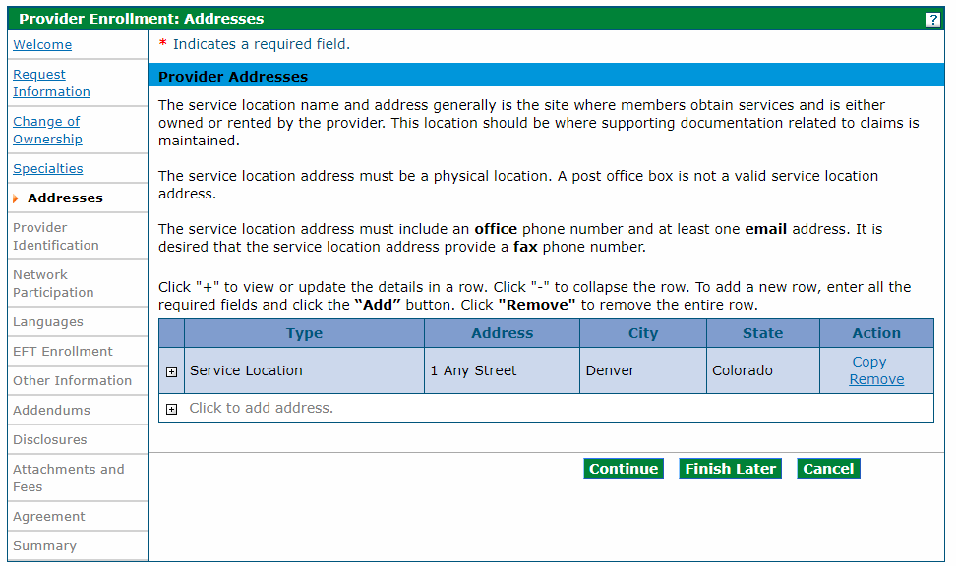
Click the + sign beside Click to add address to add the next address. Click Copy if the next address is the same, then edit as needed. The Copy feature is helpful when two (2) or more addresses are the same.
Provider Addresses Section - Add Another Address
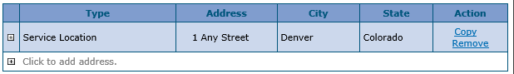
Select Billing or Mailing in the Address Type drop-down list and complete the information to add a billing or mailing address. There is one (1) additional field when the Billing or Mailing address panels are displayed.
Pay To Name or Mail To Name – Enter the person, area or entity to which billing or mailed information should be sent (e.g., Office Manager, Billing Manager, Front Desk, Mail Room, etc.) in these required fields.
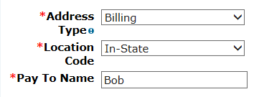
Click the Remove link in the Action column to delete an entire row. The row must be re-entered once removed.
Provider Addresses Panel – Completed
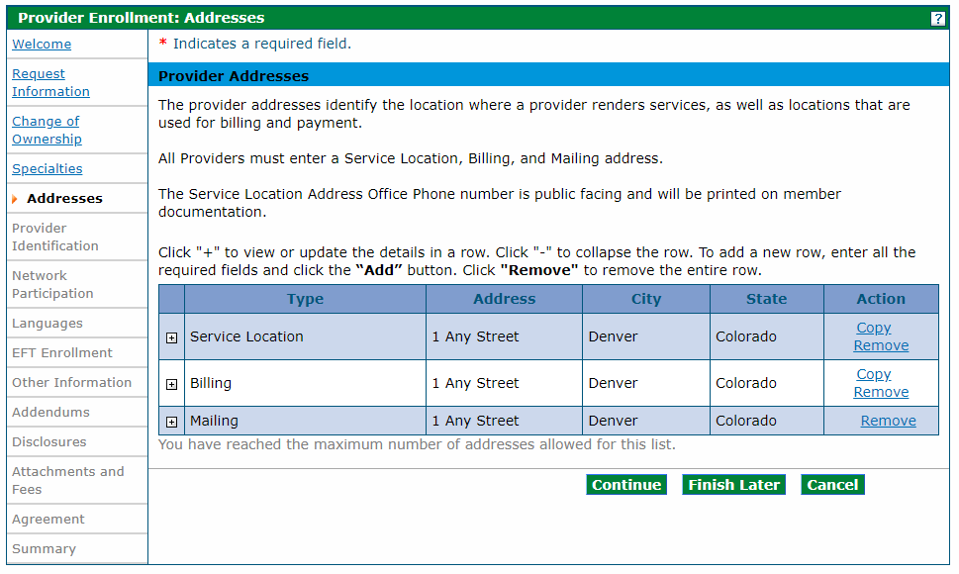
Click Continue, Finish Later or Cancel when all three (3) addresses are entered.

Provider Identification Panel
The example below displays a Group enrollment type. The panel may look similar to the following. Refer to the additional examples below.
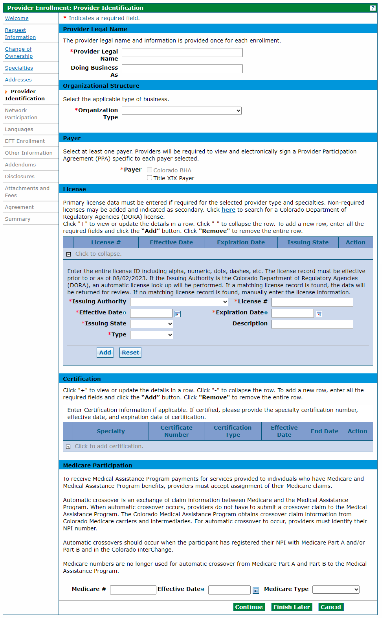
The Provider Identification panel requests information such as the legal name, a group practice or facility information, school information, and any appropriate identification numbers, such as the U.S. Drug Enforcement Administration (DEA), state license numbers and Medicare numbers. The Provider Enrollment Tool presents appropriate identification fields for the provider type, based on previous selections. For example, an individual is presented with fields to identify their education while a facility application does not include these fields.
Below is a comprehensive list of the Provider Identification fields that could display:

Provider Legal Name Section

Group, Atypical or Facility Providers
Provider Legal Name – Enter up to 70 alphanumeric characters in this required field for the provider’s legal name for a Group, Atypical provider or Facility.
Doing Business As – Enter up to 30 alphanumeric characters for the Doing Business As name of the provider in this optional field, if applicable.

Individual Providers
Last Name – Enter up to 60 alphanumeric characters in this required field for the last name of an individual provider.
First Name – Enter up to 25 alphanumeric characters in this required field for the first name of an individual provider.
Middle – Enter one (1) letter for the middle initial associated to the middle name of the provider.
Suffix – Enter up to 10 alphanumeric characters for the suffix for an individual provider, if applicable. This field should be used to indicate MD, PhD, etc.

Organizational Structure Section or Individual Provider Section

Organizational Structure Section
Organization Type – Select the organization type for the enrolling entity from the drop-down list. Typical values could include Corporation, Estate, Trust, etc. Visit the Secretary of State Business Database Search web page to locate the organization type if unsure of this information.

Individual Providers Section
Gender – Select the gender associated with an individual provider from the required drop-down list.
Birth Date – Enter eight (8) numeric characters using the MM/DD/YYYY format for the birth date associated with the individual provider. This field displays only if the enrollment type is Individual Within a Group, Ordering, Prescribing, Referring (OPR) or Billing Individual. The Birth Date must be between 0 and 150 years old.
Degree – Select the appropriate professional degree received by the individual provider from the drop-down. The Degree field is required if any of the Professional Education fields are completed.
School – Enter up to 25 alphanumeric characters for the name of school from which the individual provider received the degree. The School Name field is required if any of the Professional Education fields are completed.
Year of Graduation – Enter four (4) numeric characters for the year in which the provider obtained the degree. The Year of Graduation field is required if any of the Professional Education fields are completed. Year of Graduation cannot be more than 125 years in the past or future.

Group Association Section (Only for Individual Within a Group Enrollment Type)
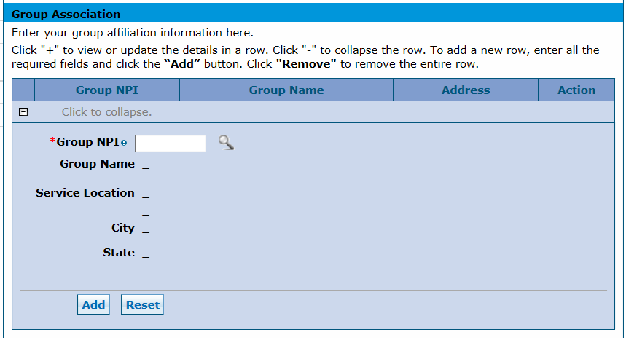
The Group Association section of the Provider Identification panel is required and displays only for providers that previously selected Individual Within a Group as the enrollment type. All groups to which the individual provider affiliates should be entered in this section.
Check with the Group representative(s) to ensure the groups are enrolled before completing this portion of the enrollment process. The affiliation cannot be completed if a Group is not enrolled.

Group NPI
Enter the Group’s NPI. The enrolled group’s name, service location address, city and state populate if the NPI returns a single group location. Click the Add button to add this group affiliation.
An error message displays at the top of the panel indicating Provider ID does not return a single Provider. Click the magnifying glass to search for a provider if the group NPI is associated with multiple locations. Click the magnifying glass icon next to the Group NPI field to display a list of address locations for the group NPI entered. Select the appropriate address location from the list, then click the Add button to add the affiliation.
Click the Reset button and re-enter the information if the information is not correct and the user would like to start over.
The panel updates and looks similar to the following after the user clicks the Add button:

Group Association Section – Add
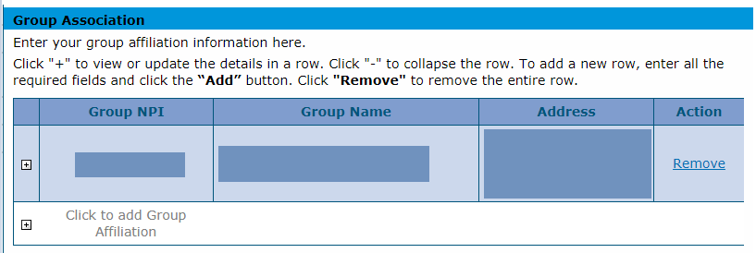
Click the + sign beside Click to add Group Affiliation to add each group affiliation if an individual is part of more than one (1) group. If an individual is affiliated to more than 16 groups, group 17 through the last group must be a separate attachment uploaded in the Attachment and Fees panel.

Payer Section
Payer – Select the appropriate payer. Applicable payer checkboxes are enabled, and at least one (1) payer must be selected.

License Section
If the license is a Colorado Department of Regulatory Agencies (DORA), an automatic lookup is performed when the Issuing Authority and License # are entered. The Effective Date, Expiration Date and Issuing State are retrieved and populated automatically if a match is found in DORA.
Issuing Authority – Select the agency that issued the license. (Examples: Colorado DORA, Colorado Department of Public Health and Environment [CDPHE]). The Issuing Authority field is required if any of the other License fields are completed.
License # – Enter up to 20 characters for the entire license number, including alphanumeric, dots, dashes, etc. The License # field is required if any of the other License fields are completed. Each license listed in the application must have a corresponding attachment for verification showing the license number, the effective date and the expiration date of the license.
Effective Date (License) – Enter eight (8) numeric characters using the MM/DD/YYYY format for the effective date for the license number assigned to the provider. Enter the effective date, not the issue date. The Effective Date field is required if any of the other License fields are completed.
Expiration Date (License) – Enter eight (8) numeric characters using the MM/DD/YYYY format for the expiration date for the license number assigned to the provider. The expiration date cannot be before the effective date. The Expiration Date is required if any of the other License fields are completed.
Issuing State – Select the state from which the license is issued from the drop-down list. The Issuing State field is required if any of the other License fields are completed.
Description – Enter up to 50 characters for the license description in this optional free form field.
Type – Select the appropriate value for the license type in the drop-down list. Valid values are Primary or Secondary. Provider types or specialties that require a license must add required licenses with a type of Primary. Visit the Information by Provider Type web page, click the Provider Type drop-down and refer to the Required Attachments section for more information on required licenses. Non-required licenses may be added with a type of Secondary. The Type field is required if any of the other License fields are completed.

Certification Section
Specialty – Select the Specialty from this required drop-down list. Typical values could include Physician, Pharmacy, Nursing Facility, etc.
Certificate Number – Enter 20 alphanumeric characters for the Certification Number in this required field.
Certification Type – Select the appropriate Certification Type from this required drop-down list. Values could include Accreditation, National Specialty Board, Other, Tax Exempt, etc.
Effective Date – Enter eight (8) numeric characters using the MM/DD/YYYY format for the effective date for the certification. This field is required if the Certificate Number is completed.
End Date – Enter eight (8) numeric characters in this required field using the MM/DD/YYYY format for the end date for the certification. The End Date cannot be before the Effective Date.
Click the Add button to add the certificate information. Click the + sign next to Click to add certification to add additional certificates.
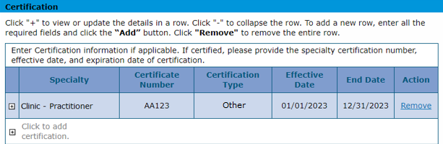

Essential Safety Net Provider (ESNP) Section
ESNP Approval # – Enter up to 50 alphanumeric characters for the Certification Number in this required field.
Effective Date – Enter eight (8) numeric characters using the MM/DD/YYYY format for the effective date for the ESNP record.
Expiration Date – Enter eight (8) numeric characters in this required field using the MM/DD/YYYY format for the end date for the ESNP record. The End Date cannot be before the Effective Date.
Click the Add button to add the ESNP information. Click the + sign next to Click to add ESNP Approval to add additional records.
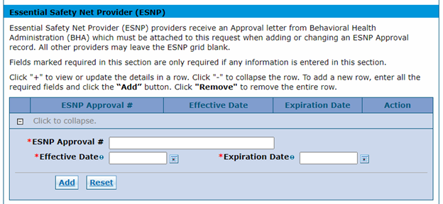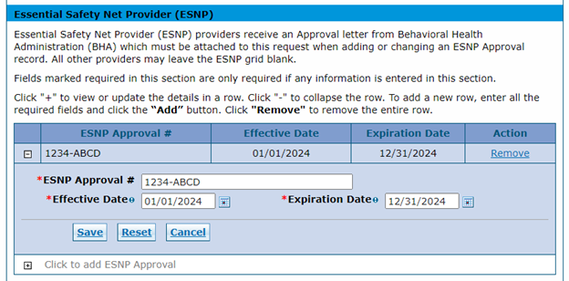
A copy of the ESNP Approval is required as an attachment.
Note: The ESNP section is optional and will not apply to all providers.

Medicare Participation Section
Medicare # – Enter 10 alphanumeric characters for the Medicare number assigned by the federal government to the provider. The Medicare Number field is required if any of the other Medicare fields are completed.
Effective Date (Medicare Number) – Enter eight (8) numeric characters using the MM/DD/YYYY format for the effective date of the Medicare #. This is the date the Medicare contractor received the signed and dated Certification Statement. The Effective Date field is required if any of the other Medicare fields are completed.
Medicare Type – Select the Medicare Type associated with the Medicare # from the drop-down list. The Medicare Type field is required if any of the other Medicare fields are completed. Typical values could include Medicare Part A, Medicare Part B, etc.

CLIA Certification Section or DEA Section

CLIA Certification Section
CLIA # –Enter up to 10 numeric characters for the Clinical Laboratory Improvement Amendment (CLIA) certification number assigned to Group, Facility or Atypical providers. The CLIA # field is required if any other CLIA fields are completed. A copy of the CLIA certificate is required as an attachment. The CLIA data panel displays in applications for individuals.
Effective Date (CLIA) – Enter eight (8) numeric characters using the MM/DD/YYYY format for the CLIA certification number's effective date. The Effective Date field is required if the CLIA # field is completed.
End Date (CLIA) – Enter eight (8) numeric characters using the MM/DD/YYYY format for the CLIA certification number's end date. Enter 12/31/2299 if there is no end date for the CLIA certification. The End Date field is required if any of the other CLIA fields are completed.

DEA Section
DEA # – Enter nine (9) alphanumeric characters for the Drug Enforcement Agency (DEA) number assigned to the provider. The DEA # is required if the Effective Date field is completed.
Effective Date (DEA) – Enter eight (8) numeric characters using the MM/DD/YYYY format for the DEA number’s effective date. The Effective Date field is required if the DEA # field is completed.

Other Identifiers

Managed Care Organizations (MCOs)
Health Plan Identifier (HPID) – Enter up to 15 alphanumeric characters for the provider’s Health Plan ID. The HPID is for only MCOs.

Pharmacy Enrollments
NCPDP Provider ID Number – Enter 10 alphanumeric characters in this optional field for the provider’s National Council for Prescription Drug Programs (NCPDP) Provider ID Number. This field is applicable to Pharmacy enrollments only.
Pharmacy Classification – Select the classification of the Pharmacy ID from the drop-down list. Values included are such as Chain, Federal Government, Hospital, etc.
Click Continue, Finish Later or Cancel when the panel is complete.

Billing Individuals, Individual Within Group and OPR
Below is an example of the panel for an Individual Within a Group Provider Type selection.
Provider Identification Panel – Individual Within a Group
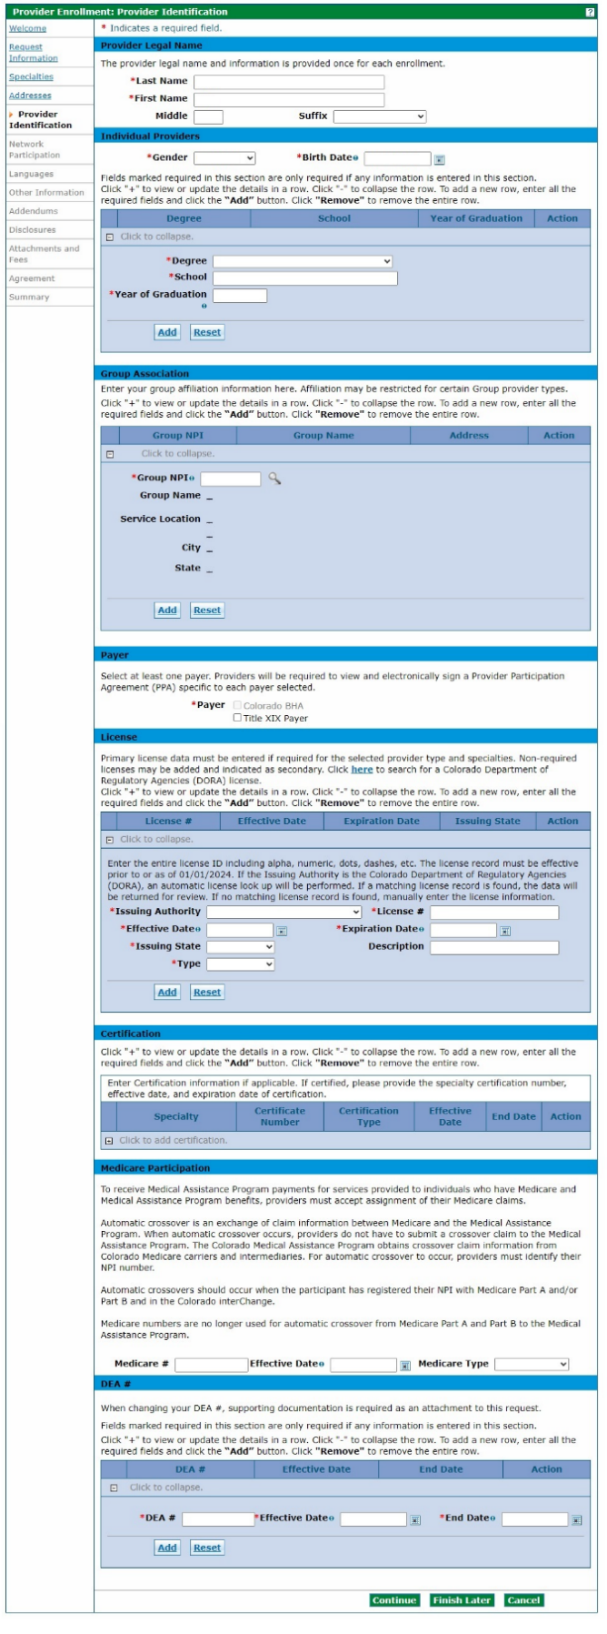
Fields marked required in this section are required only if information is entered in this section.
A license may be required depending on the Provider Type and/or Specialty selected.

Facility and Atypical
Below is an example of the panel for an Atypical Provider Type selection.
Provider Identification Panel – Atypical
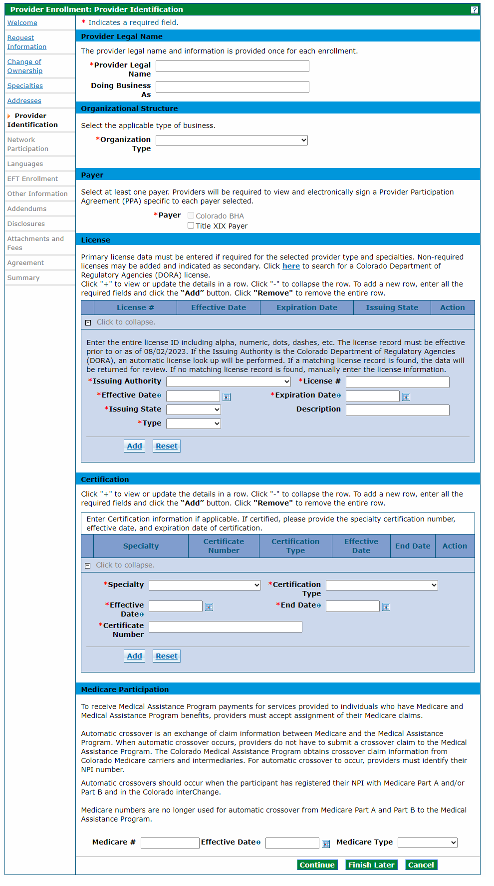
Visit the Secretary of State Business Database Search web page to locate the organization type if unsure of
this information.
A license may be required
depending on the Provider Type and/or Specialty selected.

Network Participation Panel
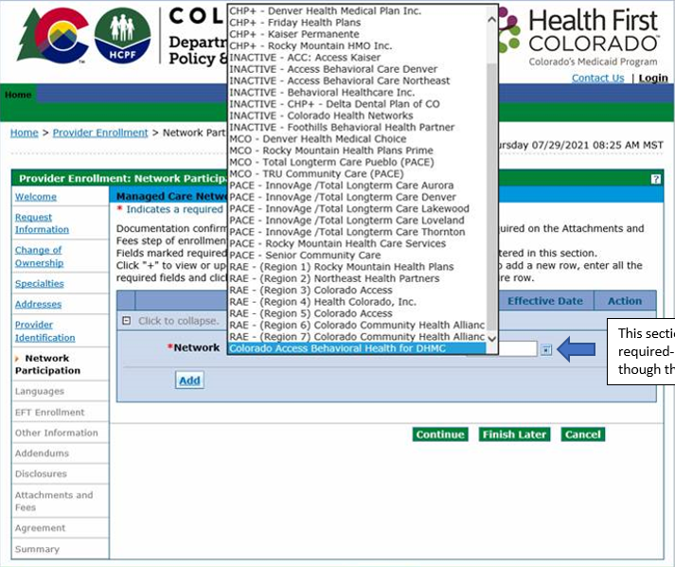
This section is not required, even though there is an asterisk (*).

Selection for PACE-Only Subcontractors
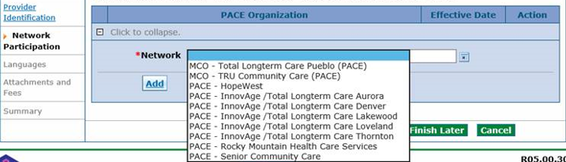
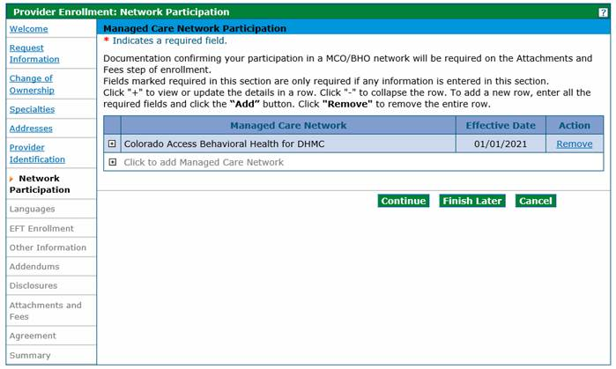
The Network Participation panel is where providers may enter any medical networks in which they participate. Adding a network option does not create an enrollment into that network.
Select from the available Colorado networks:
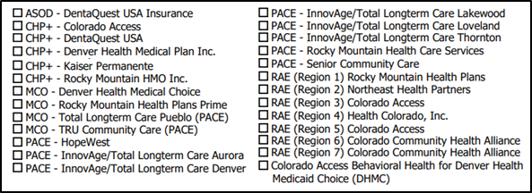
Click the Add button once a network and its effective date are selected to add it to the list.
Network Participation Panel – MCO/RAE Add Network
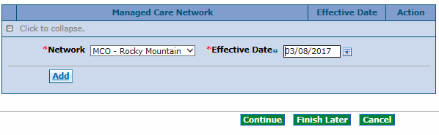
Click the + sign next to Click to add Managed Care Network to add another network if a provider is a member of more than one (1) network. Repeat the steps above until this panel is complete.
Network Participation Panel – MCO/BHO Network Add another MCO Network
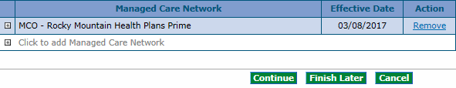
Click Continue, Finish Later or Cancel when the panel is complete.

Languages and Primary Employer/Owner Panel

Languages Section
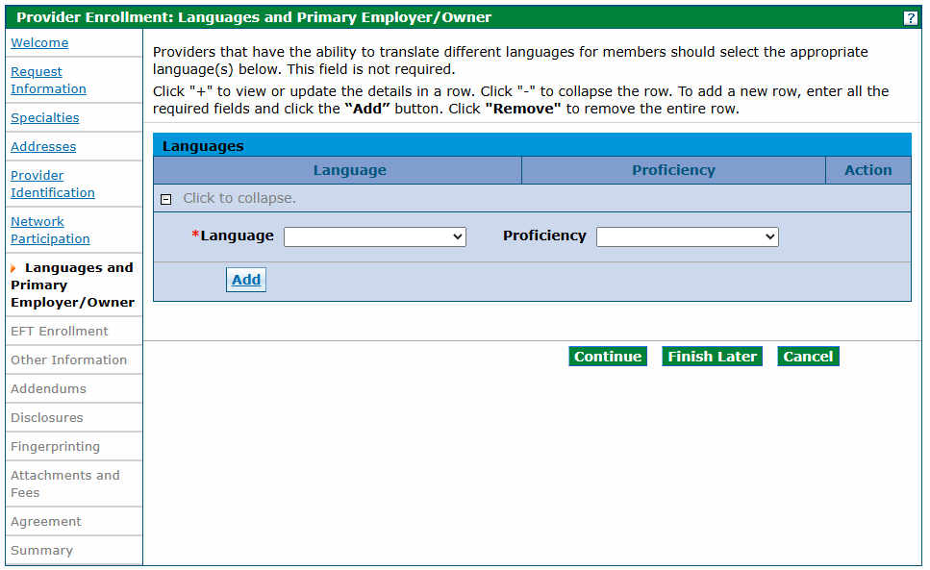
The user may enter up to 60 available languages and the proficiency level spoken within the office or facility. This information is searchable on the Health First Colorado Find a Doctor web page.
Click the Add button after each language is selected. The screen updates and adds the selected item to the list of languages. Click the Remove link in the Action column to remove a language.
Languages Panel – Add Additional Language
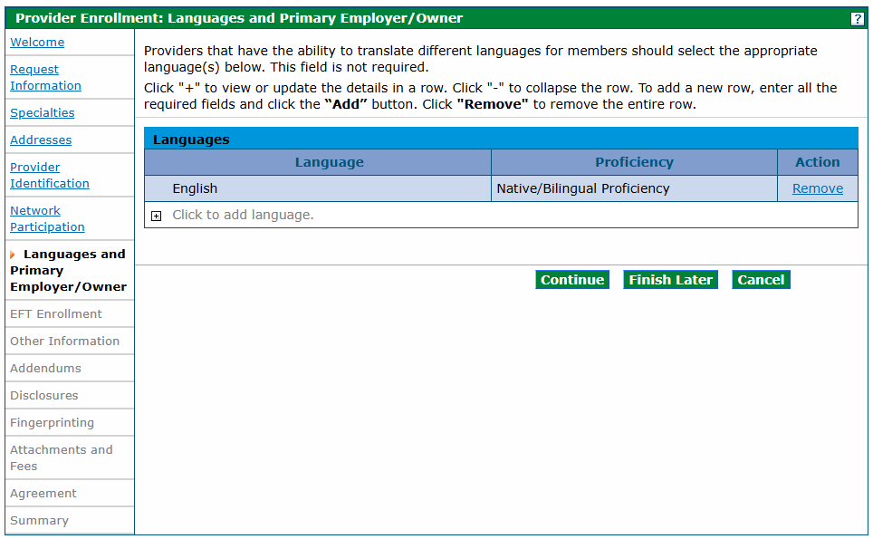
Click Continue, Finish Later or Cancel when the panel is complete.

Primary Owner Section
Group and facility providers are required to select a Primary Owner from the drop-down list.
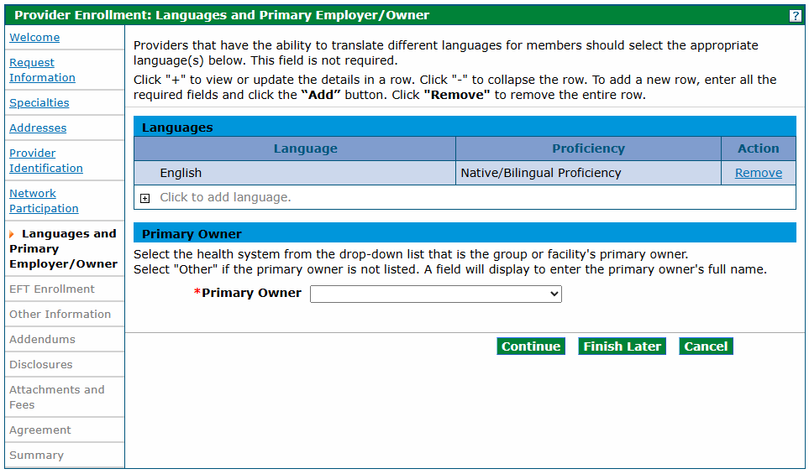
If Other is selected from the drop-down list, an optional free form field will appear for the user to enter the primary owner’s full name.
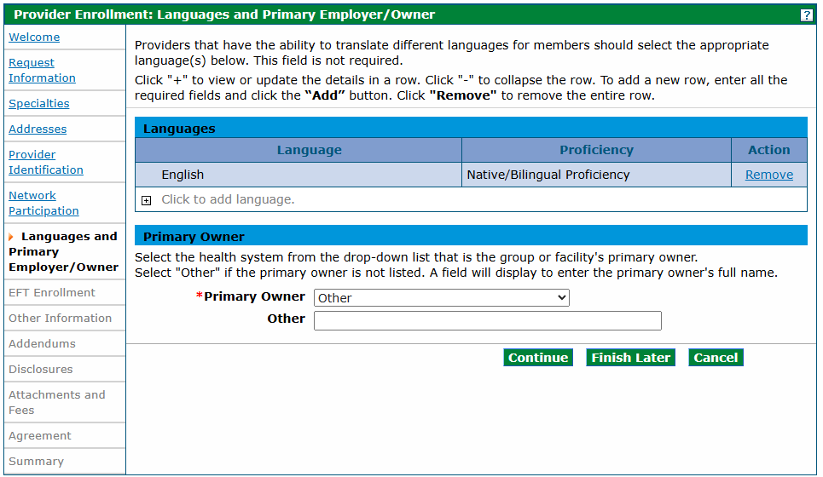
Click Continue, Finish Later or Cancel when the panel is complete.

Primary Employer Section
Ordering, Prescribing, and Referring (OPR) and Individual Within a Group providers are required to select a Primary Employer from the drop-down list.
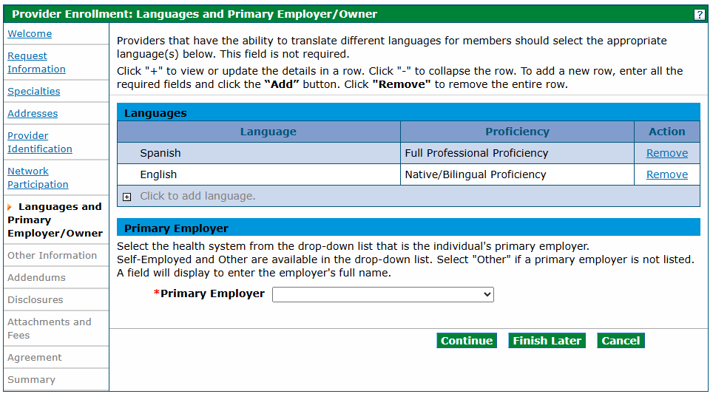
If Other is selected from the drop-down list, an optional free form field will appear for the user to enter the primary employer’s full name. 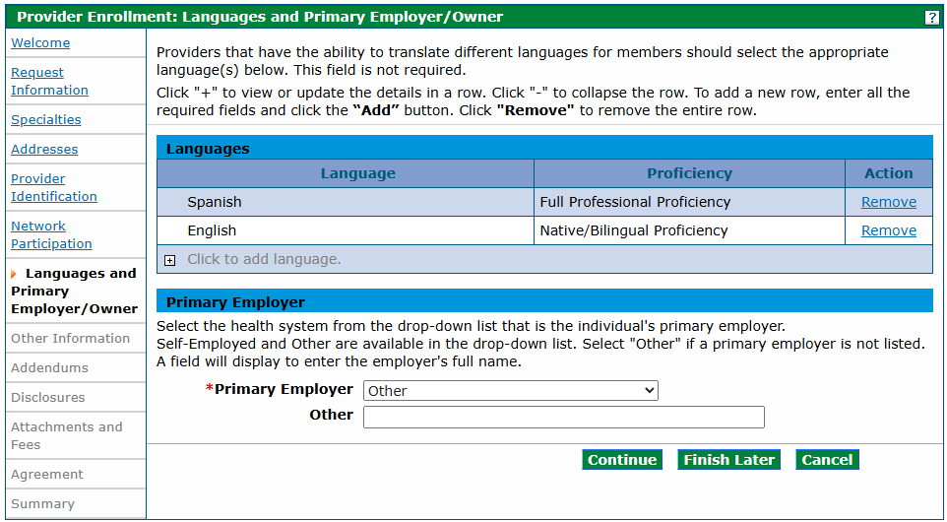
Click Continue, Finish Later or Cancel when the panel is complete.

Electronic Funds Transfer (EFT) Enrollment Panel
Note: The EFT Enrollment panel does not display for PACE-Only Subcontractor or Fiscal Intermediary provider enrollment types.
The following comprehensive list describes the fields on the EFT Enrollment panel:
EFT Enrollment Panel – Part 1
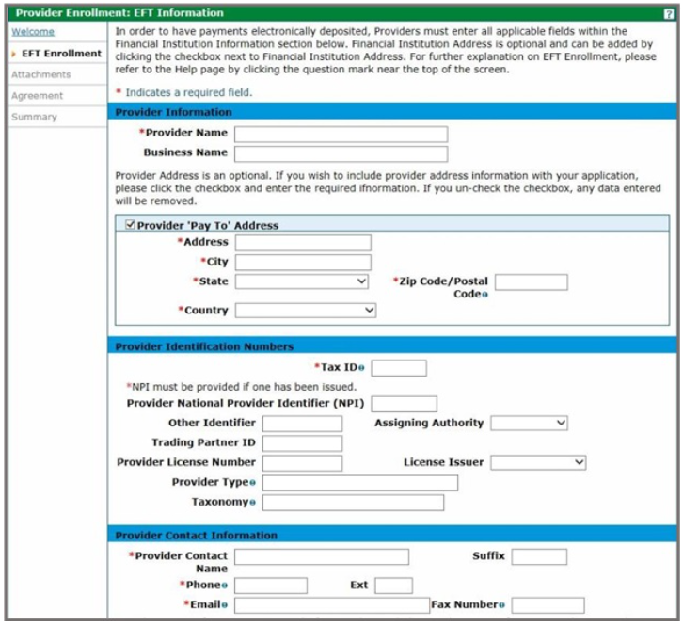
A scanned copy of a bank letter or a voided business check must be added on the Attachments and Fees panel.
This panel collects information needed for direct deposit of claims reimbursement into a bank account via EFT. EFT allows quicker access to claim payments by depositing them directly to the bank account.
Not all enrollment types see this panel. If the user is an Individual Within a Group, the user does not see this panel as the Group submits claims on behalf of the individual and would be responsible for submitting the information for this panel. If the user is an OPR provider, the user does not see this panel as an OPR provider does not submit claims for payment.

Provider Information Section
Provider Name – This field prepopulates with the complete legal name of the institution, corporate entity, practice or individual provider that was entered previously in the application. If applicable, this field is display-only and is supplied by the value from the Provider Identification panel.
Business Name – This field prepopulates with the name under which the business or operation is conducted that was entered previously in the application. If applicable, this field is display-only and is supplied by the value from the Provider Identification panel.

Provider Pay To Address Section
Address – Enter the address associated to the provider. If applicable, this field is display-only and is supplied by the value from the Pay To Address panel.
City – Enter up to 30 alphanumeric characters for the city associated to the provider address. If applicable, this field is display-only and is supplied by the value from the Pay To Address panel.
State – Select the state associated to the provider’s Pay To Address from the drop-down list.
Zip Code / Postal Code – Enter the Zip Code associated to the provider address. If applicable, this field is display-only and is supplied by the value from the Pay To Address panel.
Country – Select the country code associated to the provider’s address from the drop-down list. This field is supplied by the values from the Pay To Addresses panel.

Provider Identification Numbers Section
Tax ID – Enter nine (9) numeric characters for the Tax ID Number used to identify the business entity. If applicable, this field is display-only and is supplied by the value from the Request Information panel.
Provider National Provider Identifier (NPI) (Provider Identification Numbers) – Enter 10 numeric characters for the unique identification number for the provider. If applicable, this field is display-only and is supplied by the value from the Request Information panel.
Other Identifier – Enter 10 alphanumeric characters for an additional provider identifier. If applicable, this field is display-only and is supplied by the value from the Request Information panel.
Assigning Authority – Select the organization that issues and assigns the additional provider identifier from the drop-down list. If applicable, this field is display-only and is supplied by the value from the Request Information panel. This field is required if the Other Identifier field is completed.
Trading Partner ID – Enter 10 alphanumeric characters in this optional field for the provider’s submitter ID assigned by the health plan or the provider’s clearinghouse or vendor.
Provider License Number – Enter 20 alphanumeric characters for the provider’s license number. If applicable, this field is display-only and is supplied by the value from the Request Information panel.
License Issuer – Enter up to 30 alphanumeric characters for the entity that issued the provider’s license number. This field is supplied by the Request Information panel.
Provider Type – Enter up to 50 alphanumeric characters for the type of provider. If applicable, this field is display-only and is supplied by the value from the Request Information panel.
Taxonomy Code – Enter 10 alphanumeric characters for the provider’s taxonomy code. The code set is structured into three (3) distinct levels including provider type, classification and area of specialization. If applicable, this field is display-only and is supplied by the value from the Request Information panel.

Provider Contact Information Section
Provider Contact Name – Enter up to 70 alphanumeric characters for the name of the contact person. If applicable, this field is display-only and is supplied by the value from the Request Information panel.
Suffix (Provider Contact) – Enter up to 30 alphanumeric characters for the suffix of the contact person. If applicable, this field is display-only and is supplied by the value from the Request Information panel.
Phone (Provider Contact) – Enter 10 numeric characters using the 999-999-9999 format for the provider contact’s phone number. If applicable, this field is display-only and is supplied by the value from the Request Information panel.
Ext (Provider Contact) – Enter four (4) numeric characters for the extension for the contact person. If applicable, this field is display-only and is supplied by the value from the Request Information panel.
Email (Provider Contact) – Use the name@domain format to enter up to 50 alphanumeric characters for the email address for the contact person. If applicable, this field is display-only and is supplied by the value from the Request Information panel.
Fax Number (Provider Contact) – Enter 10 numeric characters using the 999-999-9999 format for the provider contact’s fax number. If applicable, this field is display-only and is supplied by the value from the Request Information panel.
This panel also includes several optional sections that can be completed during the enrollment process, which are indicated by blue arrows on the panel below.
EFT Enrollment Panel – Part 2
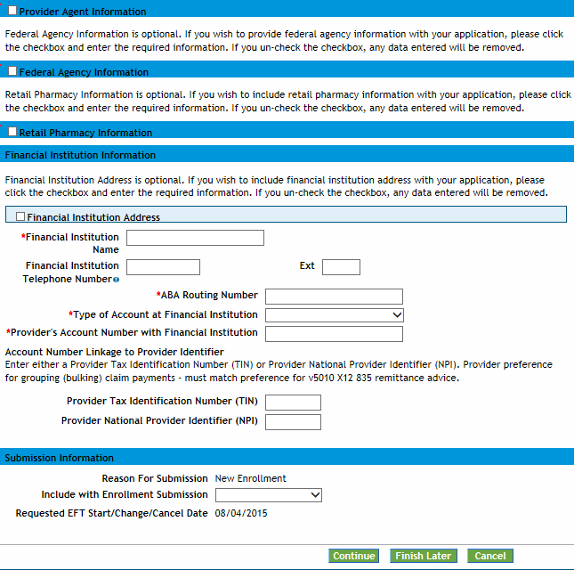
Either a TIN or an NPI is required.
Selecting the white checkboxes opens each area. This information is optional. Unselecting the checkboxes closes each area and removes any information entered in these fields.

Provider Agent Information Section
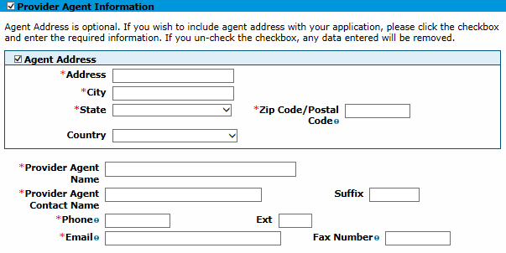
Agent Address – Enter up to 55 alphanumeric characters for the number and street name of the agent address. This field is required only when the Agent Address checkbox is selected.
City – Enter up to 30 alphanumeric characters for the city associated to the agent address. This field is required only when the Agent Address checkbox is selected.
State – Select the state associated to the agent address in this drop-down list. This field is required only when the Agent Address checkbox is selected.
Zip Code / Postal Code – Enter nine (9) numeric characters for the Zip code associated to the agent address. This field is required only when the Agent Address checkbox is selected.
Country – Select the country code associated to the agent address from the drop-down list. This field is required only when the Agent Address checkbox is selected.
Provider Agent Name – Enter up to 70 alphanumeric characters for the name of the agent. This field is required only when the Provider Agent Information checkbox is selected.
Provider Agent Contact Name – Enter up to 70 alphanumeric characters for the name of the agent contact. This field is required only when the Provider Agent Information checkbox is selected.
Suffix (Agent Contact) – Enter up to 30 alphanumeric characters for the suffix of the agent contact. This field is required only when the Agent Address checkbox is selected.
Phone (Agent Contact) – Enter 10 numeric characters using the 999-999-9999 format for the agent contact’s phone number. This field is required only when the Provider Agent Information checkbox is selected.
Ext (Agent Contact) – Enter four (4) numeric characters for the telephone number extension for the agent contact. This field is required only when the Agent Address checkbox is selected.
Email (Agent Contact) – Use the name@domain format to enter up to 50 alphanumeric characters for a valid email address for the agent contact. This field is required only when the Provider Agent Information checkbox is selected.
Fax Number (Agent Contact) – Enter 10 numeric characters in this required field using the 999-999-9999 format for the agent contact’s fax number.

Federal Agency Information Section
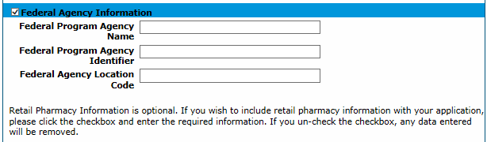
Federal Program Agency Name – Enter up to 70 alphanumeric characters for the name of the Federal Program Agency.
Federal Program Agency Identifier – Enter up to 10 alphanumeric characters for the identifier of the Federal Program Agency.
Federal Agency Location Code – Enter up to 25 alphanumeric characters for the location code of the Federal Program Agency.

Retail Pharmacy Information Section
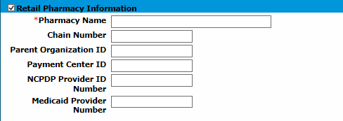
Pharmacy Name – Enter up to 70 alphanumeric characters for the pharmacy name. This field is required only when the Retail Pharmacy Information checkbox is selected.
Chain Number – Enter five (5) alphanumeric characters for the identification number assigned to the entity allowing linkage for a business relationship (i.e., chain, buying groups or third-party contracting organizations). This may also be known as Affiliation ID or Relation ID.
Parent Organization ID – Enter 10 alphanumeric characters for the headquarter information for chains, buying groups or third-party contracting organizations where multiple relationship entities exist and need to be linked to a common organization such as common ownership for several chains.
Payment Center ID – Enter 10 alphanumeric characters for the assigned payment center identifier associated with the provider/corporate entity.
NCPDP Provider ID Number – Enter seven (7) alphanumeric characters for the National Council for Prescription Drug Programs (NCPDP)-assigned unique identification number.
Medicaid Provider Number – Enter 10 alphanumeric characters for the number issued to a provider by the U.S. Department of Health and Human Services (HHS) through state health and human services agencies.

Financial Institution Information Section
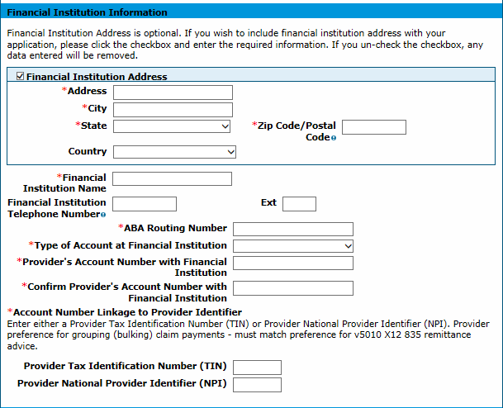
Either a TIN or an NPI is required.
Several required fields are indicated with a red asterisk in the Financial Institution Information section. The user has the option to enter the Financial Institution’s address information by selecting the white checkbox indicated by a blue arrow on the panel above.
Address (Financial Institution) – Enter up to 55 alphanumeric characters for the number and street name of the financial institution address. This field is required only when the Financial Institution Address checkbox is selected.
City (Financial Institution) – Enter up to 30 alphanumeric characters for the city associated to the financial institution address. This field is required only when the Financial Institution Address checkbox is selected.
State (Financial Institution) – Select the state associated to the financial institution address in the drop-down list. This field is required only when the Financial Institution Address checkbox is selected.
Zip Code / Postal Code (Financial Institution) – Enter nine (9) numeric characters for the zip code associated to the financial institution address. This field is required only when the Financial Institution Address checkbox is selected.
Country (Financial Institution) – Select the country code associated to the financial institution address in the drop-down list. This field is required only when the Financial Institution Address checkbox is selected.
Financial Institution Name – Enter up tp 39 alphanumeric characters in this required field for the name of the provider's financial institution.
Financial Institution Telephone Number – Enter 10 numeric characters using the 999-999-9999 format for the phone number for the provider's financial institution. This field is required only when the Financial Institution Address checkbox is selected.
Ext (Financial Institution) – Enter four (4) numeric characters for the telephone number extension for the provider's financial institution. This field is required only when the Financial Institution Address checkbox is selected.
ABA Routing Number – Enter nine (9)-digits in this required field for the identifier of the financial institution where the provider maintains an account to which payments will be deposited.
Type of Account at Financial Institution – Select the type of account the provider uses to receive EFT payments (e.g., Checking, Savings) in the required drop-down list.
Provider's Account Number with Financial Institution – Enter 10 alphanumeric characters in this required field for the provider's account number at the financial institution to which EFT payments will be deposited.
Provider Tax Identification Number (TIN) – (Financial Institution Information) – Enter nine (9) numeric characters for the federal Tax ID Number (TIN) used to identify a business entity. Either a provider’s NPI or TIN is required.
Provider National Provider Identifier (NPI) (Financial Institution Information) – Enter 10 numeric characters for the unique identification number for the provider. Either a provider’s NPI or TIN is required.

Submission Information Section
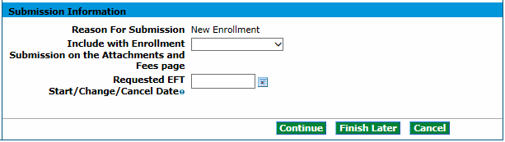
Reason For Submission – New Enrollment is the only option that populates for the reason for the EFT enrollment.
Include with Enrollment Submission – Select Bank Letter or Voided Check in the drop-down list. The bank account verification document type must be attached as part of the enrollment application. The user must attach the bank letter or the voided check in the Attachment and Fees panel.
Requested EFT Start/Change/Cancel Date – Enter eight (8) numeric characters using the MM/DD/YYYY format for the date on which the requested action is submitted. This field is display-only and defaults to the current date.
Click Continue, Finish Later or Cancel when the panel is complete.

Other Information Panel
Note: The Other Information panel does not display for PACE-Only Subcontractor or Fiscal Intermediary provider enrollment types.
The example below displays a Group enrollment type. The screen may look similar to the following:
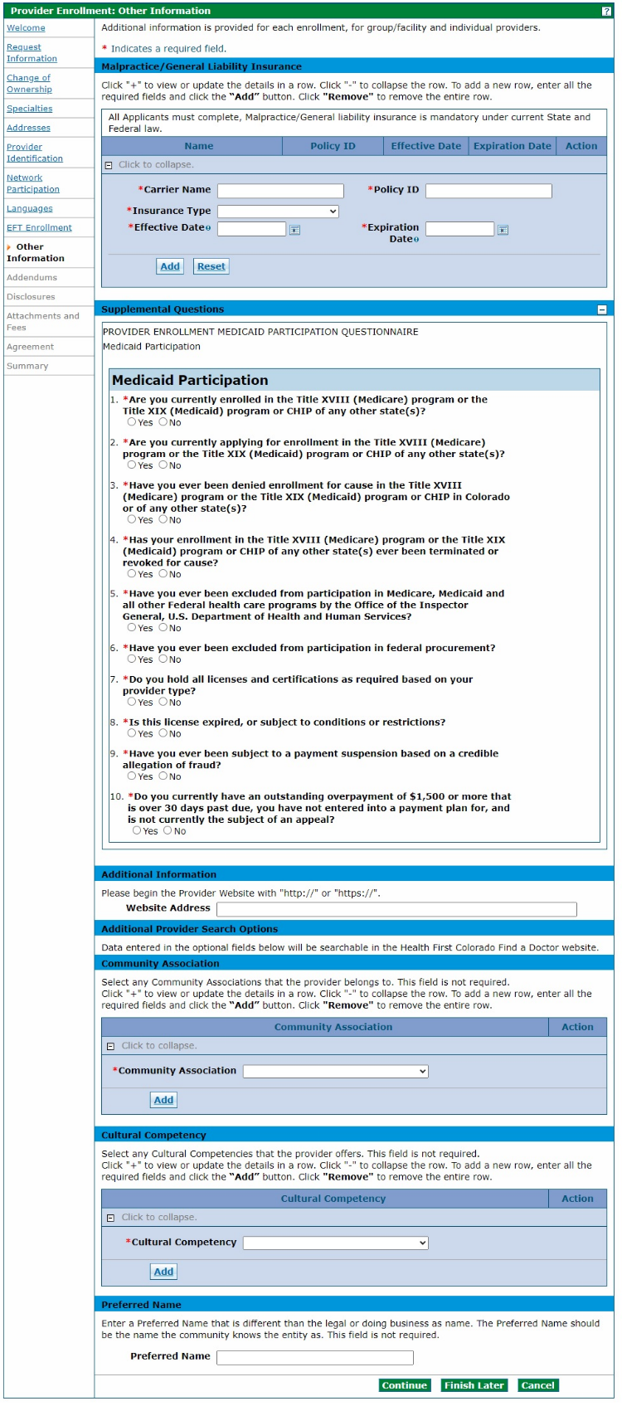
The Other Information panel is where the user may enter additional information for the practice or facility, such as degrees, schools attended, number of Medicaid-eligible or certified/licensed beds and liability insurance information. The Provider Enrollment Tool automatically presents the appropriate questions based on the Enrollment Type selected earlier in the process.
An example of each Other Information panel and possible fields are listed in the following sections.

Malpractice/General Liability Insurance Section
Carrier Name – Enter up to 25 alphanumeric characters in this required field for the name of the insurance carrier.
Policy ID – Enter up to 20 alphanumeric characters in this required field for the Policy ID for the insurance carrier.
Effective Date – Enter eight (8) numeric characters in this required field using the MM/DD/YYYY format for the effective date for the provider insurance.
Expiration Date – Enter eight (8) numeric characters in this required field using the MM/DD/YYYY format for the expiration date for the provider insurance.
Click the Add button to add the policy. Click the + sign next to Click to add commercial insurance to add additional policies.
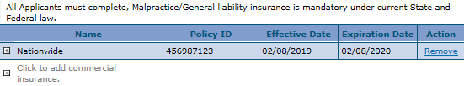

Supplemental Questions Section
Select Yes or No for the Supplemental Questions. These fields are required.
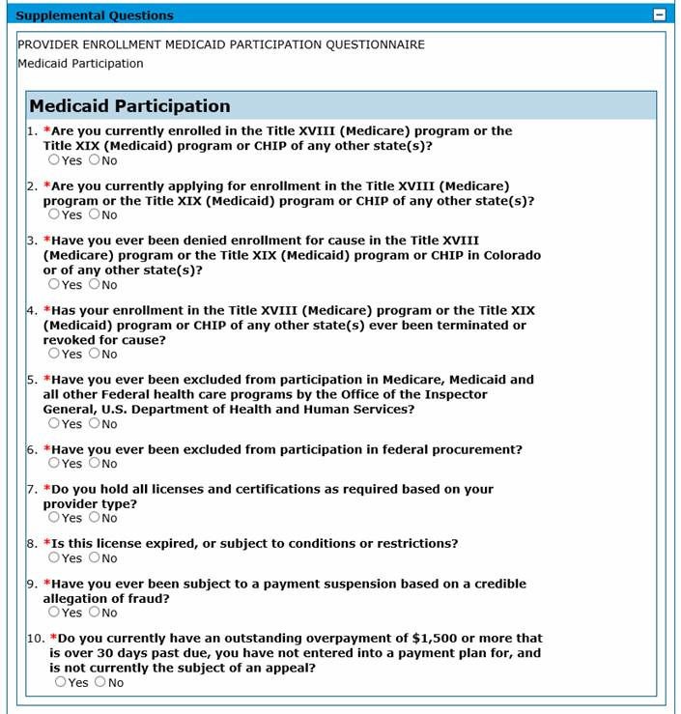
Selecting Yes to questions 1-4 opens a required text box to elaborate on the answer.
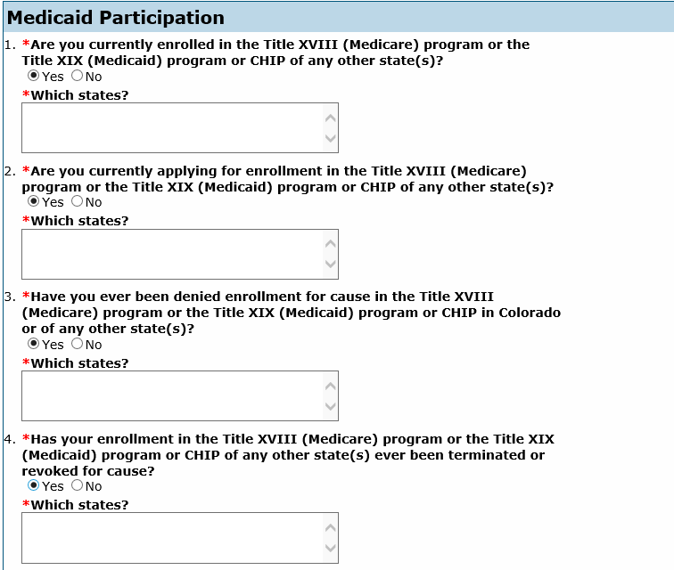

Additional Information Section
Website Address – Enter up to 55 alphanumeric characters for the provider’s website URL in this optional field.

Institutional Bed Information Section
A facility enrollment type has the following section in these panels:

Assisted Care Facilities
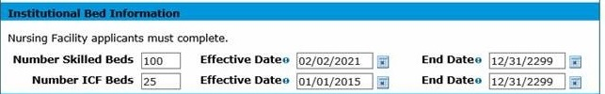
Number of ICF Beds – Enter five (5) numeric characters in this required field for the number of beds at the nursing facility for Intermediate Care Facilities (ICF) patients.
Effective Date – Enter eight (8) characters in this required field using the MM/DD/YYYY format for the effective date of the hospital bed.
End Date – Enter eight (8) characters in this required field using the MM/DD/YYYY format for the end date of the hospital bed.

Hospitals
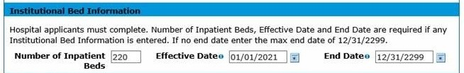
Number of Skilled Beds – Enter five (5) numeric characters in this required field for the number of beds in a facility that are certified and/or licensed.
Effective Date – Enter eight (8) characters in this required field using the MM/DD/YYYY format for the effective date of the hospital bed.
End Date – Enter eight (8) characters in this required field using the MM/DD/YYYY format for the end date of the hospital bed.

Substance Use Disorder (SUD) Disorder Facilities
The following section displays for a facility enrollment with Provider Type 64 SUD Continuum.
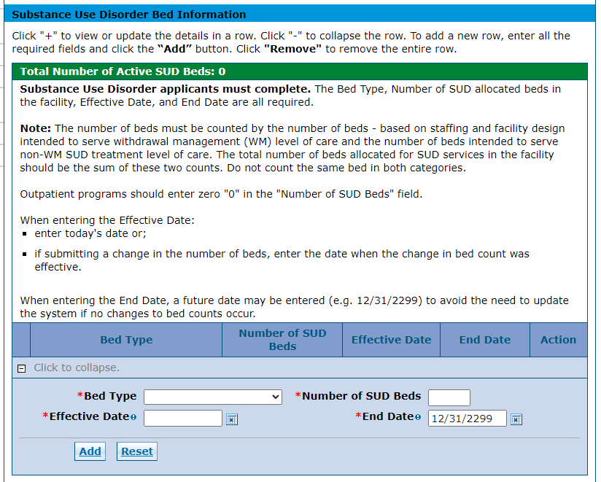
Bed Type – Select a bed type for this required field. The values displayed in the drop-down list will be determined by the active specialties entered at the beginning of the enrollment process. Possible values are Facility Residential and Facility Residential Withdrawal.
Number of SUD Beds – Enter up to five (5) numeric characters in this required field for the number of beds in an SUD facility that are certified and/or licensed.
Effective Date – Enter eight (8) characters in this required field using the MM/DD/YYYY format for the effective date of the SUD bed.
End Date – Enter eight (8) characters in this required field using the MM/DD/YYYY format for the end date of the SUD bed.

At least one (1) active SUD bed record must be entered before proceeding with the enrollment. If both Facility Residential and Facility Residential Withdrawal options are displayed in the Bed Type drop-down list, an active record for both bed types must be entered.
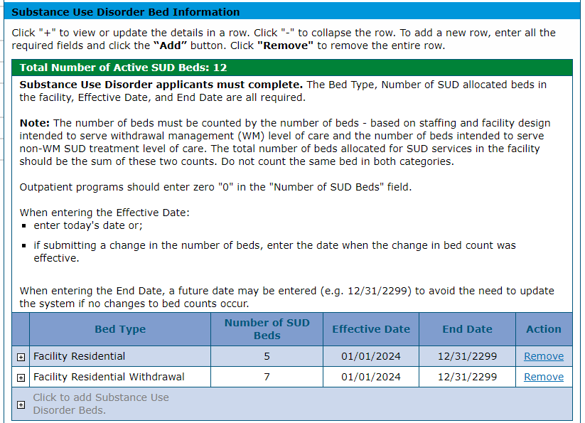

Note: Some SUD Continuum specialties do not allow SUD bed records to be entered. The SUD bed records for those specialties will have the Number of SUD Beds set to zero (0) for both bed types and cannot be changed.
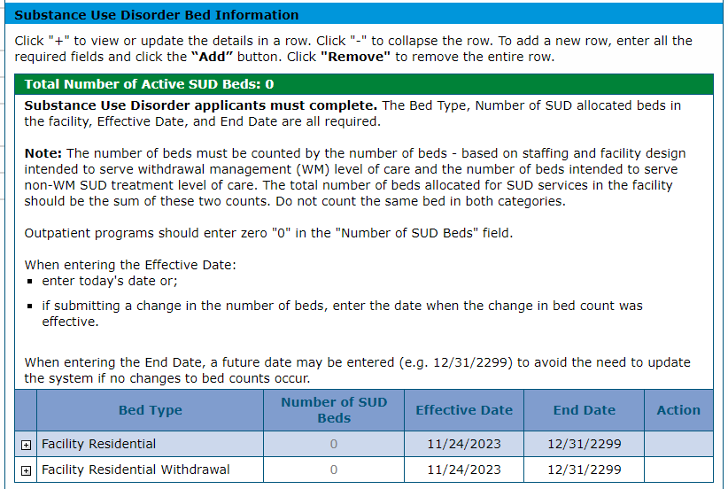
Refer to the Provider Maintenance - Provider Web Portal Quick Guide for more information on updating bed counts for Assisted Care Facilities (ACFs), hospitals and SUD facilities.

The following section displays for an individual enrollment with Provider Type 24 Non-Physician Practitioner Individual (Registered Nurses only).
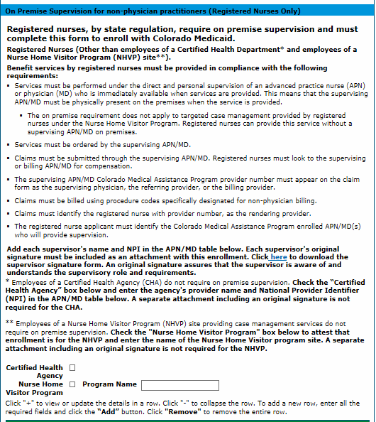
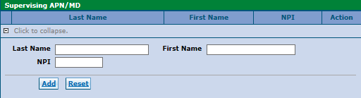
Registered Nurses are required to complete and attach the RN Supervision Form, located on the Provider Forms web page under the Provider Enrollment & Update Forms drop-down, in addition to completing information on the On Premise Supervision for Non-Physician Practitioners panel in the application.

On-Premises Supervision for Non-Physician Practitioners (Registered Nurses Only) Section
Nursing Home Visitor Program – Select this required checkbox to indicate if the registered nurse is exempt from entering information for the on-premises supervision. Nurses participating in only the Nursing Home Visitor Program (NHVP) are not required to enter a supervising Advanced Practice Nurse (APN)/ Medical Doctor (MD) but are required to enter the program site name if the checkbox is selected.
Program Name – Enter up to 50 alphanumeric characters in this required field for the name of the NHVP in which the registered nurse participates.

Supervising APN/MD Section
Last Name – Enter up to 60 alphanumeric characters in this required field for the last name of the supervising APN/MD.
First Name – Enter up to 50 alphanumeric characters in this required field for the first name of the supervising APN/MD.
NPI – Enter up to 15 alphanumeric characters in this required field for the NPI assigned to the supervising APN/MD.

Additional Provider Search Options Section
This optional section presents the appropriate subsections based on the Provider Type selected earlier in the application process. All providers will see the optional subsections of Community Association, Cultural Competency and Preferred Name. Select providers will see the additional subsections of Alternate Provider Addresses and Servicing Counties.

Community Association
All providers may identify specific community associations and add as many as needed. This information is searchable on the Health First Colorado Find a Doctor web page.
Click the Add button after each Community Association is selected. The screen updates and adds the selected item. Add as many Community Association records as needed. Click the Remove link to remove a record.
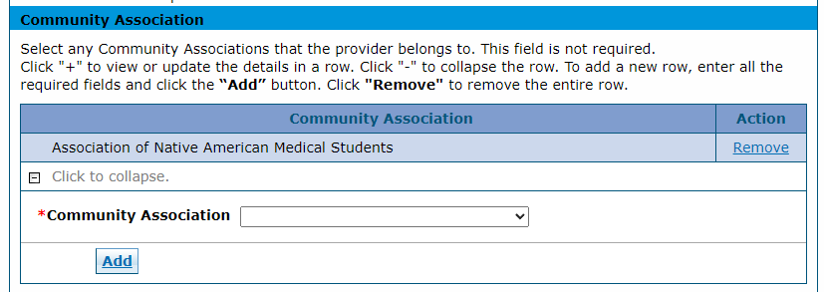

Cultural Competency
All providers may identify specific cultural competencies and add as many as needed. This information is searchable on the Health First Colorado Find a Doctor web page.
Click the Add button after each Cultural Competency is selected. The screen updates and adds the selected item. Add as many Cultural Competency records as needed. Click the Remove link to remove a record.
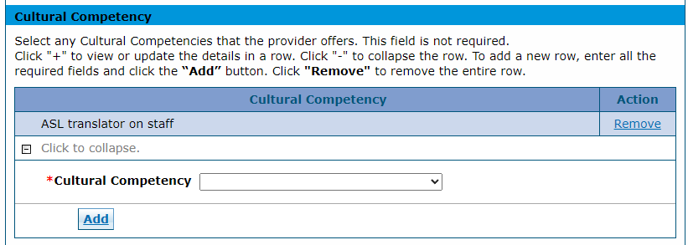

Preferred Name
All providers may specify a preferred name different than the legal name or Doing Business As (DBA) name. The Preferred Name should be the name for which the community knows the entity. This information is searchable on the Health First Colorado Find a Doctor web page.
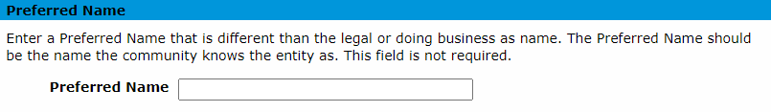

Alternate Provider Addresses
Select providers may enter up to three (3) alternate addresses different than the service location, mailing and billing addresses entered on the Addresses panel. This information is searchable on the Health First Colorado Find a Doctor web page.
Click the Add button after each address record is populated. The screen updates and adds the address. Up to three (3) addresses can be added. Click the Remove link to remove a record.
Complete address information, a primary email and an office phone must be entered to add an address.
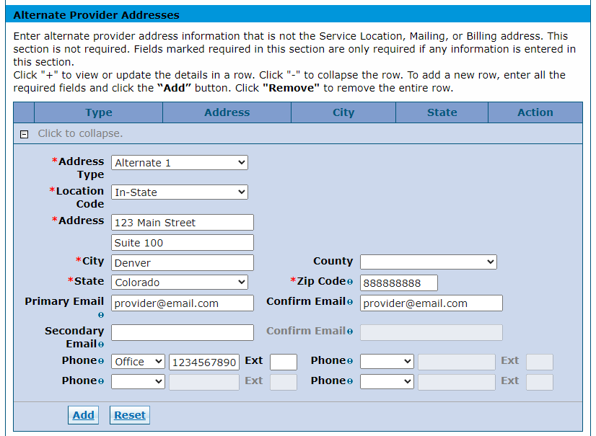
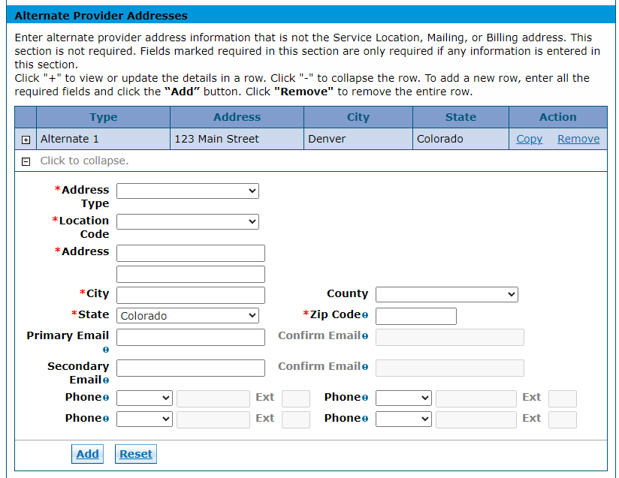

Servicing Counties
Select providers may identify the specific counties served for any of the enrolling specialties. All Specialties may be selected in the Specialty drop-down list if the provider has more than one (1) specialty. A record is added for each specialty and Servicing County. This information is searchable on the Health First Colorado Find a Doctor web page.
Click the Add button after each record is populated. The screen updates and adds the record. Duplicate records are not allowed. Click the Remove link to remove a record.
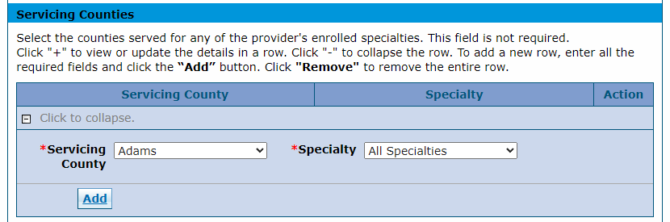
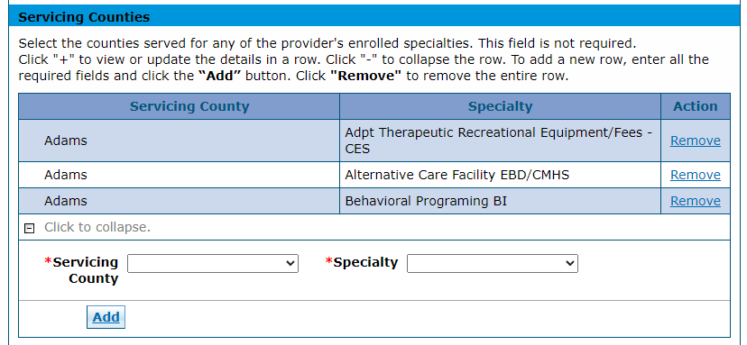

Addendums Panel
Note: The Addendums panel does not display for PACE-Only Subcontractor or Fiscal Intermediary provider enrollment types.
Only those enrolling as a Pharmacy need to complete the Dispensing Fee Attestation Questionnaire.
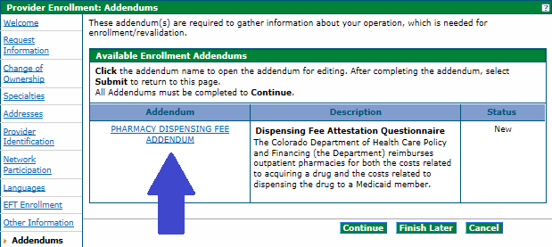

Answer Enrollment Addendum Questions Section (Pharmacy Only)
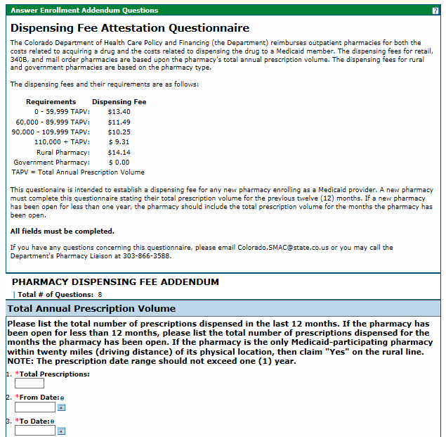
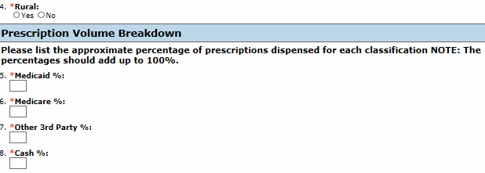

Disclosures Panel
Note: The Disclosures panel does not display for PACE-Only Subcontractor or Fiscal Intermediary provider enrollment types.
Disclosures are required for every enrollment and involve information regarding ownership/control interest, relationships, criminal convictions, etc. Click each Disclosure link and answer all questions contained within the disclosure.
The Disclosures panel indicates a New status on the right side of the panel until each is complete. All disclosures must be completed to proceed with the enrollment.
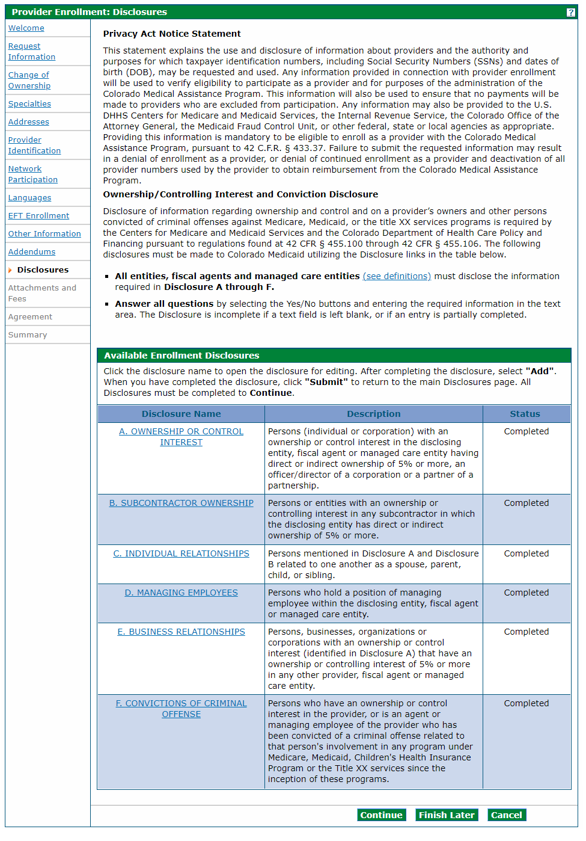
Disclosure A is regarding ownership and controlling interest for the applicant. Indicate the information for each person (individual or corporation) with an ownership or controlling interest for the applicant. It is recommended to select the No option in the first question for individual applicants (SSN enrollments) to indicate that ownership/control interest does not apply to the individual.
Disclosures Panel – Ownership/Controlling Interest Disclosure A
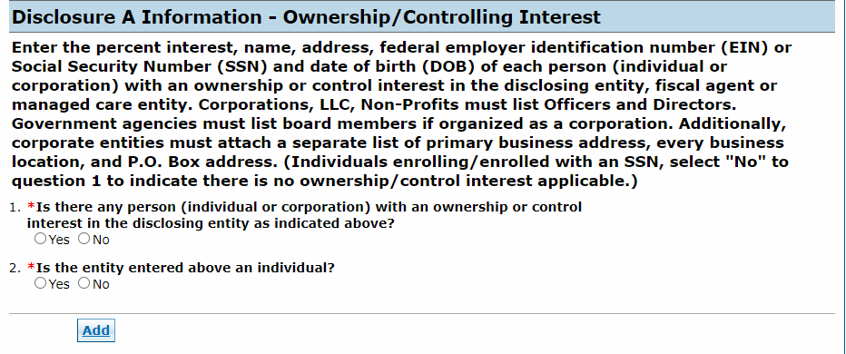
Selecting Yes opens an additional section for the required information to be entered, as shown below.
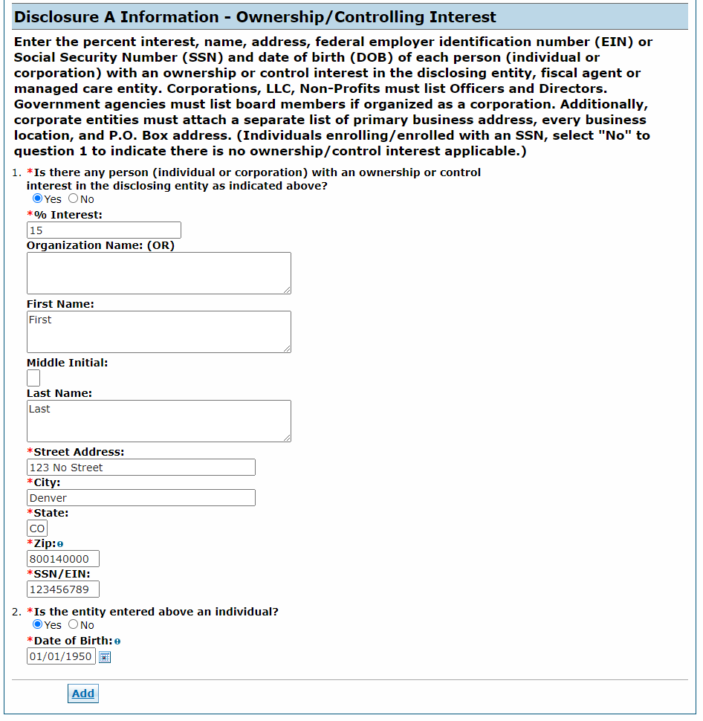
Entities that are an individual owner must select Yes to question 2 (Is the entity entered above an individual?) and enter the individual’s date of birth. The application is returned to the user to correct the information if the user selects No (not an individual) but enters information for an individual.
Click the Add button to update the panel when this information is complete.
Disclosures Panel – Ownership/Controlling Interest Disclosure A – Add or Submit
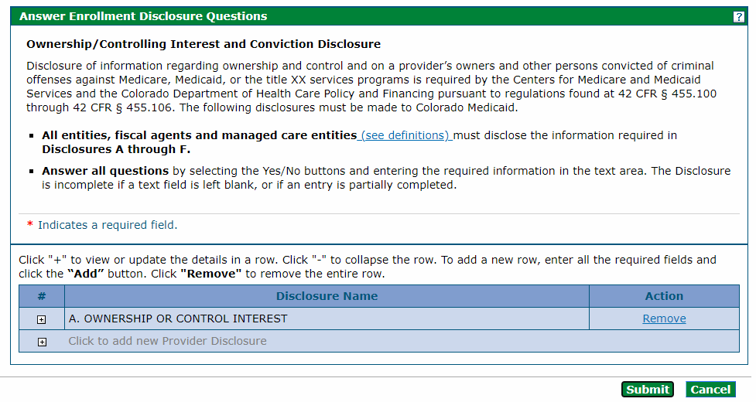
Click the + sign next to Click to add new Provider Disclosure to add additional entities.
Click the Submit button when all ownership/controlling interest is entered. The panel updates and this item on the Disclosure list reflects as Completed.
Disclosures Panel – Ownership/Controlling Interest Disclosure A – Completed
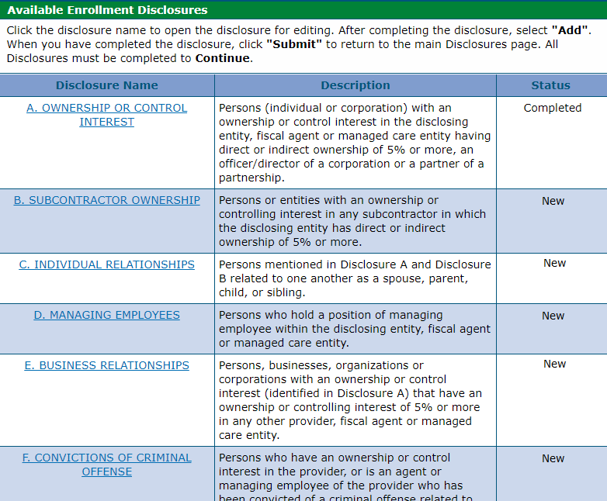
Disclosure B is regarding subcontractor ownership and control. Indicate all persons or entities with an ownership or controlling interest in any subcontractor in which the disclosing entity/applicant has direct or indirect ownership of 5% or more.
Clicking Yes opens an additional section for the required information to be entered. Click the Add button to update the panel when the information is completed.
Disclosures Panel – Subcontractor Ownership and Control Disclosure B - Questions
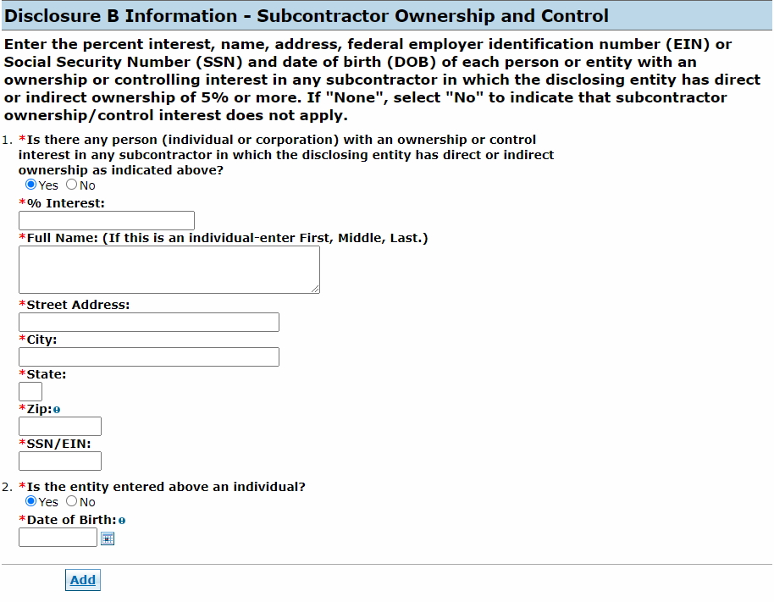
Continue to add entities as applicable. Click the Submit button when all subcontractor ownership and control information is entered. The panel updates and this item on the Disclosure list reflects as Completed.

Disclosure C is regarding individual relationships. Indicate any individuals mentioned in Disclosure A and Disclosure B that are related to one another as a spouse, parent, child or sibling.
Clicking Yes opens an additional section for the required information to be entered.
Disclosures Panel – Individual Relationships Disclosure C – Questions
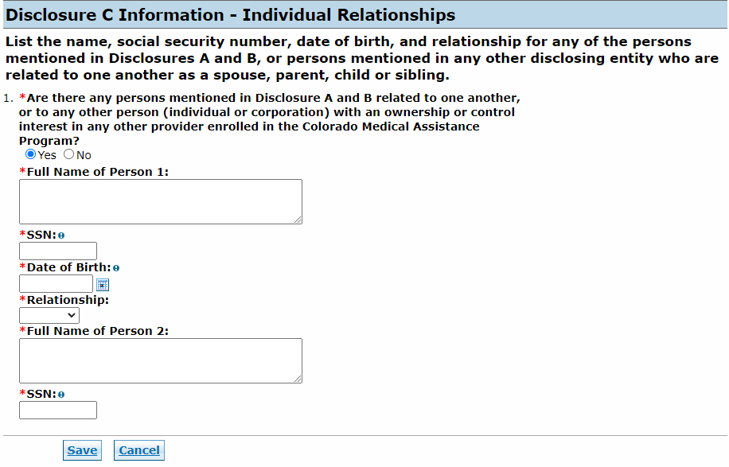
Click the Add button to update the panel when the information is completed.
Continue to add individuals as applicable. Click the Submit button when all individual relationships are entered. The panel updates and this item on the Disclosure list reflects as Completed.

Disclosure D is regarding managing individuals. Indicate any individuals that hold a position of managing employee within the disclosing entity/applicant.
Clicking Yes opens an additional section for the required information to be entered. Click the Add button to update the panel when the information is completed.
Disclosures Panel – Managing Individuals Disclosure D – Questions
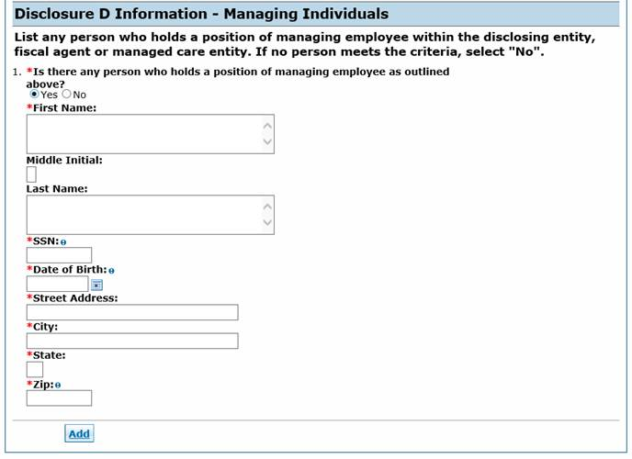
Continue to add individuals as applicable. Click the Submit button when all managing individuals are entered. The panel updates and this item on the Disclosure list reflects as Completed.

Disclosure E is regarding business relationships. Indicate any persons or entity (identified in Disclosure A) that has an ownership or controlling interest of 5% or greater in any other provider, fiscal agent or managed care entity.
Clicking Yes opens an additional section for the required information to be entered. Click the Add button to update the panel when the information is completed.
Disclosures Panel – Business Relationships Disclosure E– Questions
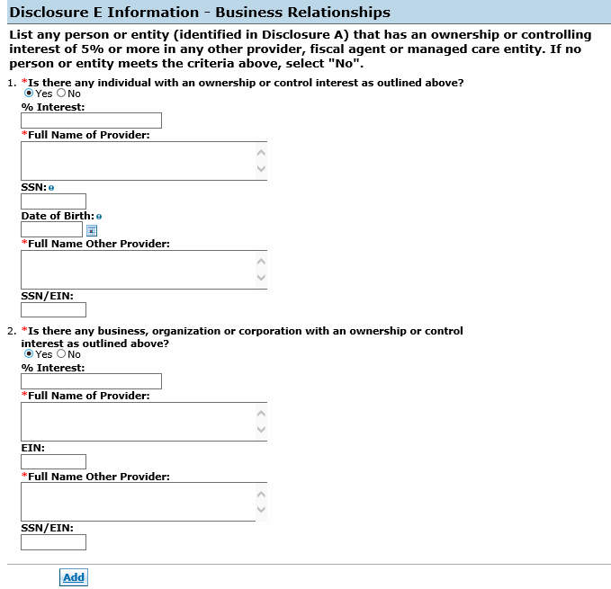
Continue to add entities as applicable. Click the Submit button when all business relationships are entered. The panel updates and this item on the Disclosure list reflects as Completed.

Disclosure F is regarding convictions. Indicate any persons with ownership or controlling interest in, or that is an agent or managing employee of the applicant who has been convicted of a criminal offense related to that person’s involvement in any program under Medicare, Medicaid, Children’s Health Insurance Program or the Title XX services since the inception of these programs.
Disclosures Panel – Conviction Disclosure F – Questions
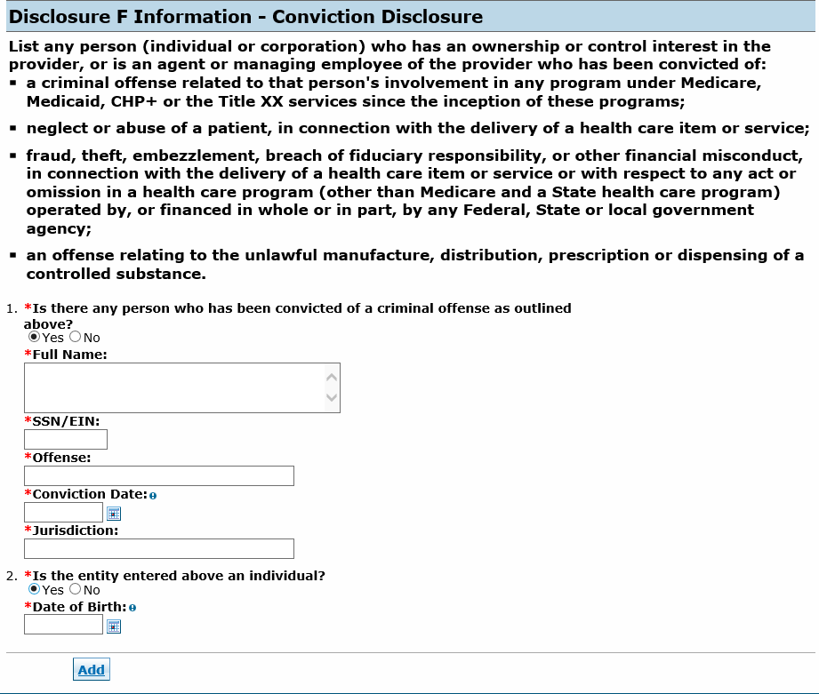
Clicking Yes opens an additional section for the required information to be entered. Click the Add button to update the panel when the information is completed.
Continue to add entities as applicable. Click the Submit button when all convictions are entered. The panel updates and this item on the Disclosure list reflects as Completed.
Disclosures Panel – Completed
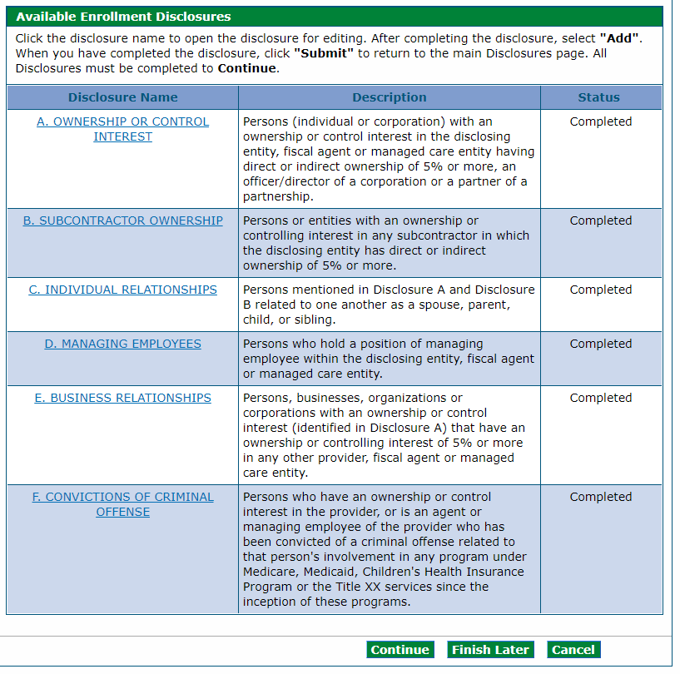
Click Continue, Finish Later or Cancel when all questions have been completed within the panel.

Fingerprinting Panel
Note: The Fingerprinting panel does not display for PACE-Only Subcontractor or Fiscal Intermediary provider enrollment types.
Enrolling providers determined by the Centers for Medicare & Medicaid Services (CMS) or the Department of Health Care Policy & Financing (the Department) to be a high-risk provider type are presented with and required to complete the Fingerprinting panel. This provider’s data is pulled from the Provider Identification and Request Information panels. Owner information is populated by the individual owner information entered on the Disclosures panel. For providers that are business entities, all owners with 5% or more interest in the business is displayed with a status indicating any individuals that need to submit fingerprints.
Visit the Information by Provider Type web page to view the risk level.

Fingerprinting Panel – Fingerprinting and Criminal Background Check
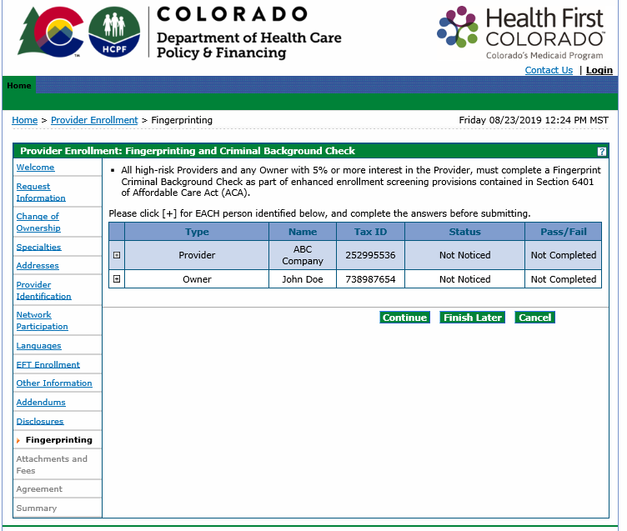
Click the + sign next to any owners that need to complete fingerprinting, then answer the questions presented within the panel.
Fingerprinting Panel – Fingerprinting and Criminal Background Check – Marked No
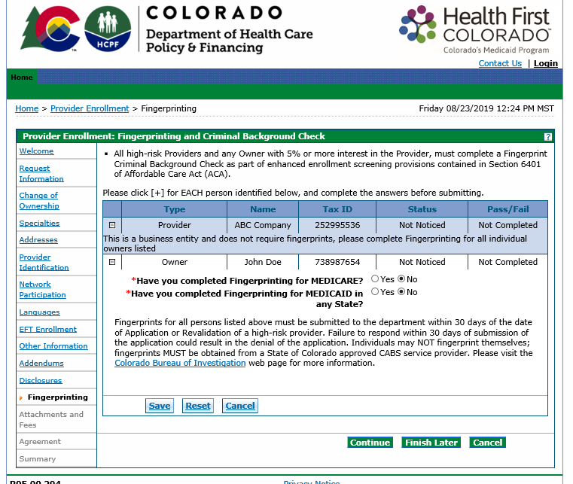
Owners that have not completed the Fingerprinting Background Check (for either Medicare or Medicaid) must follow the instructions on this panel to have fingerprints submitted within 30 calendar days of the submission of the enrollment application.
Visit the Provider Enrollment web page and click the Fingerprinting drop-down for additional information.
Owners that have completed the Fingerprinting Background Check (for either Medicare or Medicaid) should select Yes next to the appropriate selection. The panel updates after Yes is selected and requests confirmation of the state in which the fingerprinting was completed. Select the checkbox next to the acknowledgement statement.
Fingerprinting Panel – Fingerprinting and Criminal Background Check – Marked Yes
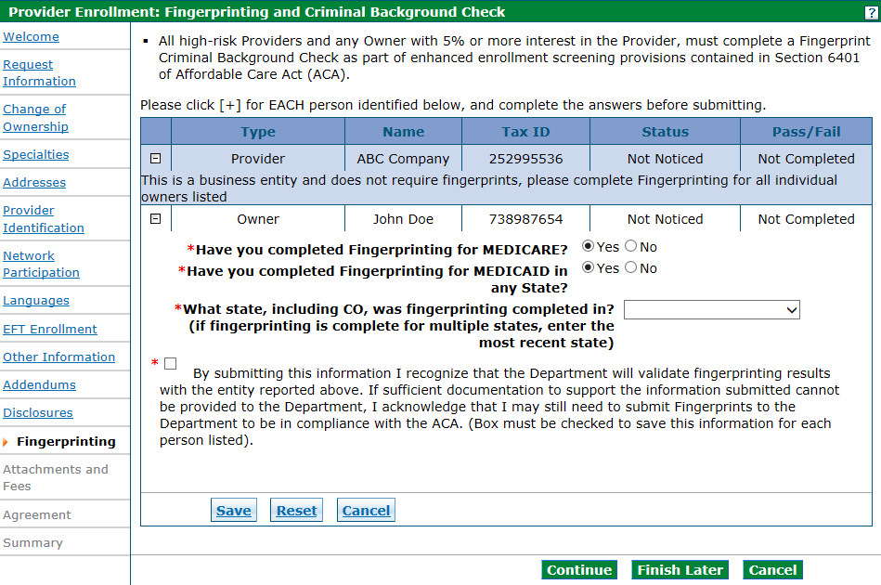
Click Save once completed with each owner, then click Continue to move to the next section.
Note: Providers and owners requiring fingerprinting are given specific instructions on how to proceed once the application is submitted.

Attachments and Fees Panel
Any required attachments may be submitted electronically on the Attachments and Fees panel. Attachments sent by mail, email or fax cannot be accepted and must be added on this panel.

Attachments Section
Not all documents listed under Supporting Documentation may apply to the application being submitted.
The user must scan and attach:
- Insurance face sheet for nursing facilities.
- License or certifications (if applicable)
- W-9 signed and dated within the past six (6) months (if applicable)
- Voided check or bank letter dated within the past six (6) months (if applicable)
- RN Supervision Form (required only for registered nurses)
- Hardship waiver request letter and supporting documentation (if applying for a hardship waiver). Refer to the Financial Hardship subsection below for more information.
- Proof of payment (if the application fee has already been paid to Medicare or in another state for this location)
- Visit Information by Provider Type web page for additional documentation required for the provider type.
Visit the Provider Forms web page and click the Provider Enrollment & Update Forms drop-down to access any applicable forms that may need to be printed, completed, signed and uploaded to the enrollment application.
Read the Gainwell Technologies forms carefully before attaching. Some forms require the user to include additional attachments. The Behavioral Therapy Provider Attestation Form requires licenses, certifications, diplomas, etc.
Click the appropriate link to open the document to submit a required attachment. Some documents can be completed electronically while others require the user to print and scan a document. The user should work with internal IT support if they are unfamiliar with this process.

Application Fee Section
The Provider Enrollment Tool calculates any required enrollment fees and guides the user through the payment process.
The Affordable Care Act (ACA) requires certain providers to remit an enrollment application fee. The Centers for Medicare & Medicaid Services (CMS) sets the fee amount annually. This fee is assessed at initial enrollment, revalidation and change of ownership, as required, and is assessed in full for each service location enrolled in Colorado Medicaid. Visit the Provider Enrollment web page for the current amount.
The application fee questions as shown in the panel below are displayed only if the Enrollment Type selected previously should have a fee.
No fee is required if the service location has enrolled or revalidated with Medicare or another state’s Medicaid program in the last 5 (five) years and paid an application fee. A copy of the receipt indicating payment is not required for proof of payment to Medicare. Proof of payment to another state’s Medicaid program may be uploaded on this panel in the Attachments section with a selection type of Other.

Financial Hardship
Users requesting a waiver for financial hardship must include a letter describing the financial hardship and why the hardship justifies an exception, as well as any additional supporting documentation that the user believes may aid the Department and CMS in the determination.
- Recommended supporting documentation includes most recent entity tax return(s), financial profit/loss exports (i.e., QuickBooks, Xero, etc.), three (3) or more bank statements and any additional documentation that would validate the hardship(s) indicated within the hardship letter.
  - Additional supporting documentation may include but is not limited to historical cost reports, recent financial reports such as balance sheets and income statements, cash flow statements, liability obligations, tax returns, etc.
The enrollment will be delayed while a determination is made if the user applies for an application fee waiver. The letter and supporting documentation must be uploaded on this panel in the Attachments section with an Attachment Type of Other.
An example of the Attachments and Fees panel is shown below.

Attachments and Fees Panel – No Fee Required
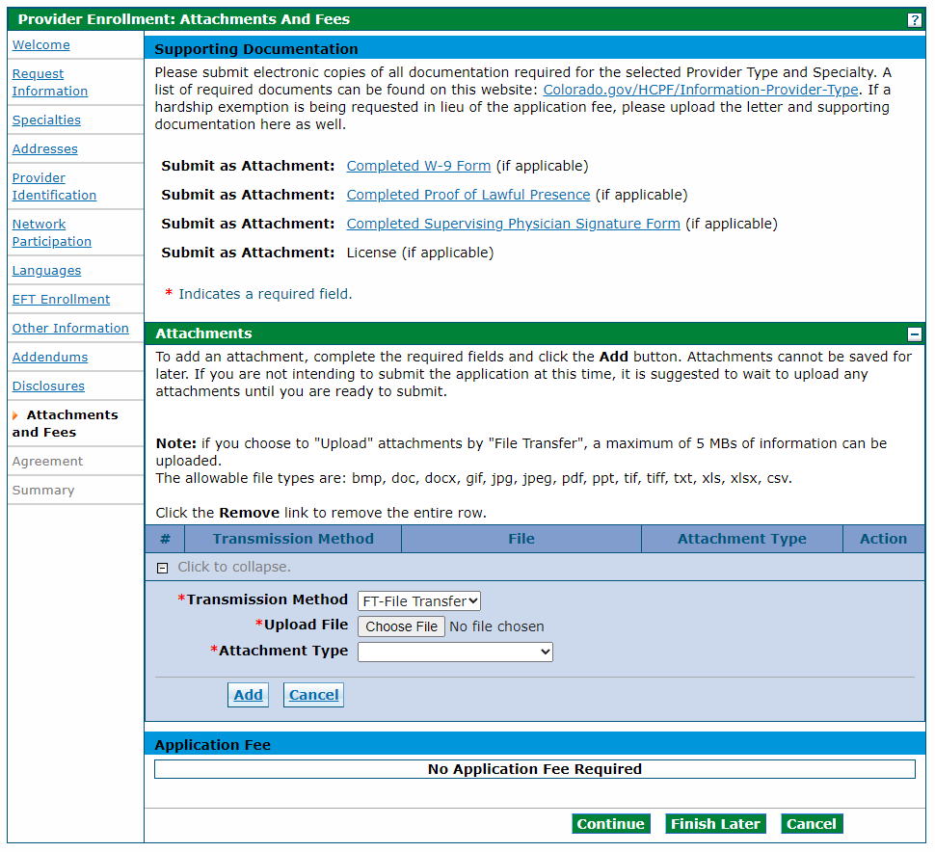
The application displays No Application Fee Required if a fee is not required for the provider type.

Click Add to attach each document.
Attachments and Fees Panel – Fee Required
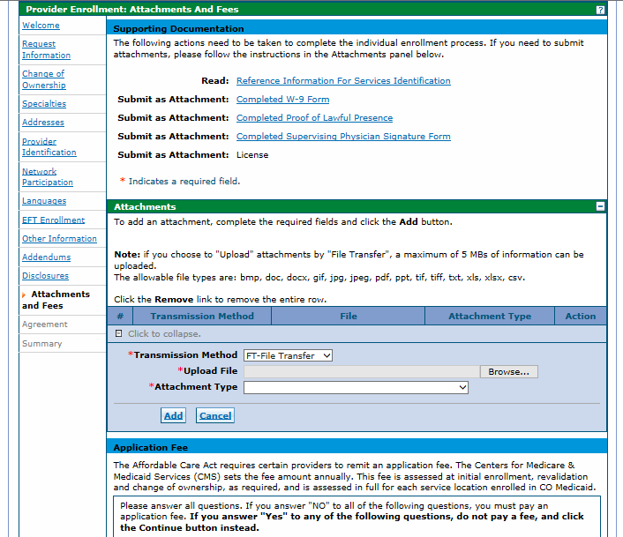
This panel displays if a fee is required for the provider type.
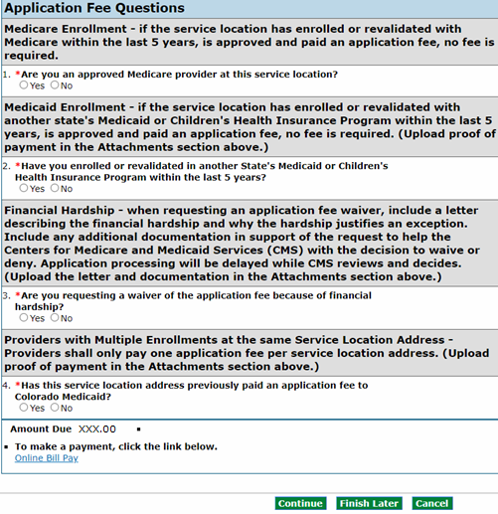
Users that answer Yes to any of these questions do not need to pay the fee. Click Continue.
Click the Online Bill Pay link if an application fee is due, and a payment form opens in a pop-up window:
Online Bill Pay Pop Up
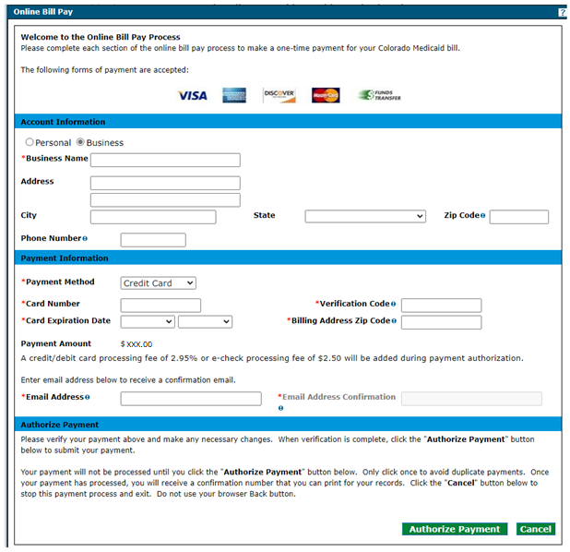
Note: A processing fee of 2.95% is charged for a debit/credit card payment, and a processing fee of $2.50 is charged for an e-check.

Agreement Panel
Note: The Agreement panel does not display for PACE-Only Subcontractor or Fiscal Intermediary provider enrollment types.
Below is the Agreement panel. The terms of enrollment are stated here. Acceptance of these terms is required to submit the enrollment application. Failure to accept these terms means that no enrollment application is retained or submitted.
Click the link to the Provider Participation Agreement (PPA) and read the agreement. Multiple PPAs display if multiple payers were selected. All PPAs must be read and acknowledged.
Note: Users that do not print the Provider Participation Agreement may view a copy of this agreement on the Provider Forms web page.
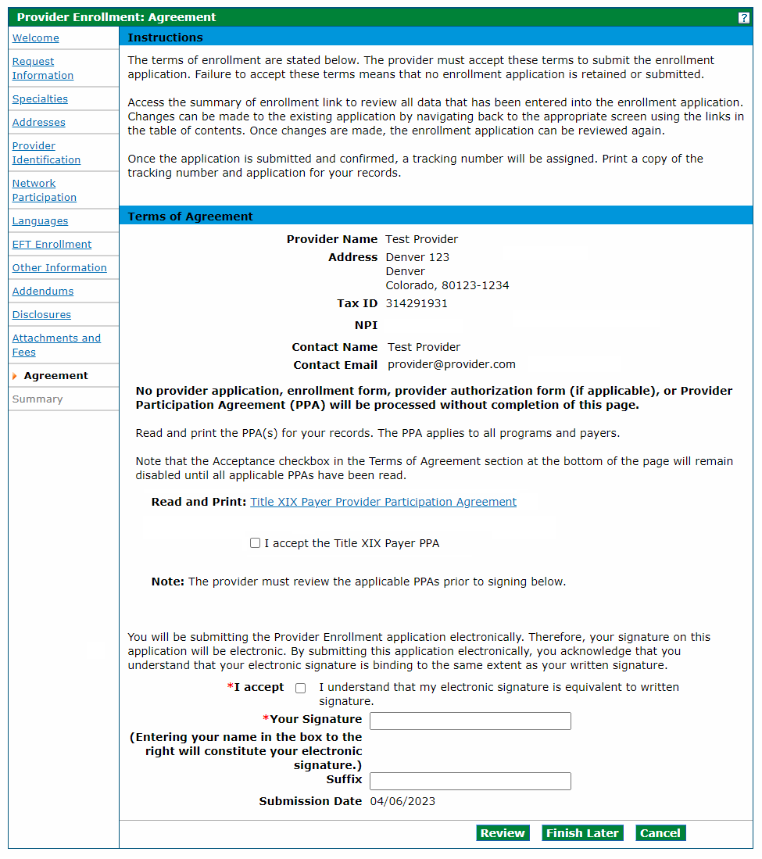
A checkmark appears next to the PPA link once complete.
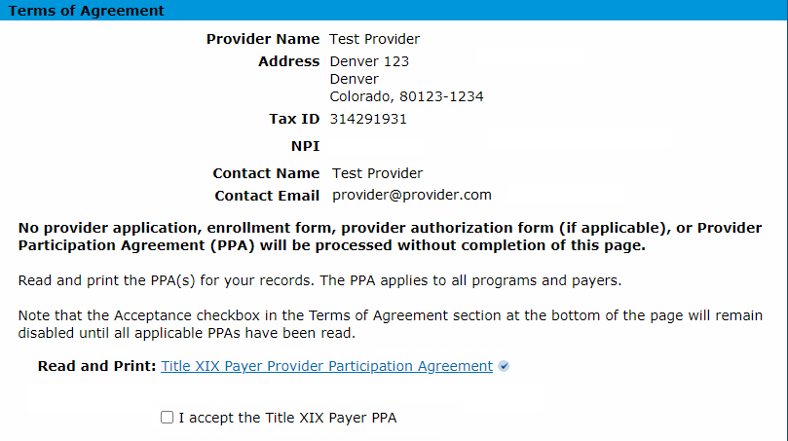
Select the I accept checkbox for each PPA.
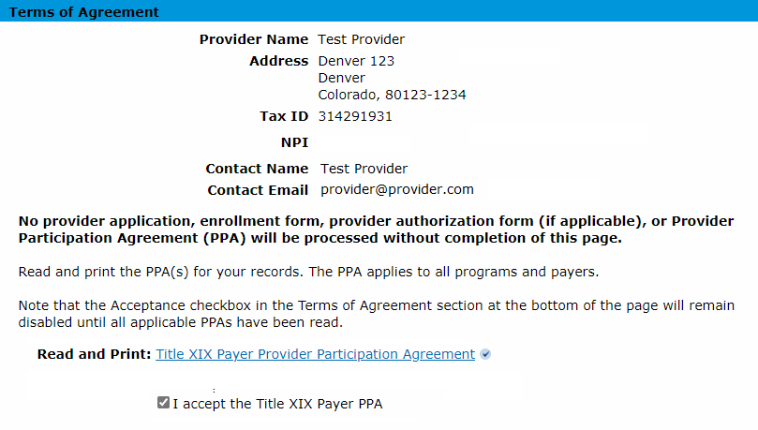
Enter the provider’s name as the electronic signature and select the I accept box to complete the panel. The Review button becomes active:
Agreement Panel - Provider Participation Agreement
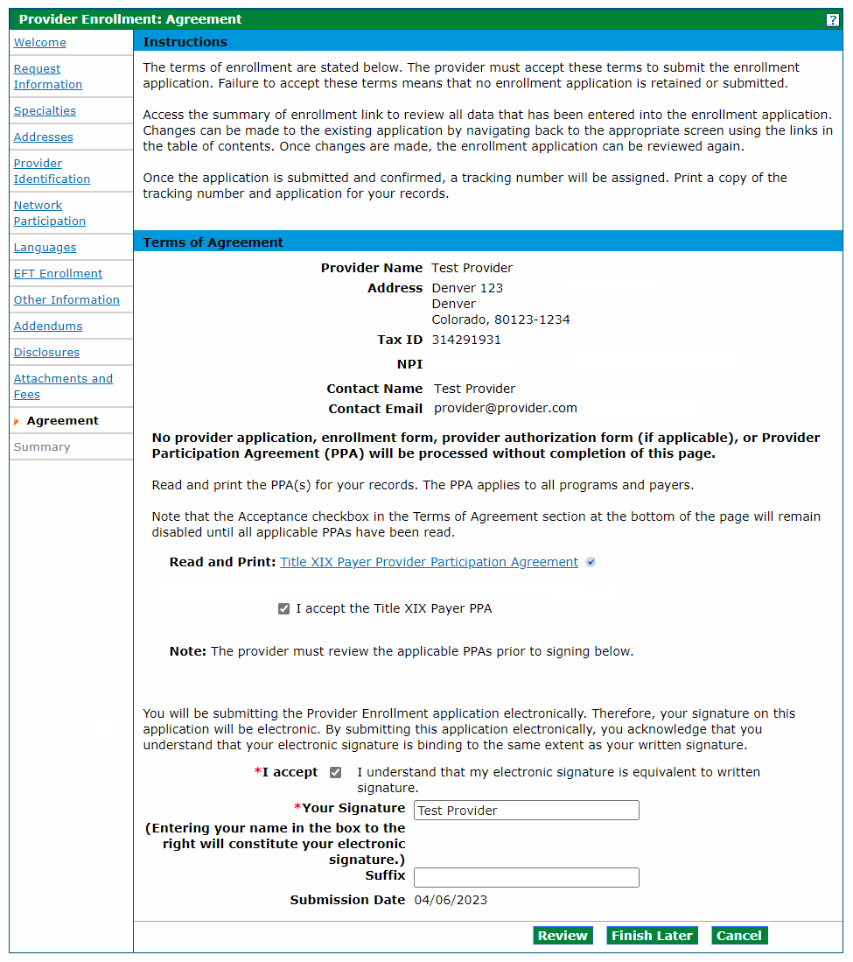

Summary Panel
The Summary panel shows the application in its entirety. The user should review all information for accuracy and may be requested to confirm the information and print a copy of the summary.
The user is asked if they have printed a copy of this enrollment for their records. Click OK if the user has already printed a copy or does not wish to print a copy. The user may click Cancel to return to the application to print a copy.
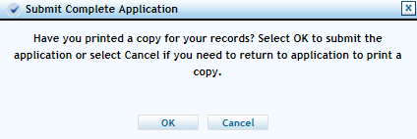
Click Confirm to submit the application for processing once the Submit Complete Application dialog box shown above disappears.
The application is not submitted for processing until the Confirm button at the bottom of the summary panel is clicked:
Enrollment Summary Panel – Confirm Button – Application Submission
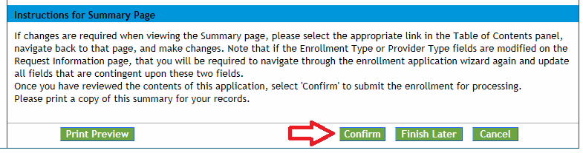
Users that have not previously saved the application are prompted to set up a password and security questions as reviewed in the Completing the Application section of the manual.

After the Application Is Submitted
Visit the Next Steps after Enrollment Application web page for further instructions.
Resources
The Provider Enrollment Manual is supplemented with the Provider FAQ Central web page. This list is updated often and should be bookmarked for future reference.
Providers may contact Gainwell Technologies, the fiscal agent for the Department, for additional support by calling the Provider Services Call Center or visiting the Provider Enrollment web page for additional information.

Resume Enrollment
The Resume Enrollment link may be clicked for incomplete applications or if the application was completed but the user received an email from Gainwell Technologies stating additional or corrected information is needed.
No changes may be made to the information entered in the Provider Web Portal once the application is submitted unless an application is returned to a provider for updates or corrections.

Provider Portal - Resume Enrollment Link


Provider Web Portal - Resume Enrollment - Login
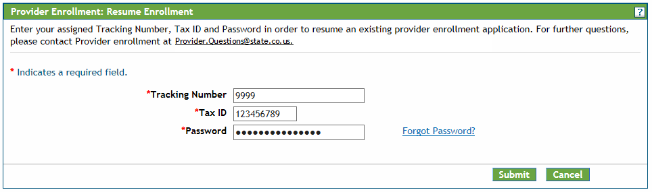
The Tax ID entered must be an exact match to the Tax ID used when enrolling on the application.

Enrollment Status
Providers may check the status of applications using the Enrollment Status link.
Provider Portal - Enrollment Status Link

Click the Enrollment Status link shown above. Enter the Tracking Number (ATN) and Tax ID Number (TIN), then click Search.
Enrollment Status Login
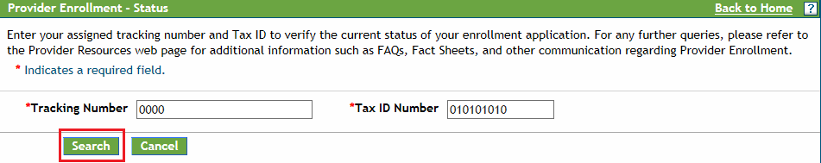
The Provider Enrollment - Summary section displays showing the current status of the application.
Enrollment Status – Summary
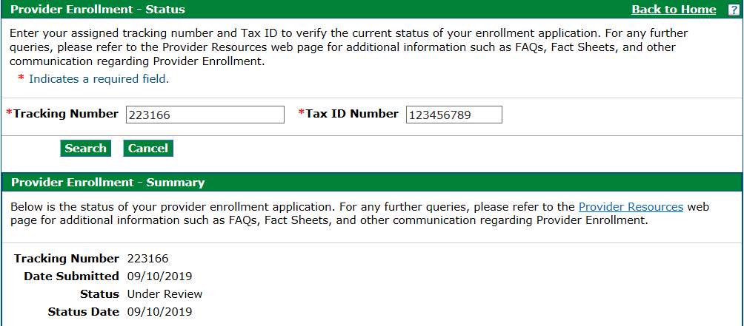
Even if notes display here indicating the application needs to be returned to the provider, the user cannot access the application to make corrections until the status reads one of the following:
- Returned to provider for Additional Information
- Returned to provider for Additional Authorization(s)
- Returned to provider for Missing Documentation
A notification email is sent to the contact email address from the application to notify of the status once the application is returned.
Click Resume Enrollment (refer to the previous section) to log in to the application and make required corrections. Click the Continue button at the bottom of each panel to navigate through the application.

Site Visits
Pre-enrollment site visits are required for providers designated as “moderate” or “high” categorical risks to the Medicaid program are required, per federal requirement 42CFR 455.432.
The purpose is to verify that information submitted to the Department by a provider is accurate and to determine compliance with federal and state enrollment requirements. The user is contacted for the required site visit if the provider type falls into one of these risk categories. A representative will visit the service location to verify certain aspects of the enrollment. Providers that refuse a site visit may be excluded from Health First Colorado.
Refer to the risk levels on the Information by Provider Type web page for further information about risk categories by provider type.

Provider Enrollment Notifications
The applicant receives several email notifications during the enrollment process:
- The applicant receives an email at the email address entered in the contact information upon successful submission of an online enrollment application.
- An email is sent by Gainwell Technologies during the application review process to the email address entered in the contact information if additional information and/or missing documentation is needed. The applicant is then able to return to the application on the Provider Web Portal to address the issues through the Resume Enrollment link. Gainwell Technologies is notified of the application update and continues processing once these requirements are completed.
- Another email is sent once the application has been reviewed to the address entered in the contact information advising of the outcome.
  - If the application is approved, the user is advised that the provider is enrolled but that certain steps must be completed with the fiscal agent to begin billing for services.
    - The user receives instructions for registering the assigned provider ID number in the Provider Web Portal once the application has been approved for enrollment. Refer to the Provider Web Portal Registration Quick Guide for registration instructions.
Note: PACE-Only Subcontractors cannot register for the Provider Web Portal and must contact the Provider Services Call Center to update their provider information or to disenroll.

Forms
Visit the Provider Forms web page and click the Provider Enrollment & Update Forms drop-down to locate forms that may need to be printed, completed, signed and uploaded to the enrollment application.

