Buy-In Process (“Relay Race”)

County
CBMS
CMS
Baltimore
(federal)
SSA,
RRB,
PERA
Stops or starts deduction & Issues Refund
State
MMIS
Schedule
Buy-In Accretion to create state requests (RIC S): | Sunday night
Send RIC S transactions to CMS Baltimore: | Monday morning
CMS Responses to State, SSA, RRB, PERA: | Monday-Friday
Post CMS Responses to MMIS tables: | Thursday night
View CMS Responses in MMIS: | Friday
Send transactions from MMIS Buy-In to CBMS: | Friday
CBMS posts Buy-In transactions for viewing: | Saturday
View Buy-In transactions in CBMS: | Monday

Medicare Buy-In Overview

1) Part A = Hospital Insurance (HI)
Part B = Supplementary Medical Insurance (SMI)

2) ~99% of Medicare Beneficiaries get Part A free.
~1% of Medicare Beneficiaries do not get Part A free because they have not contributed 40 quarters during their working life. These are the “M bennies” identified by a BIC (Beneficiary Identification Code) of M.

3) Beneficiaries can refuse or withdraw from Part B.

4) CO will pay Part B premiums (Buy-In) for ANY client on ANY MEDICAID program (either regular Medicaid or Medicare Savings Program). CO will NOT pay the Part B premiums for any client on a Non-Medicaid Medical Assistance program (OAP-State Only, CICP, CHP+).

5) CO will only pay Part A premiums for “M bennies” who meet the income & resource criteria for QMB (Qualified Medicare Beneficiary) AND who have either ACTIVE or CONDITIONAL Part A enrollment in place.

6) If a client has free Part A, CO Part B buy-in will override the client’s refusal or withdrawal from Part B, and trigger new Part B entitlement beginning the first month of buy-in. This does not work for Part A (“M bennies”).

Part A Buy-In

1) Part A Status must be either Active or Conditional, per SOLQ-I. If not, client must apply for conditional Part A at Social Security Administration during General Enrollment (Jan 1-Mar 31 each year).
If Part A has terminated, Buy-In begin date must be prior to Part A termination date.

2) Client must qualify for QMB, shown in the CBMS med spans. Apply at the county department of social/human services or a medical assistance (MA) site.
Enter Part A approval date into M’Care Expense Detail screen, add MSP to the case & run EDBC. CBMS med spans should show QMB (TPL 11-25) the next day.

3) Contact Buy-In Officer to send Part A Buy-In request to CMS Baltimore.

Match Criteria

Last Name | First Name | Middle Initial | DOB | Sex
First 6 characters  Replace hyphens or special characters with a space. | First 3 characters  If you see the full middle name separated from the first initial by a space, enter what you see into the first name field in CBMS Case Summary & Individual Demographics | SOLQ will only display the middle initial, never the full middle name. | Month & Year  Day of Birth alone, or middle initial alone will not cause buy-in to reject, but both together will cause a reject. | M  Or  F

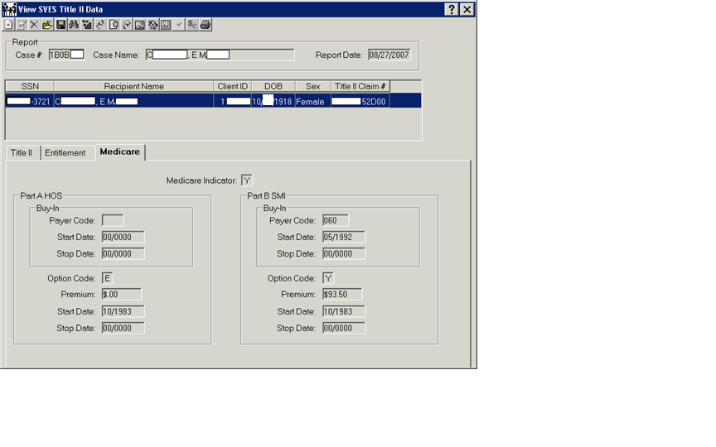

Payer Code | Option Code | Buy-In  Start Date | Buy-In  Stop Date | Premium  Start Date | Premium  Stop Date
Z99 = Conditional  S01-S99 = State Payment  Blank = Self Pay if Option Code = Y, | Y = Premium is payable  E = Free Part A  Blank = not enrolled | Populated if state has started buy-in (1st of the month); zeroes if no buy-in. | Populated if buy-in has stopped (end of the month); zeroes if buy-in is ongoing or never started. | First month of entitlement; zeroes if not enrolled | First month of non-entitlement; zeroes if entitlement ongoing or never enrolled.

How to Read CBMS Med Spans

TPL Code indicates presence or absence of other resources (other payers) such as Medicare and/or other health insurance.
Grant Code and SISC Code combination indicates SLMB or QI-1.
We only do Part A Buy-In for QMB, either QMB-Only or QMB-Dual.

 | TPL CODE AND DESCRIPTION
MEDICARE  AND  MEDICAID | 01 | Medicare Part A
 | 02 | Medicare Part B
 | 03 | Medicare Part A and B
 | 04 | Medicare Part A & B + Other Ins.
 | 05 | Medicare Part A + Other Ins.
 | 06 | Medicare Part B + Other Ins.
QMB ONLY | 11 | Medicare Part A, QMB
 | 13 | Medicare Part A and B, QMB
 | 14 | Medicare Part A & B + Other Ins, QMB
 | 15 | Medicare Part A + Other Ins, QMB
 | 16 | Medicare Part B + Other Ins, QMB
QMB DUAL | 21 | Medicaid, Medicare A, QMB
 | 23 | Medicaid, Medicare A & B, QMB
 | 24 | Medicaid, Medicare A & B + Other Ins, QMB
 | 25 | Medicaid, Medicare A + Other Ins, QMB
SLMB | GRANT=2, TPL=01,03,04 or 05; SISC = CS
QI-1 | GRANT=2, TPL=01,03,04 or 05; SISC = CT

Medicare Buy-In Med Span Patterns (valid patterns)
*Buy-In Eligibility Code. FYI: MMIS puts the BEC on the buy-in file based on the Grant, TPL, POC, & SISC.
Eligibility Type | *BEC | Grant | TPL | Med Flag | POC | SISC
QMB-Only | P | 1 or 3 | 11-15 | A | XX or YX | B
QMB-Dual | P | 1 or 3 | 21-25 | B | Anything | B
Categorically Eligible, but not QMB | Z | 1 or 3 | 01-06 | 2 or blank | 2nd character = S, U or X | B
Medical Assistance Only, not categorically eligible, not QMB (300%-er) | M | 3 | 01-06 | 2 | 2nd character = T or W | A
SLMB | L | 2 | 00 | Blank | YX | CS
QI-1 | U | 2 | 00 | Blank | YX | CT
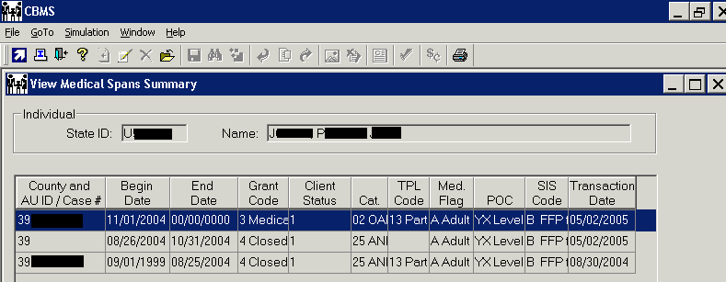
Match Criteria — Compound Name

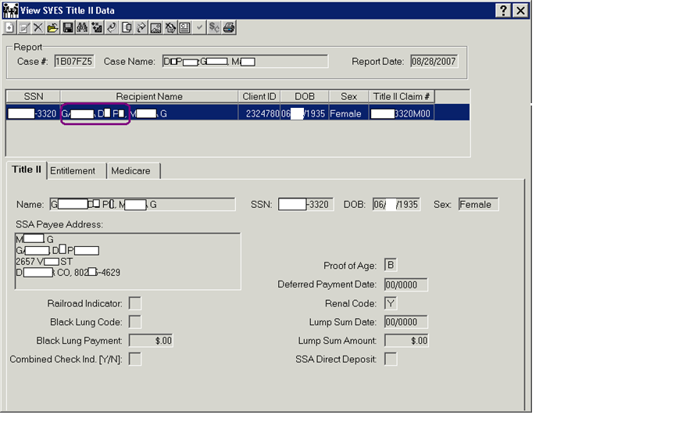

Note spaces in last name. Enter name in CBMS Case Summary and Individual Demographics WITH SPACES

Match Criteria — Space in Last Name

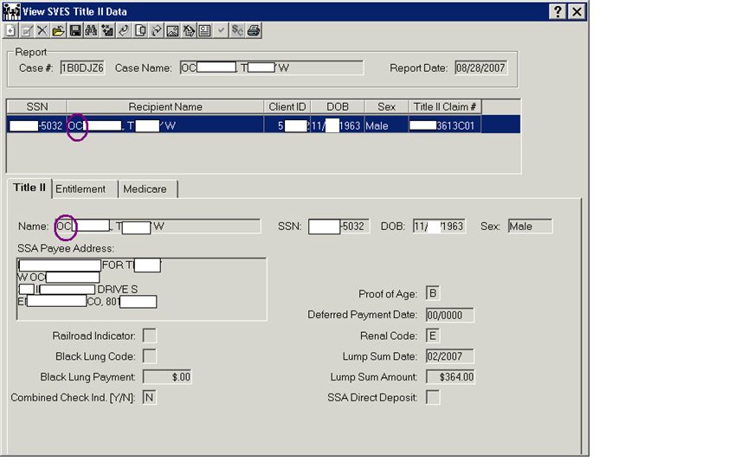

Note small space where an apostrophe would be. Be sure to put the space in the name in CBMS.

Match Criteria — Hyphen in Last Name

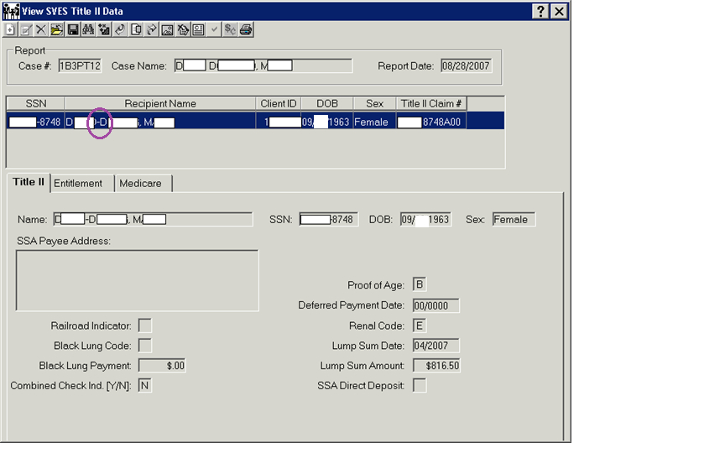

Note hyphen in last name.

