The purpose of this change form is to highlight revisions to the State Behavioral Health Services (SBHS) Billing Manual. Unless otherwise noted, the State (HCPF and BHA) has agreed that it will accept coding provided under the previous edition through September 30, 2025. Providers must implement the October edition by September 30, 2025, for dates of service October 1, 2025, and thereafter, regardless of submission date.

Change | Reason for the Change
90847– update coding page | Error on page
Appendix D error  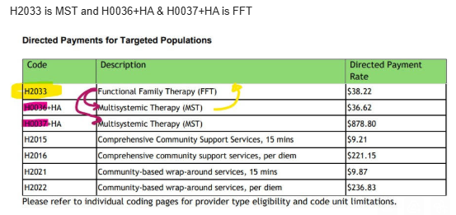 | Error fixed in manual
Language for NCCI edits | Effective July 1, 2025, HCPF is requiring RAEs to implement all National Correct Coding Initiative (NCCI) edits. CMS created the NCCI to reduce improper payments stemming from incorrect coding and billing practices. NCCI prevents reimbursement for inappropriate combinations of Current Procedural Terminology (CPT) codes. Visit the CMS NCCI for Medicaid web page for more information on NCCI edits.
Removed POS 02, 10, 09, 41, 42 from BHST A0425 and A0999 | Clarify POS for BHST services

