Welcome!

Medicare Buy-In

Objectives

By the end of this presentation, you will:

- Understand the overall Medicare Buy-In process (“relay race”).
- Be able to read and interpret the Buy-In summary screen.
- Be able to identify problems that can block Buy-In and take the appropriate corrective action.
- Know when Part A Buy-In is needed.
Medicare Buy-In Overview

1) Part A = Hospital Insurance (HI)
Part B = Supplementary Medical Insurance (SMI)

2) ~99% of Medicare Beneficiaries get Part A free.
~1% of Medicare Beneficiaries do not get Part A free because they have not contributed 40 quarters during their working life. These are the “M bennies” identified by a BIC (Beneficiary Identification Code) of M.

3) Beneficiaries can refuse or withdraw from Part B.

4) CO will pay Part B premiums (Buy-In) for ANY client on ANY MEDICAID program (either regular Medicaid or Medicare Savings Program). CO will NOT pay the Part B premiums for any client on a Non-Medicaid Medical Assistance program (OAP-State Only, CICP, CHP+).

5) CO will only pay Part A premiums for “M bennies” who meet the income & resource criteria for QMB (Qualified Medicare Beneficiary) AND who have either ACTIVE or CONDITIONAL Part A enrollment in place.

6) If a client has free Part A, CO Part B buy-in will override the client’s refusal or withdrawal from Part B, and trigger new Part B entitlement beginning the first month of buy-in. This does not work for Part A (“M bennies”).

7) CO will not pay the first 2 months’ premiums for 300%ers who are not QMB.

Part A Buy-In

1) Part A Status must be either Active or Conditional, per SOLQ-I. If not, client must apply for conditional Part A at Social Security Administration during General Enrollment (Jan 1-Mar 31 each year).

2) Client must qualify for QMB, shown in the CBMS med spans. Apply at the county department of social/human services or a medical assistance (MA) site.
Enter Part A approval date into M’Care Expense Detail screen, add MSP to the case & run EDBC. CBMS med spans should show QMB (TPL 11-25) the next day.

3) Contact Buy-In Officer to send Part A Buy-In request to CMS Baltimore.

Buy-In Process (“Relay Race”)

County
CBMS
CMS
Baltimore
(federal)
SSA,
RRB,
PERA
Stops or starts deduction & Issues Refund
State
MMIS
TIMELINE OF SUCCESSFUL* BUY-IN TRANSACTIONS
Sunday night | Monday AM | Tuesday | Wednesday | Thursday | Friday | Saturday
Buy-In Accretion to create state requests (RIC S): | MMIS sends RIC S file to CMS Baltimore: | CMS responds to State (RIC D) | SSA posts buy-in to SOLQ | SSA issues refund | Refund may hit bank
RRB & Civil Service get billing file from CMS the first week of the month after we receive the RIC D. Refund usually issued 30-60 days later.
*If CMS responds with a reject (RIC F), research & error correction must be made before a new RIC S can be sent.

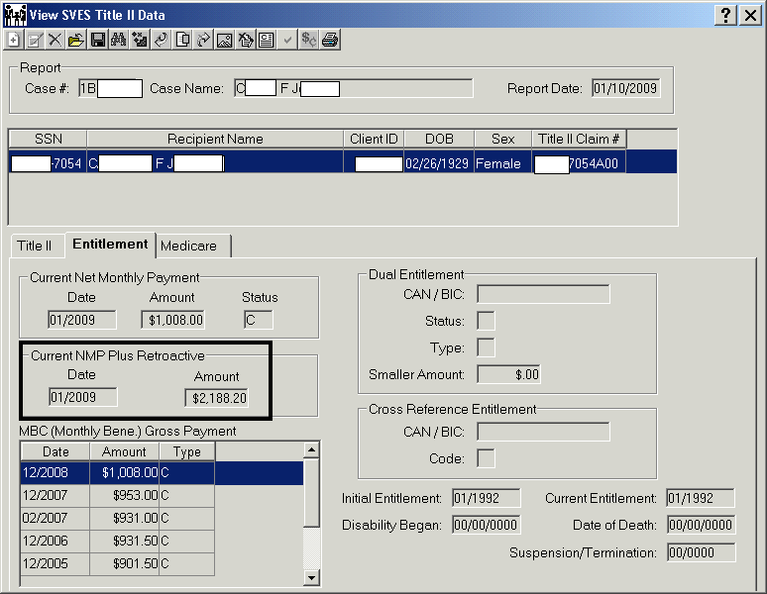

$2,188.20 refund was issued ~1/7/2009 (the Wednesday after the RIC S was sent to CMS).
Net Monthly Payment equals Gross Payment; no deduction.
If a deduction does not equal the Part B premium, it is for something else, possibly Part D.

Schedule of Interfaces between CBMS, MMIS & CMS
Buy-In Accretion to create state requests (RIC S): | Sunday night
Send RIC S transactions to CMS Baltimore: | Monday morning
CMS Responses to State, SSA, RRB, PERA: | Monday-Friday
Post CMS Responses to MMIS tables: | Thursday night
View CMS Responses in MMIS: | Friday
Send transactions from MMIS Buy-In to CBMS: | Friday
CBMS posts Buy-In transactions for viewing: | Saturday
View Buy-In transactions in CBMS: | Monday

Those Confusing Buy-In Codes!

RIC  Type | State Request | Baltimore Response | WHAT IT MEANS
S | 61 |  | State request to start Buy-In
S | 51 |  | State request to stop Buy-In due to loss of Medicaid eligibility for any reason other than death
S | 53 |  | State request to stop Buy-In due to county-reported death
S | 75 |  | State request for a finite period of Buy-In (has both begin and end dates)
S | 99 |  | State request to CMS to change State ID or Buy-In Eligibility Code; informational transaction only, does not start or stop Buy-In.
D or B |  | 11XX Series  (1161, 1167, 1180) | Buy-In has started, initial billing.
B |  | 41 | Buy-In ongoing, current monthly billing.
D or B |  | 17XX Series  (1751, 1753, 1728, etc.) | Buy-In stopped
F |  | 21XX Series  (2161, etc.) | Buy-In rejected.  The subcode will indicate why.

Scenario 1: “Perfect World” – 1 of 3

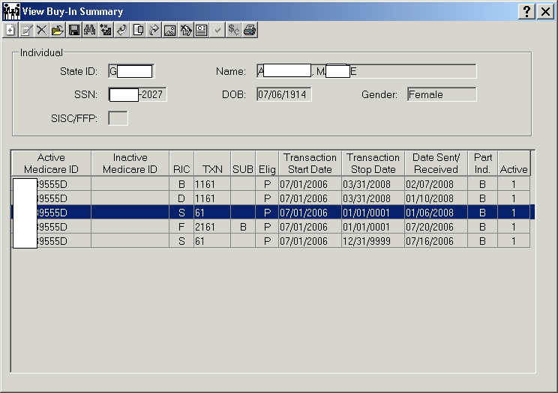
*Note: All names are fictitious.
MMIS (confidently) carries baton with txn 61 RIC S to CMS.

Medea Alberto, the client applies for QMB on 6/20/06. She has the hope she will now be able to eat something other than the store brand can soups she gets from the dented can bins or the special sale shelves. Though she considers herself lucky that she does not have things as bad as other seniors she knows.

Since Medea did remember to turn in the application (baton) CBMS approves her for QMB effective 7/1/06 on 12/20/2007. Although some paperwork was missing so the case took a while to approve.

CBMS (smiling) carries baton with med spans showing QMB begins 7/1/06 to MMIS. MMIS accretion program runs Sunday night, 1/6/2008, and creates a Buy-In Request (RIC S) effective 7/1/06, that will be sent to CMS on Monday morning.
Scenario 1: “Perfect World” – 2 of 3

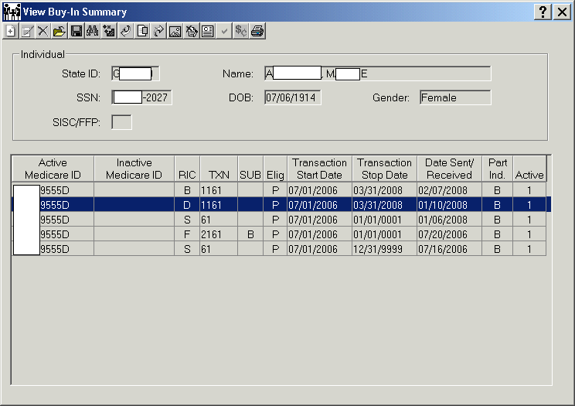

Success! CMS responds with an 1161 RIC D on 1/10/2008 (“Yes, buy-in has started effective 7/1/2006.”). CMS (smiling) carries “mini-baton” with 1161 RIC D to MMIS. Shakes hands with MMIS in congratulation.

CMS (smiling) also carries “big” baton to SSA (also smiling).

Scenario 1: “Perfect World” – 3 of 3

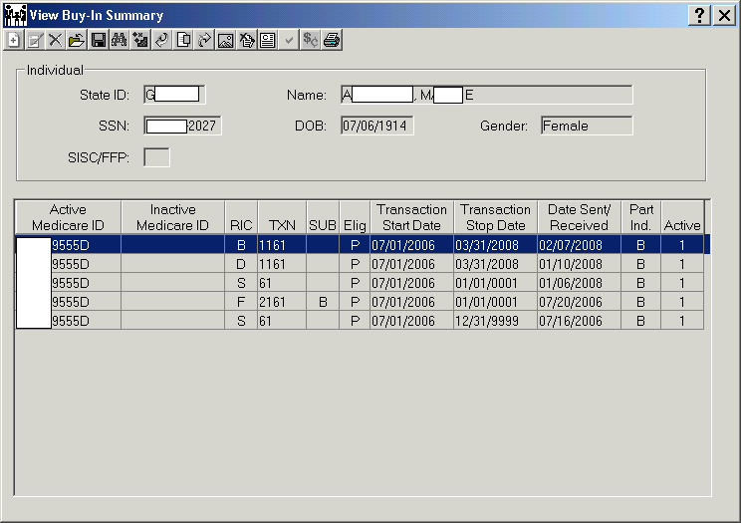

CMS bills Colorado for the Part B premiums back to 1/2006. SSA stops the Part B deduction from the client’s SSA check and issues a refund to the client for the 1/2006-3/2008 Part B premiums.

Medea is ecstatic! She can pay her medical bills that have accumulated from 2005! Now there will be no more collection agencies calling to threaten to freeze her bank accounts and a better variety of food for three actual meals a day.

PICK A NAME AND STICK WITH IT!!!

If we don’t match CMS’ data, buy-in won’t go through.

Scenario 2: Buy-In Stop, Reject, Restart – 1 of 10

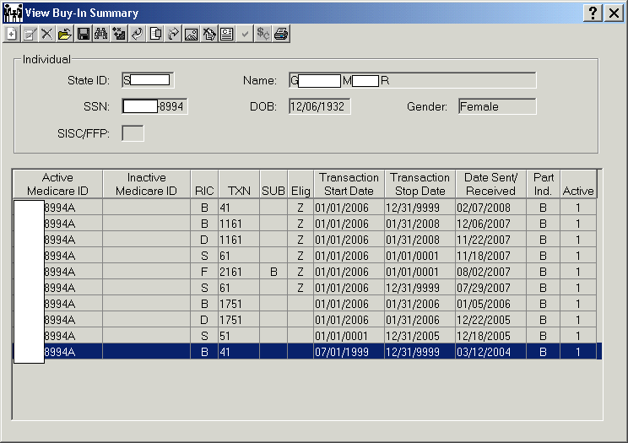

Buy-In has been ongoing since 7/1999.

Margaret Georgethopilos (she prefers to go by Maggie and has done so for fifty years) is blissfully unaware that her world is about to come crashing down. And that the next year is going to be a very trying time for her. Growing up in the Great Depression has taught her to be thrifty and save. She also has developed a great belief that her government will always take care of her. So while her Social Security check is her only source of income she is still able to set aside a few dollars each month.

Scenario 2: Buy-In Stop, Reject, Restart – 2 of 10

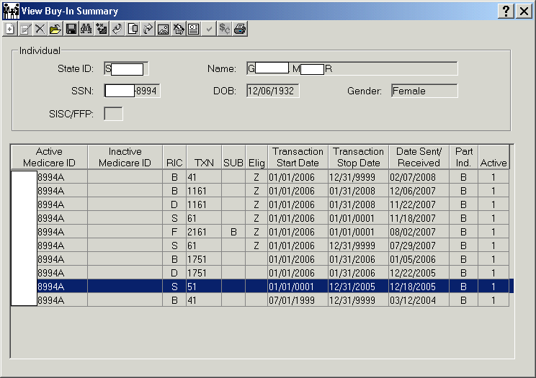

Request to stop buy-in due to loss of eligibility sent to CMS Baltimore.

CBMS sends notice telling Maggie she lost Medicaid eligibility due to “failed to return RRR packet.” Maggie is shocked because she knows she did mail the packet to her worker and the government has never let her down!

CBMS sends updated med spans to MMIS showing eligibility end date 12/31/2005. CBMS (grim-faced) carries baton to MMIS team showing eligibility end date.

MMIS buy-in termination program sends a txn 51 RIC S (request to stop buy-in) effective 12/31/2005 to CMS Baltimore on 12/18/2005. MMIS (“grim reaper”) carries baton with txn 51 & buy-in end date to CMS group.

All the while Maggie is totally oblivious about her buy-in being stopped. And while it has been several days since her birthday she is planning to use a little of her savings to go out on the town. Actually out on the town for Maggie is a movie and a meal at the local cafeteria. But she has just not gotten around to it yet.

Scenario 2: Buy-In Stop, Reject, Restart – 3 of 10

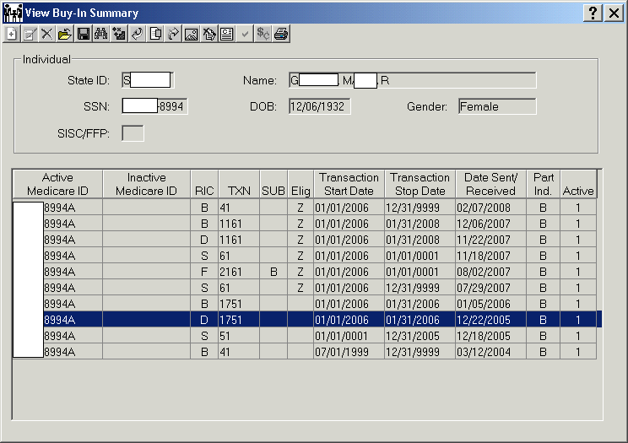

CMS responds to state request and agrees to stop buy-in effective 1/1/2006.

CMS member (grinning evilly) carries a “mini-baton” with txn 1751 RIC D back to MMIS. Another CMS member (also grinning evilly) carries baton with 1751 RIC D to SSA.

Maggie is uneasy because she received a warning notice from CBMS but hasn’t felt the financial impact yet. She has been uneasy enough that while it’s been a month since her birthday she has not gone out on the town to celebrate yet. Each day that passes her anxiety increases exponentially.

Scenario 2: Buy-In Stop, Reject, Restart – 4 of 10

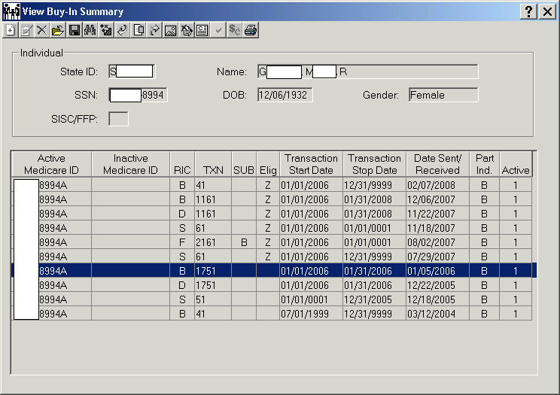
SSA sends notice to the client that the Part B premium will be deducted from her next SSA check. Colorado receives credit for the premium.

SSA updates their system to show buy-in stopped 12/31/05. They don’t know why, all they can see is buy-in stopped by the state. SSA sends notice to the client that the Part B premium will be deducted from her next SSA check.

SSA’s determined, grim-faced collection agent carries baton to Maggie and demands payment. She is appalled! What am I going to do? How will I eat? I could be evicted! And she will never get to celebrate her birthday now. Her thoughts combined with the emotion of total fear that floods into her mind as she listens to the collection agent’s demands.

With total delight the SSA’s agent sees the panic cross her face. And like a rabid dog he jumps into his dissertation on what will be done to Maggie if she does not pay up. This just adds to Maggie’s level of panic and desperation!
Scenario 2: Buy-In Stop, Reject, Restart – 5 of 10

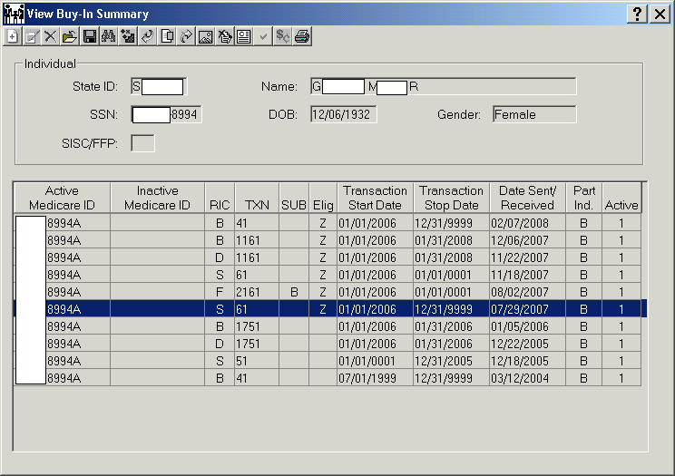

Case reopened; new request to start buy-in effective 1/06 sent 7/29/2007.

Maggie goes to the county (CBMS) in a panic (carrying baton)! “How do I fix this? I know I turned in my redetermination packet 2 weeks ago!”

The sympathetic and diligent worker helps Maggie complete the redet packet and enters it into CBMS and explains the following steps in the relay race, hoping to minimize Maggie’s total panic. (Maggie puts the redet on the baton and passes it to CBMS.

CBMS puts open med spans on the baton and (smiling) carries the baton to MMIS, showing eligibility has reopened.

MMIS accretion program creates new 61 requesting buy-in restart effective 1/2006 (picking up where the termination left off). MMIS (smiling) carries baton with new 61 RIC S to CMS.
Scenario 2: Buy-In Stop, Reject, Restart – 6 of 10

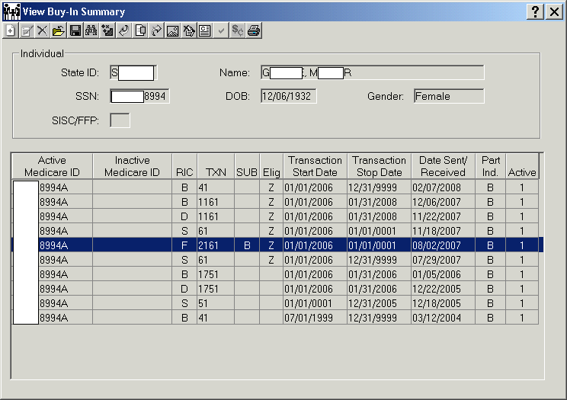

Request rejected due to “personal characteristics don’t match.”

CMS responds with a 2161 subcode B RIC F: “No. HIC# exists but personal characteristics don’t match.” CMS carries baton with 2161 subcode B RIC F back to MMIS, shaking their heads.

Maggie is now panicked to a level she has not felt since being unable to eat for days during the Great Depression as a five-year-old child! She’s about to be evicted! And was planning to go to the grocery, until the eviction notice showed up.

She runs to her county worker in a terrible state. “I don’t know what to do!”
The CBMS worker (calmly, in a Dick Tracy detective hat) pulls up SOLQ on the client. “Mr. Tracy” discovers that SSA Title 2 has a different last name and first name for the client than CBMS has.
SSA has “Maggie George”, she shortened things up when she started working as a bookkeeper and obtained her social security card when she turned sixteen, while CBMS has “Margaret Georgethoplis”, her given name. Maggie says “Margaret Georgethoplis” is her correct name. Her Social Security card has the correct name but her Medicare card has it wrong.

The county worker tells her to contact SSA to fix their data. Maggie (determined and desperate, seems a bit huffy) carries the baton with the wrong name to SSA and anxiously requests SSA to change her name in Title 2 to match Numident.

SSA fixes her name in Title 2. Maggie (triumphant but still fearful, and seeming huffy) carries the baton with the corrected name “Margaret” back to CBMS. Wondering what next can go wrong! Is she going to be homeless or not?

CBMS notifies State Buy-In Officer that SSA has changed the Title 2 name, so now CBMS matches SSA Title 2. CBMS (tiredly, because she/he has been dealing with the panicked and nearly hysterical client who seems to the worker to be very irate) carries the baton to State Buy-In Officer.

Scenario 2: Buy-In Stop, Reject, Restart – 7 of 10

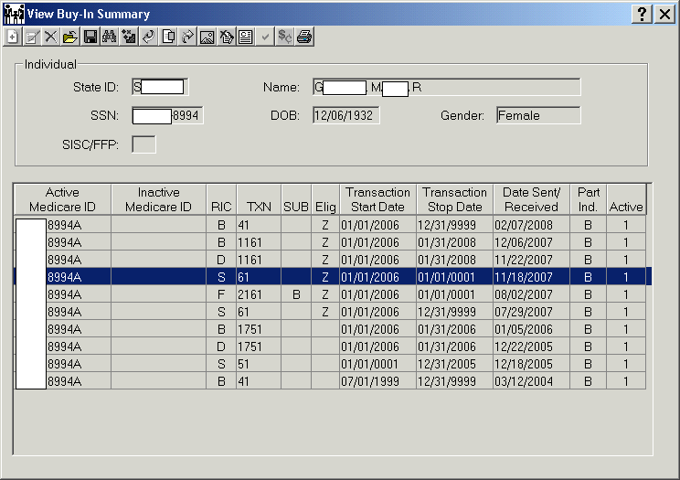

Last name changed @ SSA. New request effective 1/2006 resubmitted.

State Buy-In Officer manually creates a new txn 61 RIC S that will be sent to CMS the following Monday AM. A new request effective 1/2006 is resubmitted 11/18/2007. MMIS dutifully carries baton with new 61 RIC S effective 1/2006 to CMS.
Scenario 2: Buy-In Stop, Reject, Restart – 8 of 10

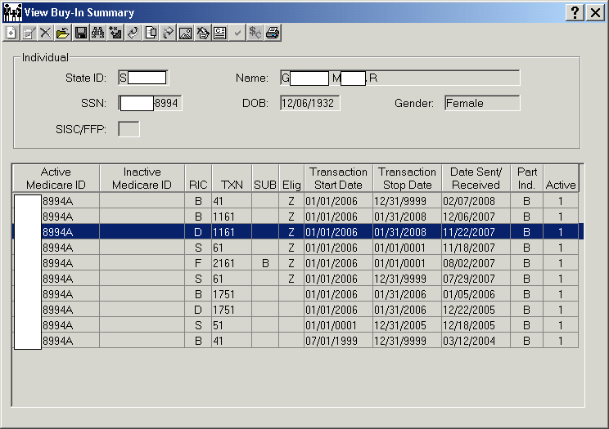

Success! Buy-in will restart. A refund should be sent shortly. RIC B to follow.

Success! CMS (smiling and congratulatory) responds with a “Yes. Buy-in will restart.”

CMS carries “mini-baton” with the 1161 RIC D to MMIS and shakes MMIS’ hand in congratulation.

CMS also carries “big” baton with 1161 RIC D to SSA.

Buy-In restarted effective 1/2006; refund should be sent ~11/22/2007 or shortly thereafter. RIC B to follow.
Scenario 2: Buy-In Stop, Reject, Restart – 9 of 10

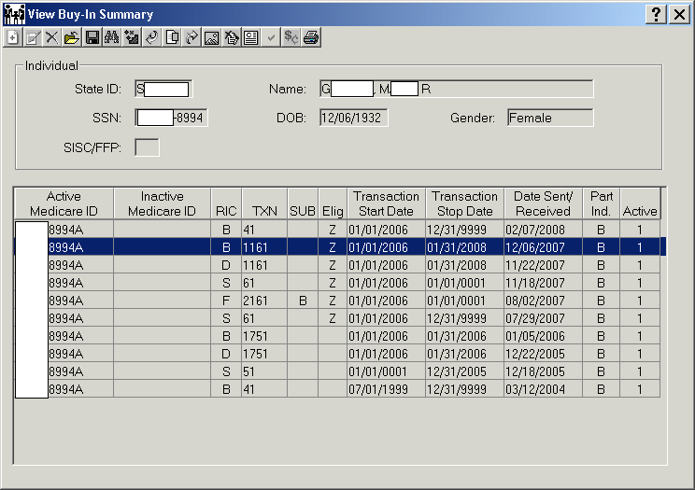

SSA stops the deduction of the Part B premium from Maggie’s check and issues a refund of the premiums the client paid while she was waiting for buy-in to kick back in. CMS sends Colorado the bill for the Part B premiums.

SSA carries the baton and refund check to the client and hands the check to the Maggie.

Maggie is ecstatic, jumping for joy! At least in her mind’s eye she sees herself jumping for joy. At seventy-five she really does not do much but lean into her walker. She can now pay her rent and have money for food and medicines. Her life is saved! She was just never sure how an old woman in a walker could live for very long on the street. She had lived like that for a while when she was young, but then she was very fleet of foot.

It was a long year, but at least now she can celebrate her birthday!
Scenario 2: Buy-In Stop, Reject, Restart – 10 of 10

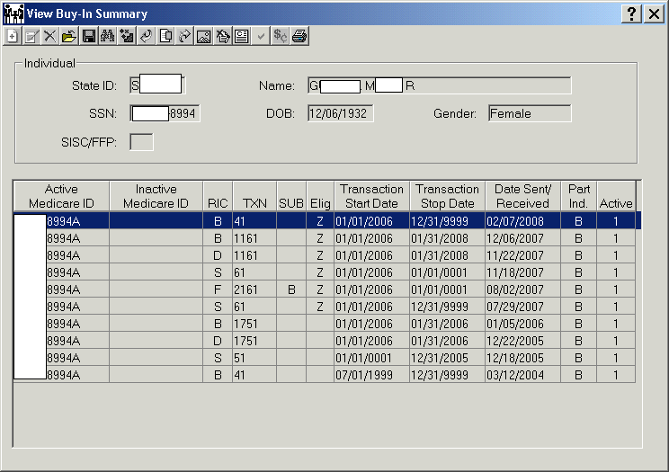

Buy-In is ongoing, paid through 3/2008.

Colorado will continue to be billed for the Part B premiums until buy-in stops in the future.

Maggie is happy and all is well again. The despair she felt is all but gone, though an emotional scar remains.
Administrative Finality

SSA will not change a date of birth if doing so would be a disadvantage to the client and there is no fraud involved. SSA instructs the beneficiary to use the SSA DOB when contacting SSA and other government agencies and intermediaries (Medicare, health care providers, etc.).

Citations:
- POMS GN 04030.010: The Effect of a Revised Date of Birth More Than 4 Years After Initial Determination
- 20 CFR 404.435(a) (3), 404.905, 404.988, and 404.989
- SSR 82-45a
Scenario 3: Administrative Finality – 1 of 5

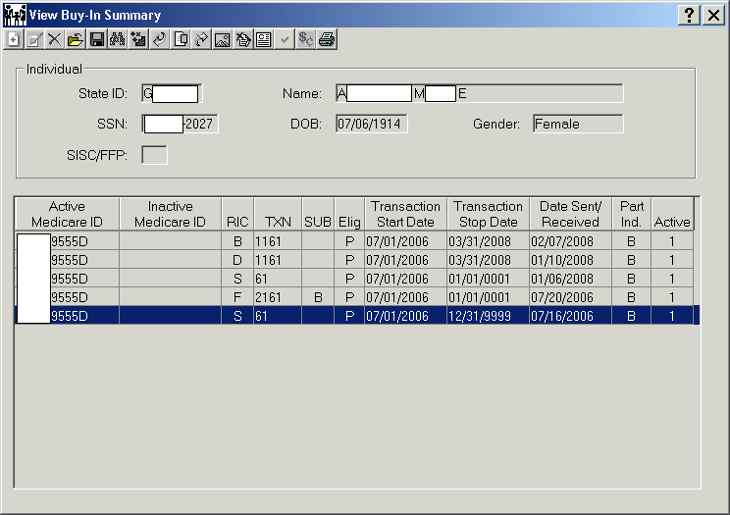

MMIS (confidently) carries baton with txn 61 RIC S to CMS.

Matilda Anthony, a woman still elegant and vibrant at 92, applies for QMB on 6/20/06. Matty (hopefully) turns in a whole baton to CBMS. CBMS approves her for QMB effective 7/1/06 on 7/10/2006.

CBMS (smiling) carries baton with med spans showing QMB begins 7/1/06 to MMIS.

MMIS accretion program runs Sunday night, 7/20/2006, and creates a Buy-In Request (RIC S) effective 7/1/06, that will be sent to CMS on Monday morning.

Scenario 3: Administrative Finality – 2 of 5

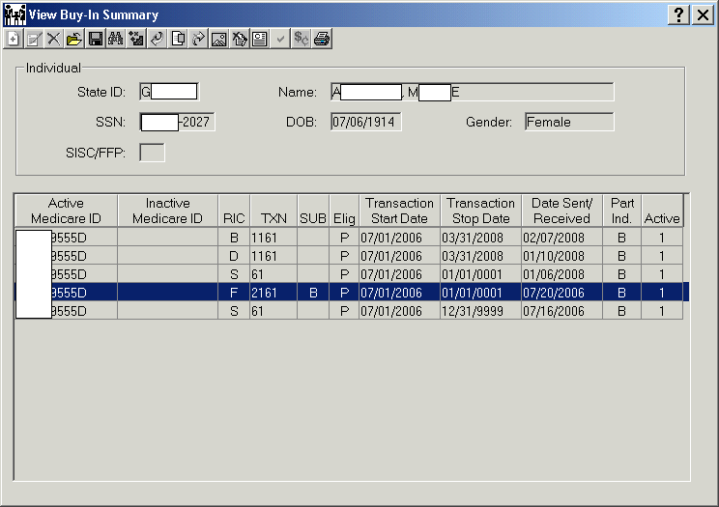

Request rejected due to “personal characteristics don’t match.”

CMS responds with a 2161 subcode B RIC F: “No. HIC# exists but personal characteristics don’t match.” CMS carries baton with 2161 subcode B RIC F back to MMIS, shaking their heads.

Matty patiently waits and waits for her refund. She is upset! She was counting on that money! She has resorted to Alpo in order to pay for her prescriptions! She can’t go on this way much longer! When she sees a friend at the store she talks about the stray she has taken in. But it never quite eases the embarrassment she feels.

She runs to her CBMS worker in a terrible state. “I don’t know what to do! I need my prescriptions to live.” Full of empathy for the poor woman the compassionate county worker (calmly, in a Dick Tracy detective hat) pulls up SOLQ on the client.

“Mr. Tracy” discovers that SSA Title 2 has a different date of birth for the client than CBMS has. SSA has 7/6/1912 while CBMS has 7/6/1914. Matty states 1914 is correct and has a birth certificate to prove it. CBMS worker tells client to contact SSA to fix their data.

Matilda (determined and maybe a bit huffy) carries baton with the wrong DOB and original birth certificate with the correct DOB to SSA and tells SSA to correct her DOB in Title 2. SSA tells the client that they refuse to correct her DOB in Title 2 because doing so would hurt her too badly.

Changing the DOB in Title 2 would cause her to have to pay back two years’ worth of benefits she received erroneously. This would be too much of a financial hardship on her and SSA’s Administrative Finality rules won’t allow it. SSA gives her a letter telling her to use SSA’s DOB.

Matty (unhappy and even more stressed) dejectedly carries the baton with the wrong DOB and letter from SSA back to CBMS.

Upon seeing the letter the county worker changes the CBMS DOB to match SSA Title 2 and notifies the State Buy-In Officer that CBMS now matches SSA Title 2.

CBMS (tired and exasperated, because she/he has been dealing not only with the irate client but also with a stubborn SSA) carries the baton to the State Buy-In Officer.

Scenario 3: Administrative Finality – 3 of 5

New buy-in request effective 7/1/06 sent to CMS Baltimore on 1/6/2008.

The State Buy-In Officer waits 2-3 business days for the CBMS update to hit MMIS. At which time the Buy-In Officer manually creates a new RIC S to resubmit to CMS the following Monday. MMIS carries baton with new 61 RIC S to CMS.
Scenario 3: Administrative Finality – 4 of 5

CMS responds with an 1161 RIC D (“Yes” response) received 1/10/2008.

CMS (smiling) carries “mini-baton” to MMIS and shakes their hand in congratulations. Buy-In is successful on only the 2nd attempt!

CMS also carries the big baton to SSA. SSA stops the Part B deduction from the client’s check and issues a refund of the 7/2006-1/2008 premiums. Buy-In has started effective 7/2006; refund should be sent ~1/10/2008 or shortly thereafter. The RIC B (billing record) will follow the first week of the next month.

Scenario 3: Administrative Finality – 5 of 5

CMS bills the State for the premium months of 7/2006-3/2008.

SSA carries the baton with a check for the refund to the client and hands the refund check to Matilda.

Matty is ecstatic! She can finally pay for her prescriptions and still have enough money to buy “human” groceries! Matty thinks, “guess the stray she took in will just have to run away”, it must have gotten tired of Alpo. She knows that she did. At least for now no more worries about becoming homeless.

Administrative Finality - Workaround

December 13, 2007 letter from CMS:

“The State may carry that incorrect DOB in its system in order to properly effectuate Medicare Buy-In. Should SSA make a change correcting the individual’s date of birth, then the State should make its records consistent.”

“SIDMOD Compromise”

To comply with CMS’ direction, CO Department of Human Services (DHS) has agreed to allow the CBMS name and date of birth to match CMS’ data — including spaces and special characters – AFTER a State ID has been assigned.

BEFORE a State ID is assigned, follow SIDMOD rules: Enter the name and DOB as it appears on the birth certificate — no spaces or special characters.

AFTER a State ID has been assigned, follow CMS’ rules: Enter the name and DOB to match SSA Title 2 or RRB data — including spaces and special characters. Enter the suffix in the last name field when applicable.

Match Criteria

1. HIC#: Health Insurance Claim # (Medicare ID#)
2. Last Name: First 6 characters, including spaces and special characters.
3. First Name: First 3 characters, including spaces and special characters.
4. Middle Initial: Middle initial alone will not cause buy-in to reject.
5. Date of Birth: Month & Year
6. Sex Code: M or F
7. SSN: Client’s own SSN

Match Criteria

Last Name | First Name | Middle Initial | DOB | Sex
First 6 characters  including spaces and special characters. | First 3 characters  If you see the full middle name separated from the first initial by a space, enter what you see into the first name field in CBMS Case Summary & Individual Demographics | SOLQ will only display the middle initial, never the full middle name. | Month & Year  Day of Birth alone, or middle initial alone will not cause buy-in to reject, but both together will cause a reject. | M  Or  F

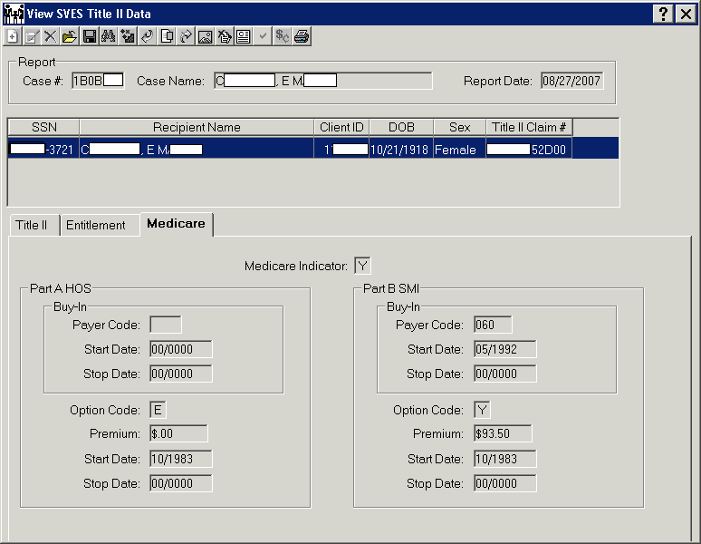

Payer Code | Option Code | Buy-In  Start Date | Buy-In  Stop Date | Premium  Start Date | Premium  Stop Date
Z99 = Conditional  S01-S99 = State Payment  Blank = Self Pay if Option Code = Y, | Y = Premium is payable  E = Free Part A  Blank = not enrolled | Populated if state has started buy-in (1st of the month); zeroes if no buy-in. | Populated if buy-in has stopped (end of the month); zeroes if buy-in is ongoing or never started. | First month of entitlement; zeroes if not enrolled | First month of non-entitlement; zeroes if entitlement ongoing or never enrolled.

HIC# (Health Insurance Claim #, aka Medicare ID)

- Enter the complete HIC#, including the BIC (Beneficiary Identification Code).
- No zeroes in the BIC.
- No hyphens, spaces, dots, etc.
- Enter RRB #s exactly as they appear on the Medicare card, but no space.
- RRB#s begin with a non-numeric character (A, MA, WA, WD, WCA, etc.).

Match Criteria — Space in Last Name

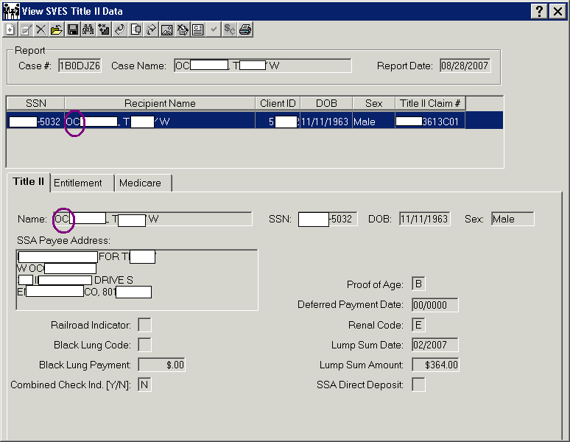

Note small space where an apostrophe would be. Be sure to put the space in the name in CBMS.
Match Criteria — Compound Name

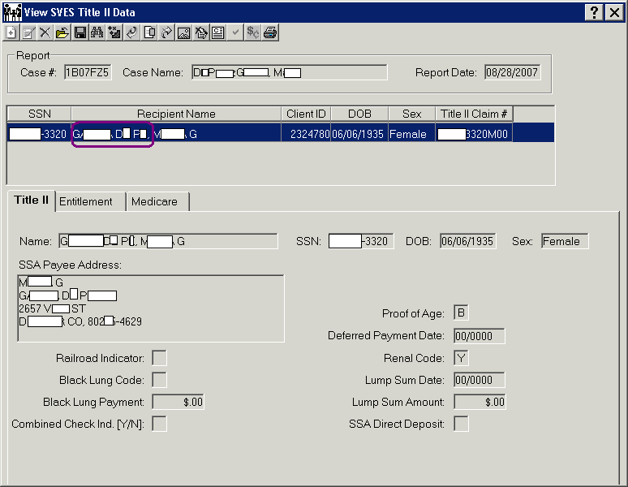

Note spaces in last name. Enter name in CBMS Case Summary and Individual Demographics WITH SPACES.
Match Criteria — Hyphen in Last Name

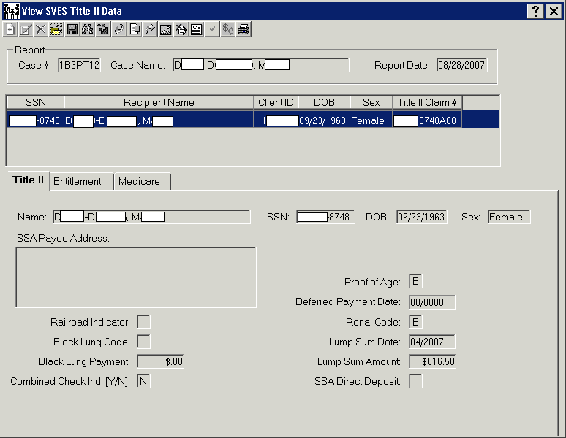

Note hyphen in last name.

CMS now allows special characters in the name fields.
R570 Buy-In Reject Report

The new Weekly Report lists clients in each county who cannot get their buy-in going due to a demographic mismatch. These are the RIC Fs with a Subcode B: “HIC# exists but personal characteristics don’t match.” We send our RIC S file weekly (each Monday morning), so we receive the CMS responses weekly (each Thursday). The new report will list the current RIC Fs received that week, so each report is a new list. There may be some repeat clients from week to week, due to multiple attempts to request buy-in. Each weekly report needs to be worked.

The report will be available on-line, via the File and Report Service (FRS). Each county will only have access to their own reports. Counties will be notified via e-mail when their reports are posted and are available to obtain them. Detailed instructions on how to use and work the report will also be sent via e-mail.

Buy-In accretion logic looks back two years and will keep trying to do buy-in for two years after the eligibility end date. Txn code 75 RIC S is a request for a closed period of buy-in. Txn code 2175 is CMS’ reject of our request for a closed period of buy-in.

For closed cases, counties can choose to do any of the following:

- Change CBMS data to match SSA Title 2, if someone (client, relative, nursing home, etc.) is likely to want to claim the Part B refund; then let me know to resubmit.

- If nobody is likely to claim the Part B refund, make a list of those clients and skip them.

- Skip all the 2175s.
Protect Client Privacy!

When e-mailing client info to HCPF, send only:

- Client initials
- State ID
- Case Number

NEVER send a complete Social Security Number or Medicare ID Number!

*Don’t spell out “State ID” or “Case Number.”

Other Resources — Medicare Buy-In

CBMS User’s Guide to Medicare Buy-In
Document #072806-CDHCPF1, released 7/28/2006

State On-Line Query-Internet (SOLQ-I) Guide
Document #061906-CBMS1, released 6/19/2006

Bendex Modernization Reference Guide
Document #022807-CBMS1, released 2/28/2007
Statutory Authority — Medicare Buy-In

Federal: Social Security Act Sec. 1843
42 U.S.C. 1395v

State: C.R.S. 25.5-5-104
C.R.S. 25.5-5-105

Volume 8 – 10 C.C.R. 2502: 8.062

Contacts

Sharon L. Brydon
Buy-In Officer
(303) 866-5402 – phone
sharon.brydon@state.co.us

Pete Garcia
Client Health Insurance Officer
(303) 866-5701 – phone
pete.garcia@state.co.us

Eujenia Renfroe
Third Party Insurance Coordinator
(303) 866-2321 – phone
eujenia.renfroe@state.co.us

Our fax number: (303) 866-3552

