Applications Due: September 14, 2021, 11:59 PM MDT
Email to: Anoushka Millear, anoushka.millear@state.co.us

Maternal Opioid Misuse Model Overview

In the last decade, a disturbing trend has emerged in Colorado. In place of postpartum hemorrhage and eclampsia related deaths, behavioral health conditions are now the leading cause of maternal mortality. While Colorado's maternal population has been greatly impacted by the increase in maternal morbidity and mortality associated with behavioral health disorders, recent changes in the Colorado delivery system can make improving these outcomes more feasible. The latest iteration of the Department's Accountable Care Collaborative aligns the administration of physical and behavioral health services under one entity -- the Regional Accountable Entity (RAE) -- to improve member health and reduce costs.

In December 2019, the Colorado Department of Health Care Policy & Financing was awarded the Maternal Opioid Misuse (MOM) Model cooperative agreement from the Centers for Medicare & Medicaid Services (CMS) to bring this model to Health First Colorado (Colorado's Medicaid program). This model was created to better support pregnant and postpartum Medicaid members with opioid use disorders (OUDs).

Given the unique needs and existing efforts in communities across Colorado, the Department's proposed approach for the MOM model will support a maximum of seven local providers and/or RAEs (one subgrantee per RAE region) while building statewide capacity to serve pregnant and parenting women with OUD and their infants. The Department will utilize a total budget of $4.6 million to provide two components of support for integrating care:

- regionally specific sub-grants totaling up to $506,778 per site over four years for integrating SUD treatment into primary and obstetric care sites that are appropriate to their community, and
- technical assistance to sub-grantees through a learning collaborative model.

Practice site sub-grants comprise $3.55 million of the total budget with the remaining $1.05 million going towards administrative costs to support and monitor efforts statewide. Due to integrated care driving appropriate utilization of health care and decreasing deleterious outcomes that drive costs, the Department anticipates realizing savings of $1,295,888 over the five-year grant cycle.

Additional information can be found on Colorado’s MOM grant website:
https://hcpf.colorado.gov/maternal-opioid-misuse-model For any questions regarding the application, please contact the Department’s Grants Specialist, Amanda Jacquecin, at Amanda.jacquecin@state.co.us.

Application Overview

With this application, the Colorado Department of Health Care Policy and Financing invites RAEs, OB/GYN and/or SUD providers, clinics, and any other interested parties to apply to be a MOM model subgrantee. We are looking for regionally-specific, community-oriented, and innovative projects that will harness existing Medicaid services to better integrate substance use disorder services and obstetric care in order to improve outcomes for pregnant and parenting people with Opioid Use Disorders.

Applicant and Project Requirements

Applicants must meet the following requirements:
- Either is or has a partnership or a proposed partnership with a Medicaid enrolled:
  - RAE contracted behavioral health provider that: 1) has licensed providers; 2) can provide substance use disorder services; and 3) has the ability to submit and receive reimbursement for behavioral health services, AND/OR
  - Primary and/or obstetric care provider that: 1) has licensed providers; 2) can provide obstetric and postpartum care to pregnant and postpartum people (up to one year); and 3) has the ability to submit and receive reimbursement for obstetric services.
- Includes the applicable Regional Accountable Entity, as the applicant or as a partner with whom the applicant has the ability to collaborate on the sustainability of the intervention.
- Have a panel of patients that is ~30% (or more) Medicaid members, with priority given to PCMPs.
- Demonstrates capacity to collect member-level clinical data in real time and to report required data elements to CMS quarterly through a secure CMS portal for eligible enrollees.
- Has the capacity and staffing (or has a plan to create) to participate in required project meetings, including technical assistance and learning collaborative calls, and provide coordination and oversight activities identified in the above mentioned project plan.

Proposed projects must meet the following requirements:
- Enrolls Medicaid members in the prenatal period, with the intervention to span pre- and postnatal period
- Incorporates at least one of the components of physical and behavioral health integration infrastructure building (NASHP):
  - Care management and care coordination, including care transitions
  - Multidisciplinary teams
  - Systematic approaches to care using population-based tools, clinical guidelines and evidence-based practices
  - Comprehensive, patient-centered care planning
  - Quality measurement and improvement
  - Use of health information technology
- Incorporates at least one of the following evidence-based interventions:
  - Expand existing or emerging evidence-based models (Prenatal Plus, Special Connections, or other Medicaid reimbursable home visiting or clinic based services)
  - Bi-directional, co-located services (e.g. SUD services in obstetric setting, obstetric services in SUD setting, dyadic treatment for parents and newborns)
  - Paraprofessional support (including but not limited to doulas, peer recovery coaches and/or childbirth educators)
  - Hub and Spoke Model
  - Enhanced tele-solutions including E-consult or Telehealth options
  - Increased access or alignment for Medication Assisted Treatment (MAT)
  - Improved or expanded care coordination and/or wraparound services
    - If selecting this option, applicants must
      - Be explicit with how this does not duplicate existing care coordination responsibilities that exist in RAE contracts.
  - Promising local or emerging practice that is presented with:
    - Peer-Reviewed evaluation data
    - Rationale for why intervention is more appropriate for your community
- Includes feedback or research from the community, with provider and/or client input.
- Illustrates anticipated impact on Medicaid members cost and outcomes.
- Addresses the financial sustainability for continuation after the Grant Program ends.
- Has a project timeline that demonstrates ability to meet appropriate annual milestones, including conclusion of project by 12/31/2025.
- Includes appropriate budget that shows funding does not exceed $501,213.67 over 5 project years, broken down as follows:
  - Year 1 (2021): $78,656.60 [dispersed December 2021]
  - Year 2 (2022): $77,685.45 [dispersed January 2022]
  - Year 3 (2023): $126,739.89
  - Year 4 (2024): $109,995.80
  - Year 5 (2025): $108,135.92
- Does not duplicate existing RAE responsibilities.
- Does not duplicate care coordination services already provided by the RAEs
- Includes plan for how data will be collected and submitted
- Attests that applicant will meaningfully participate in grant TA and learning collaborative

Application Outline

- Project Abstract (½-1 page)
- Project Goals (½ page)
  - Applicant Project Goals Table
- Project Description (2 pages)
- MOM Model Beneficiary Persona Journey Map (1-2 pages)
  - Journey Map Table
- Project Activities and Timeline (1-2 pages)
  - Project Activities and Timeline Table
- Project Duplication Attestation (½ Page)
- Data Collection and Reporting (1-2 pages)
  - Required Data Elements Table
  - Data Security (1 paragraph)
  - Data Collection Attestation
- Technical Assistance Participation Attestation
- Health Equity Attestation
- Client and Provider Input (1 paragraph)
- Community Partnerships, including Regional Accountable Entity (1-2 paragraphs)
- Budget Narrative (2 pages)
- Sustainability (½ page)
- Application Checklists
  - Applicant Checklist Table
  - Project Checklist Table

Formatting of Application Response

The application response must be submitted in a Portable Document File (.pdf extension). The application response must be written in 12 point Times New Roman font. The application response must be single spaced, with standard 1 inch margins. The application must not exceed 29 pages (including 15 pages of directions).

Timeline for Application

August 9, 2021: MOM grant subgrantee application period opens
September 14, 2021, 11:59 PM MDT: MOM grant subgrantee application due to Anoushka Millear (MOM Project Coordinator), anoushka.millear@state.co.us
October 2021: Selected MOM grant subgrantees notified

Application Review Process

A multidisciplinary panel of HCPF employees will review, score, and evaluate each application for completeness, adherence to the grant requirements, and the quality of the proposed project. Following the application review process, selected applicants (subgrantees) will be expected to sign a State of Colorado Grant Agreement. Contracts will be finalized Fall 2021 and subgrantees will be expected to start enrolling members in the MOM Model on January 1, 2022.
--------------------------------------------------Application----------------------------------------------------
- Project Abstract (½ - 1 page)
Provide a brief high-level narrative summary of your proposed project. Include:
- Brief description of the project activities and applicant agency
- The rationale for this intervention from this agency for your community
- Population served
- Projected number of members enrolled
- Projected impact of the project
- Any community connections and/or partnerships that will support the project.
Note: This application will ask for this information in more detail further on, so the abstract can omit the finer details of the project.

Click or tap here to enter text.

- Project Goals (½ page)
The table below (Table 1) lists the federal goals for the MOM Model grant. In the “Applicant Project Goal” column, please provide a bulleted list of your project goals, assigning them to the Federal goal with which they most closely align. Each Federal goal may have zero or one or more proposed project goals.
Table 1: Federal MOM Model Goals and Applicant Project Goals
Federal Goal | Applicant Project Goal
Improve quality of care and reduce costs for pregnant and postpartum women with OUD as well as their infants
Expand access, service-delivery capacity, and infrastructure based on state-specific needs
Create sustainable coverage and payment strategies that support ongoing coordination and integration of care

- Project Description (2 pages)
Describe in narrative form the proposed project. Be sure to include the following details:
- Who: Who are the Medicaid members that will be served by this project? Who will provide the services? Identify the targeted population and the projected number of impacted members. Provide a detailed explanation that supports the choice of the target population and project.
- What: Which of the interventions listed above will this project employ, and what are the detailed activities involved in your interpretation of the intervention? What relevant prior experiences does the applicant have that will support this work?
- When: At what point in a person’s pre/post-partum period will this project intervene?
- Where: What is the geographic service area of the project (identified by ZIP Code or other clear descriptor), and will eligibility be determined based on patient residency in the geographic service area? Where will the intervention be administered (home, clinic, community)? If applicable, which departments or programs will house the project?
- Why: Which interventions have you chosen and why--why are they appropriate for your clients, community, and/or location?
- Integrated Care Goal Alignment: Of the six components of physical and behavioral health integration infrastructure building, which one (or more) does this project incorporate and why were they selected?
  - Multi-disciplinary teams
  - A systematic approach to care using population-based tools, clinical guidelines, and/or evidence-based practices
  - Care management and care coordination, including care transitions
  - Use of health information technology
  - Quality measurement and improvement

Click or tap here to enter text.

- MOM Model Beneficiary Persona Journey Map (1-2 pages)
In order to understand the order of operations for your intervention, share a hypothetical scenario for a member enrolled in your MOM Model Program.
First, examine the following MOM Model Beneficiary Persona below (Image 1). Second, review the journey map (i.e., timeline) of their pregnancy and postpartum experience (Image 2). Finally, use the Journey Map Table (Table 2) to describe the activities your project would provide to the persona at each point in time. In the “RAE Responsibility and Other Considerations” column, please explain the RAE’s responsibility as a complement and not duplication of the intervention you propose. For each point in time, please indicate whether the activity/support is an existing service provided by your organization or a new grant-related service.
If this persona is not representative of the population that you serve, feel free to adjust the details and describe those changes here.
Click or tap here to enter text.

Image 1: MOM Model Beneficiary Persona

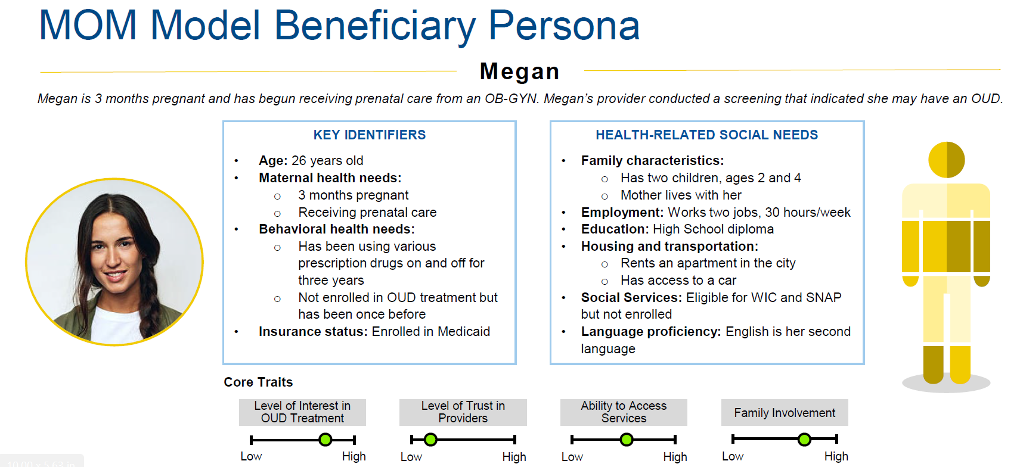

Image 2: MOM Model Beneficiary Journey Map
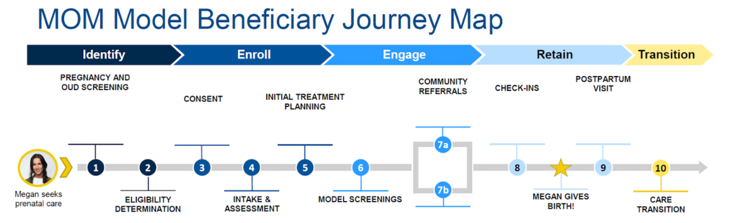

Table 2: Journey Map Table (1-2 pages)
Point in Time | Project Intervention | RAE Responsibility &  Other Considerations
1: Pregnancy and SUD Screening | Example: Megan comes in for her first prenatal visit and receives an SUD screening | Example: Need personnel on site for positive screen
2: Eligibility Determination
3: Consent
4: Intake and Assessment
5: Initial Treatment Planning
6: Model Screenings (i.e., data elements)
7a: Community Referrals, if any
7b: SUD treatment
8: Check-Ins
9: Postpartum Visit
10: Care Transition

- Project Activities and Timeline (1-2 pages)
Complete the following table (Table 3) with major tasks/activities, due dates, and the deliverables that will illustrate successful completion. Add more rows as necessary. Please complete for award notice (October 2021) through assumed project completion (December 2025).

Table 3: Project Activities and Timeline (1-2 pages)
Major Task or Activity | Completion Date | Deliverable
Example:  Develop informational flyers to recruit members | 12/20/2022 | Distribute 1000 Informational Flyers about site intervention

- Project Duplication Attestation (½ Page)
Describe how the project does not duplicate other community efforts or current RAE contracted activities. Applicants are encouraged to review RAE contracts, with particular attention to required care coordination activities, defined as:
The deliberate organization of Client care activities between two or more participants (including the Client and/or family members/caregivers) to facilitate the appropriate delivery of physical health, behavioral health, functional Long Term Services and Supports (LTSS) supports, oral health, specialty care, and other services. Care Coordination may range from deliberate provider interventions to coordinate with other aspects of the health system to interventions over an extended period of time by an individual designated to coordinate a Member’s health and social needs (Section 2.1.13.).

Click or tap here to enter text.

- Data Collection and Reporting Requirements (1-2 pages)
To ensure awardees can successfully collect and report data, please review Tables 4-6, which show the performance milestones, monitoring measures, evaluation measures, and evaluation domains for the MOM grant, including the timing of each data element (i.e., the point in time during a client’s participation in the grant at which the data element is collected).
For each program data element listed in the Data Elements Table below (Table 7), please complete to share:
- Is the data already collected, and if so, what is the timing?
- If the data element is not already collected:
  - Can you obtain the data from an existing data source (e.g., an Electronic Health Records system, paper charts), or
  - Can you substitute a similar data element already collected, and if so, what is that element?
- If neither the original data element or a similar one already exists, indicate a need to develop an approach for collecting that data element and if you will need support from HCPF in collecting and reporting any of the data elements. Note: applicants will not be penalized for requiring data support from HCPF; this question is to help HCPF plan.

Tables 4-6: Required Data Elements
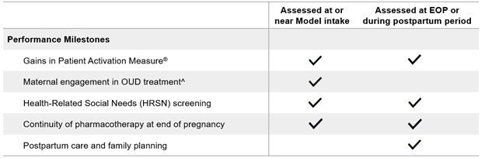
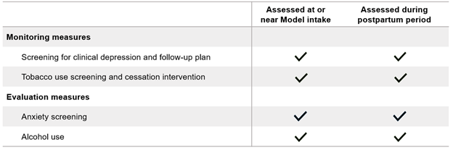
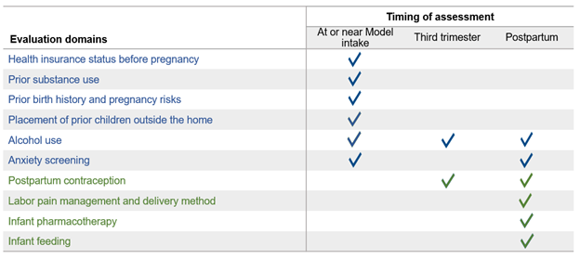

Table 7: Required Data Elements (1-2 pages)
Data Element | Already Collected (Y/N) | Timing of Data Collection | Can Data be Obtained from Existing Data Sources? | Similar Data Element Available? (Y/N) If Yes, Please Name | Need to Develop Data Collection Approach (Y/N) | HCPF Support Required for Data Collection (Y/N)
Patient Activation Measure
Maternal Engagement in OUD Treatment
Health-Related Social Needs Screening
Continuity of Pharmacotherapy at End of Pregnancy
Screening for Clinical Depression & Follow-up Plan
Tobacco Screening and Cessation Intervention
Health Insurance Status Before Pregnancy
Prior Substance Use
Prior Birth History and Pregnancy Risks
Placement of Prior Children Outside of the Home
Alcohol Use
Anxiety Screening
Postpartum Contraception
Labor Pain Management and Delivery Method
Infant Pharmacotherapy
Infant Feeding

VII.A. Data Security (1 paragraph)
Describe the data privacy and security practices that will be used to protect client data. Include any protocols, software and/or hardware, physical security practices, and any other information regarding data privacy and security.
Click or tap here to enter text.

Identify the person or persons who will be responsible for reporting the data and submitting them to the MOM data Gateway: Click or tap here to enter text.

VII.B. Data Collection Attestation
Review the included MOM grant data requirements table (Table 3) and the completed data collection and reporting table (Table 4) with the identified person or persons above. Check “Yes” to indicate that the individual(s) above has/have reviewed and understands the MOM grant data reporting and collection requirements, and that any areas where HCPF support will be needed for data collection and reporting have been included in Table 4.
☐Yes

Provide any additional data collection information as needed.
Click or tap here to enter text.

- Technical Assistance Participation Attestation
All subgrantees will be required to meaningfully participate in bi-monthly (at least) Technical Assistance (TA) meetings and projects. These will be shared learning cohorts with an expectation that each subgrantee will participate in determining topics, driving dialogue and generating content for these meetings. Check “Yes” to indicate that the organization will attest to the willingness and capacity to participate in TA.
☐Yes

- Health Equity Attestation
All subgrantees are required to participate in co-creating and implementing a health equity approach in their execution of the MOM Model. Check "Yes" to indicate that the organization will attest to their willingness and capacity to participate in this approach.
☐Yes

- Client and Provider Input (1 paragraph)
Describe the community (client, provider, advocate, etc.) input and/or existing data sources on community needs used to inform the proposed project.
Click or tap here to enter text.

- Community Partnerships, including Regional Accountable Entity (1-2 paragraphs)
Describe any community partnerships (informal or formal) that your project will develop, utilize, or enhance. Describe how your Regional Accountable Entity will be involved with the project.
Click or tap here to enter text.

- Budget Narrative (2 pages)
Using the MOM Application Budget worksheet, create a detailed budget for your proposed project. Then provide a narrative that describes and explains the rationale for each budget line item (Personnel, Fringe, Travel, Equipment, Supplies, Contractual, Other and Indirect). Describe any intended inclusion of applicant resources dedicated to the project, identifying these resources as applicant provided. Reminder: The intervention needs to leverage existing benefits to Medicaid members because the state cannot seek additional federal authority for new coverage.
Click or tap here to enter text.

- Sustainability (½ page)
Identify the plan for financial and programmatic sustainability of the project beyond the grant period.
Click or tap here to enter text.

- Application Checklists
To ensure the success of your application, please complete the following two tables: Applicant Requirements Checklist (Table 8) and Project Requirements Checklist (Table 9) (corresponding to pages 2-3 of the application). For ease of reference, please also indicate where in the application you have documented these criteria. If your program or project does not meet any criteria, include any additional information that demonstrates the strength of your application despite not meeting the criteria.

Table 8: Applicant Requirements Checklist
Applicant Requirements | Y/N | Application Section | Additional Information
Are you a...

-RAE Contracted behavioral health provider that: 1) has licensed providers; 2) can provide substance use disorder services; and 3) has the ability to submit and receive reimbursement for behavioral health services, AND/OR

-Primary and/or obstetric care provider that: 1) has licensed providers; 2) can provide obstetric and postpartum care to pregnant and postpartum people (up to one year); and 3) has the ability to bill for and receive reimbursement for obstetric services.
Are you a RAE or do you have the ability to partner with your RAE on the sustainability of the intervention?
Do your participating providers have a panel of patients that is ~30% (or more) Medicaid members, with priority given to PCMPs?
Do you have the capacity to collect member-level clinical data in real time and to report required data elements to CMS quarterly through a secure CMS portal for eligible enrollees?
Do you have (or have a plan to create) the capacity and staffing to participate in required project meetings, including technical assistance and learning collaborative calls, and provide coordination and oversight activities identified in the above mentioned project plan?

Table 9: Project Requirements Checklist
Project Requirements | Y/N | Application Section | Additional Information
Does your project enroll Medicaid members in the prenatal period, with the intervention to span the pre- and postnatal period?
Does your project incorporate at least one of the components of physical and behavioral health integration infrastructure building?
Does your project include one of the interventions listed or provide sufficient data to support another promising or emerging intervention?
Did you include information from your community to support this approach?
Have you illustrated the anticipated impact on member cost and outcomes?
Have you addressed the financial long-term sustainability of the program?
Will the project work and expenditures will be completed by 12/31/2025?
Have you completed the budget spreadsheet and narrative in the application to show you can comply with annual budgets?
Have you shown your project does not duplicate existing contractual responsibilities with RAEs?
Have you shown your project does not duplicate care coordination services already provided by the RAEs?
Have you included your plan for collecting and submitting data?
Have you attested that you will meaningfully participate in grant TA?

Applications Due: September 14, 2021, 11:59 PM MDT
Email to: Anoushka Millear, Anoushka.millear@state.co.us

This includes any provider that can bill and receive reimbursement for obstetric services (MD, NP, CNM, etc.)
Could be in budget
https://www.nashp.org/wp-content/uploads/2017/05/CMWF-Brief.pdf
Note that any approach must align with federal goals to either: a) foster coordinated and integrated care delivery through the delivery of coordinated and integrated physical health care, behavioral health care, and critical wrap-around services; b) utilize federal and state authorities flexibility to leverage the use of existing Medicaid flexibility to pay for sustainable care for the model population; or c) strengthen capacity and infrastructure to invest in institutional and organizational capacity to address key challenges in the provision of coordinated and integrated care.
Payments for Years 1 and 2 to be dispersed close to each other to help sites with startup costs
Funding for 2025 must be secured with a no-cost extension from CMS due to the original end date of 2024.
https://innovation.cms.gov/innovation-models/maternal-opioid-misuse-model
https://www.nashp.org/wp-content/uploads/2017/05/CMWF-Brief.pdf
Note: Funding for 2025 must be secured with a no-cost extension from CMS due to the original end date of 2024.
Per federal grant regulations, “Equipment” is defined as tangible personal property with a useful life of more than one year and a purchase price of $5,000 and above (CFR 200.33). The equipment may be free standing or composed of several pieces working together. “Supplies” defines supplies as all tangible personal property other than those defined in the definition of “Equipment. Ex: A laptop worth less than $5,000 that is used for a grant employee, is a supply.

