Appendix: Metric Graphs
- Assessment of need and qualification for SUD services
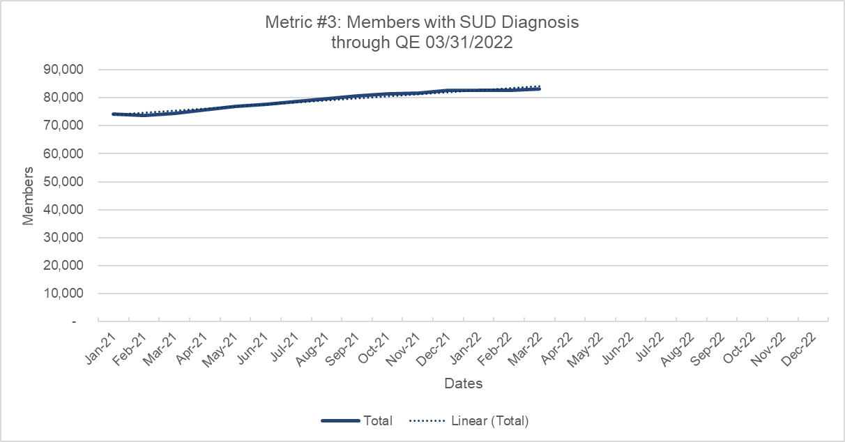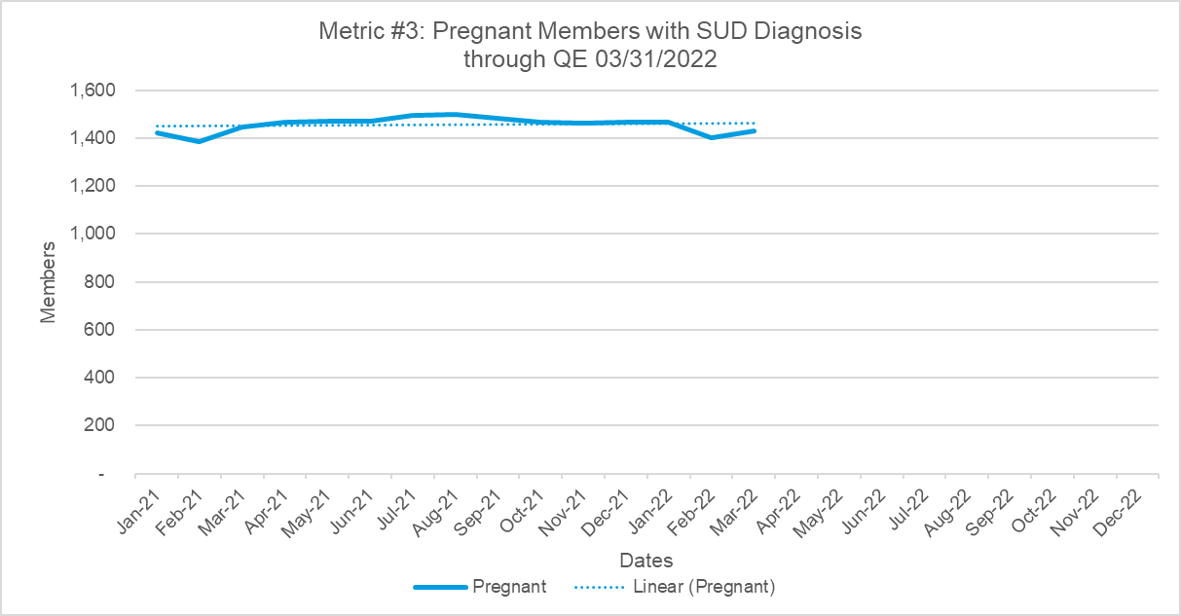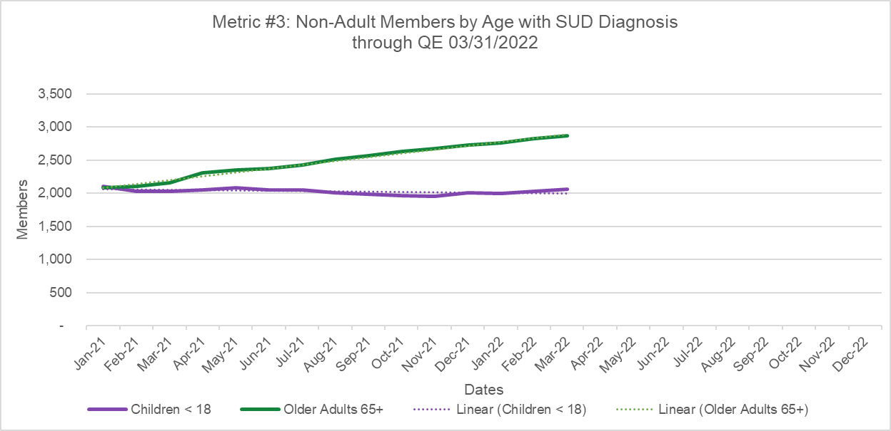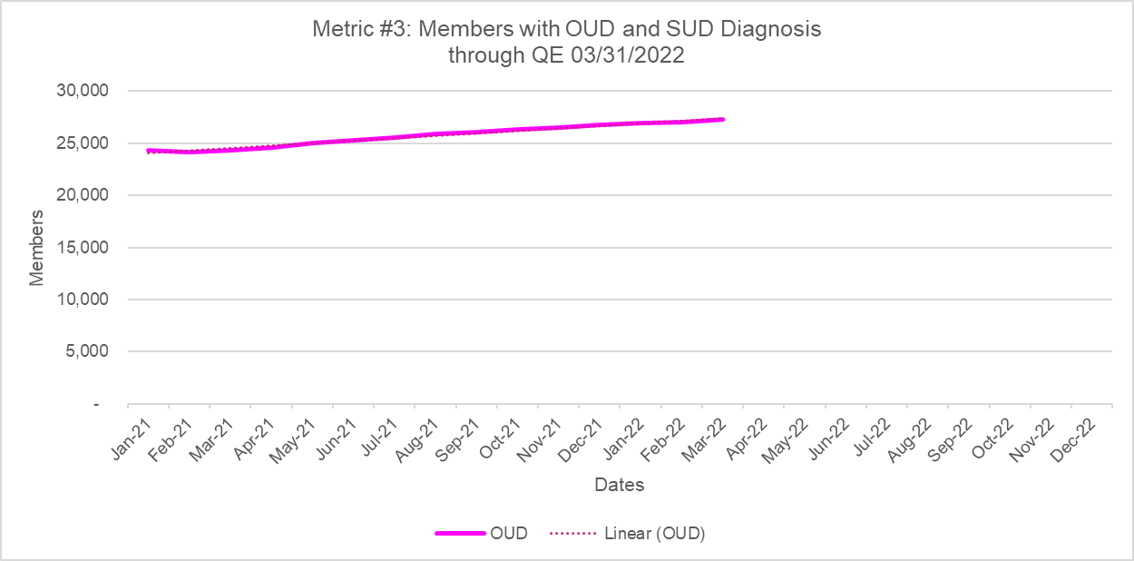
- Access to Critical Levels of Care for OUD and other SUDs (Milestone 1)
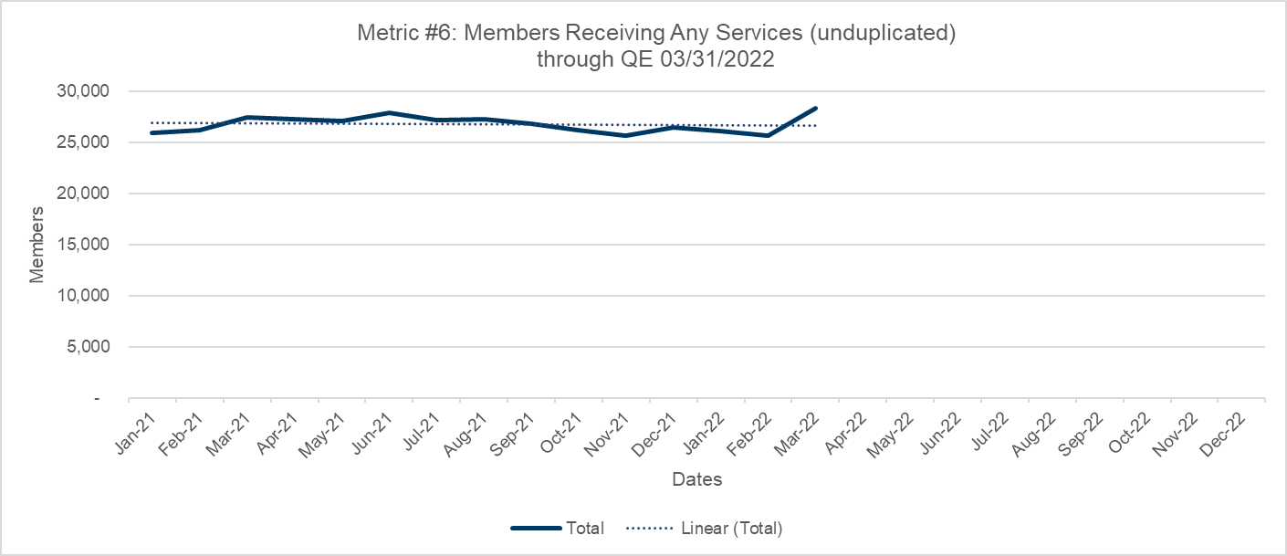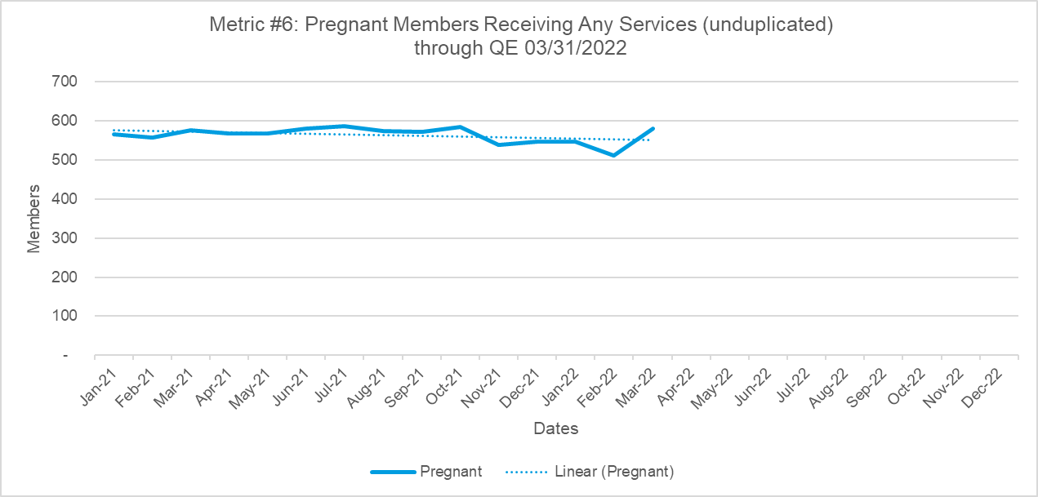
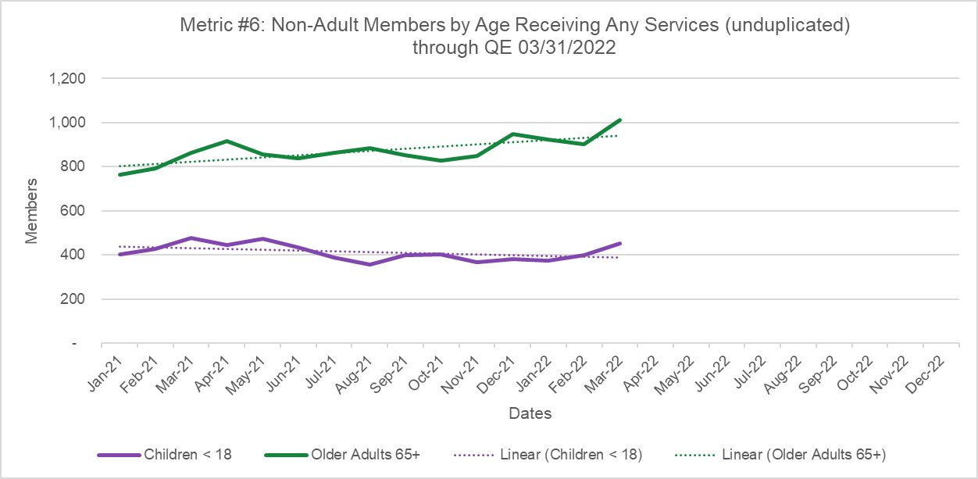

Total Members in receipt of SUD services DY1 (Metric #6 Unduplicated number is black line; Metrics #7-12 are in the stacked areas)
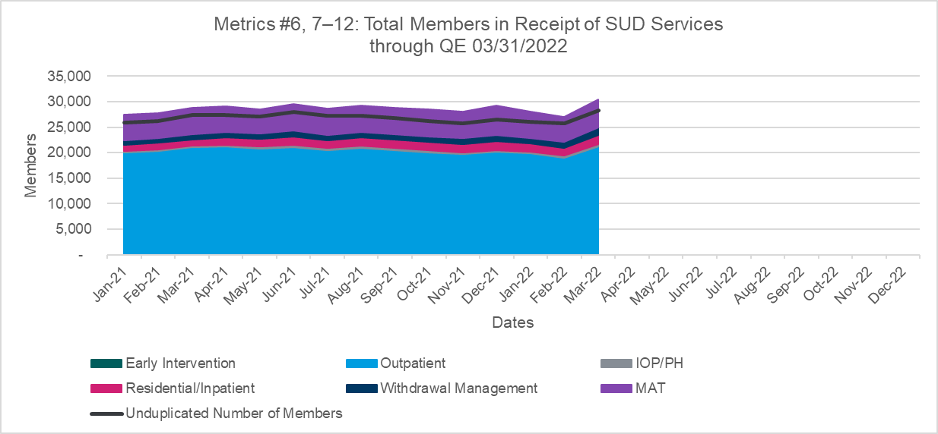 Total Members in receipt of SUD services DY1 (Metric #6 Unduplicated number is black line; Metrics #7-12 are in the stacked areas)

Note: Metric #6 includes inpatient and residential SUD services for individuals with a diagnosis of SUD in any position on a claim. Metric #10 includes inpatient and residential SUD services for individuals with a diagnosis of SUD in the primary position on a claim. For some subpopulations, this results in the unduplicated number of individuals receiving SUD services (Metric #6) exceeding the number of individuals receiving the total number of services as defined in Technical Specifications 5.0. CMS is aware of this nuance and is investigating whether to align specifications for Metrics #6 and #10. This metric programming nuance affects the subpopulations of Dual Eligibles, Older Adults, and Children. Because the number of inpatient and residential SUD services contributes to Metric #6 exceeding the sum of Metrics #7-12, it suggests that additional preventive, outpatient, and intensive outpatient care is needed to divert the acute levels of care.

Note: Metric #6 includes inpatient and residential SUD services for individuals with a diagnosis of SUD in any position on a claim. Metric #10 includes inpatient and residential SUD services for individuals with a diagnosis of SUD in the primary position on a claim. For some subpopulations, this results in the unduplicated number of individuals receiving SUD services (Metric #6) exceeding the number of individuals receiving the total number of services as defined in Technical Specifications 5.0. CMS is aware of this nuance and is investigating whether to align specifications for Metrics #6 and #10. This metric programming nuance affects the subpopulations of Dual Eligibles, Older Adults, and Children. Because the number of inpatient and residential SUD services contributes to Metric #6 exceeding the sum of Metrics #7-12, it suggests that additional preventive, outpatient, and intensive outpatient care is needed to divert the acute levels of care.
Note: Metric #6 includes inpatient and residential SUD services for individuals with a diagnosis of SUD in any position on a claim. Metric #10 includes inpatient and residential SUD services for individuals with a diagnosis of SUD in the primary position on a claim. For some subpopulations, this results in the unduplicated number of individuals receiving SUD services (Metric #6) exceeding the number of individuals receiving the total number of services as defined in Technical Specifications 5.0. CMS is aware of this nuance and is investigating whether to align specifications for Metrics #6 and #10. This metric programming nuance affects the subpopulations of Dual Eligibles, Older Adults, and Children. Because the number of inpatient and residential SUD services contributes to Metric #6 exceeding the sum of Metrics #7-12, it suggests that additional preventive, outpatient, and intensive outpatient care is needed to divert the acute levels of care.

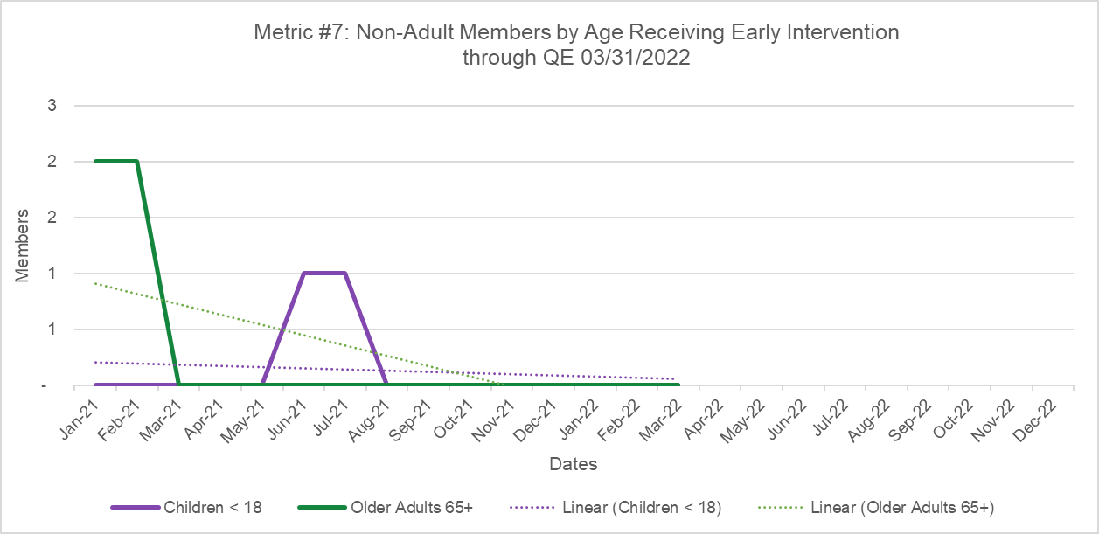
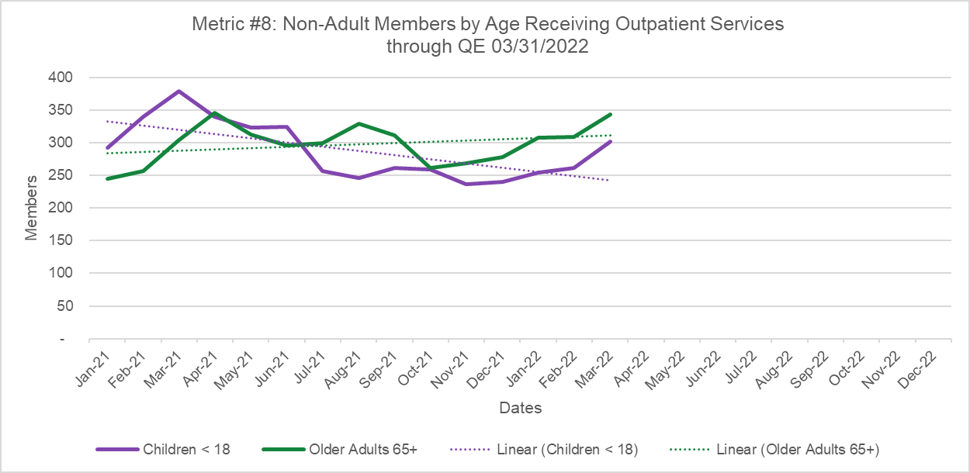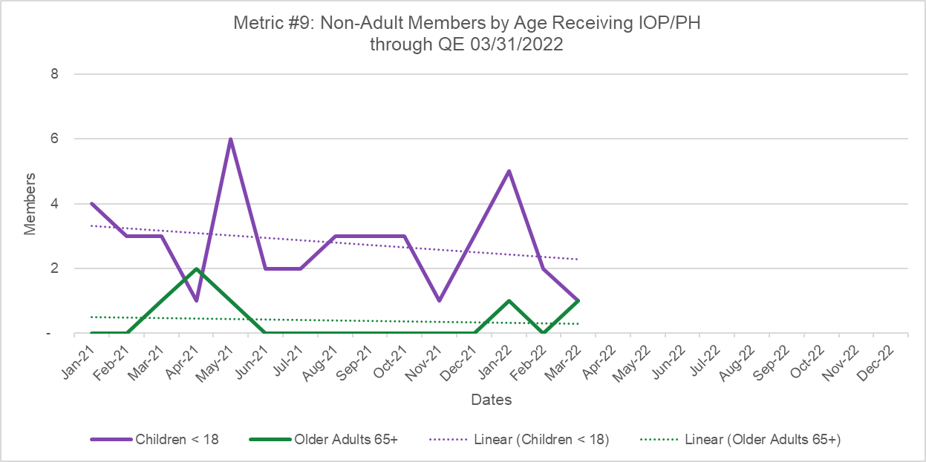
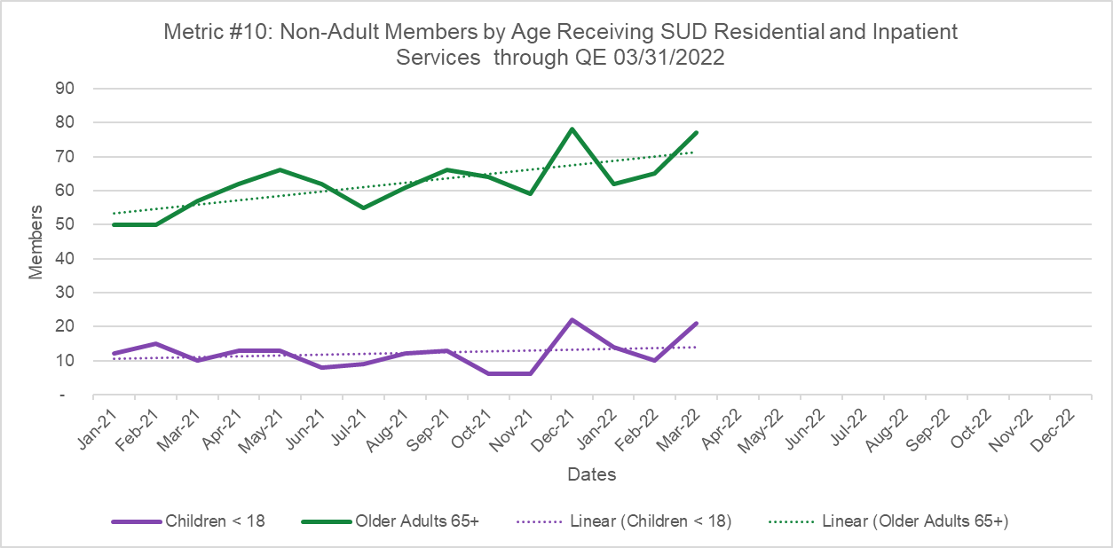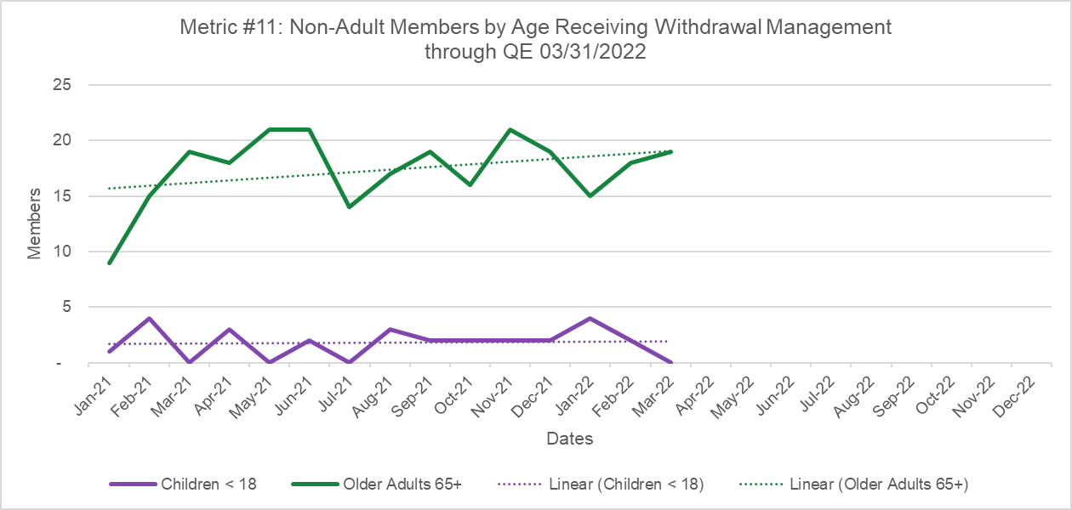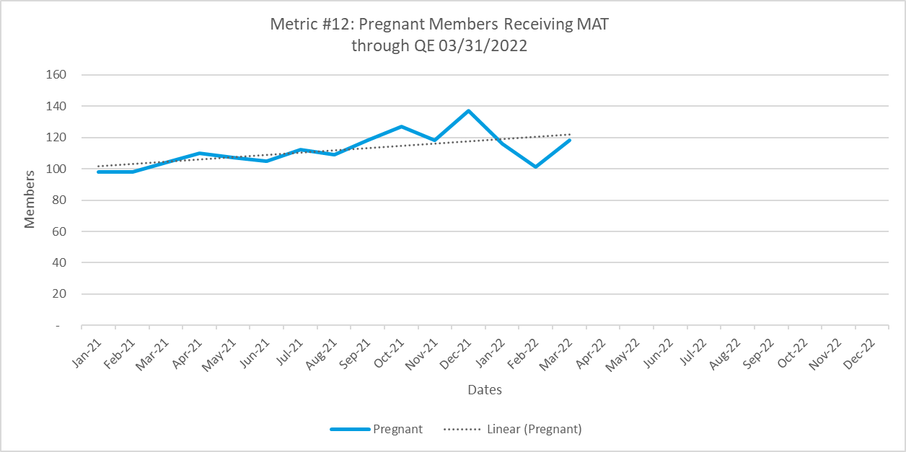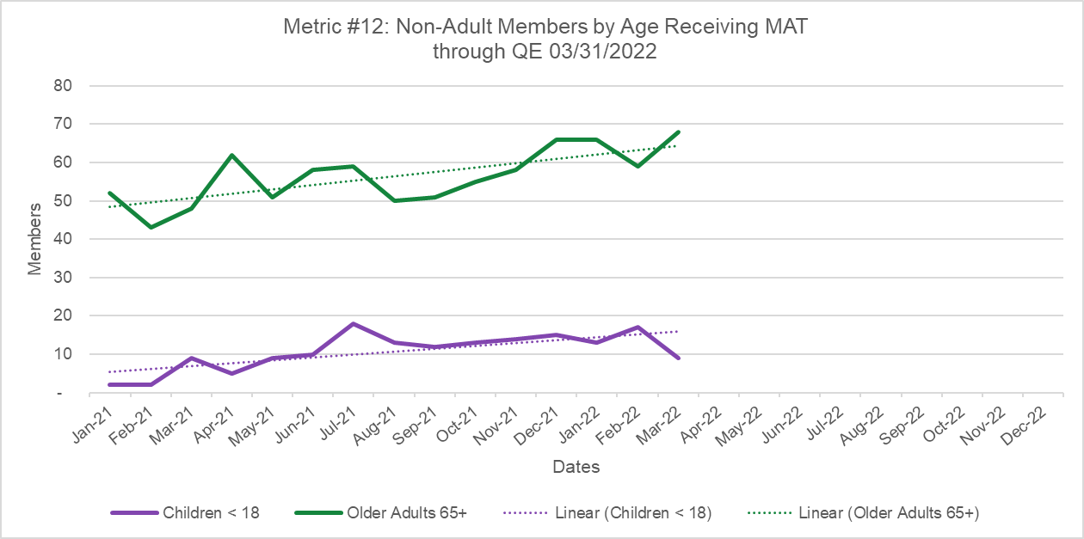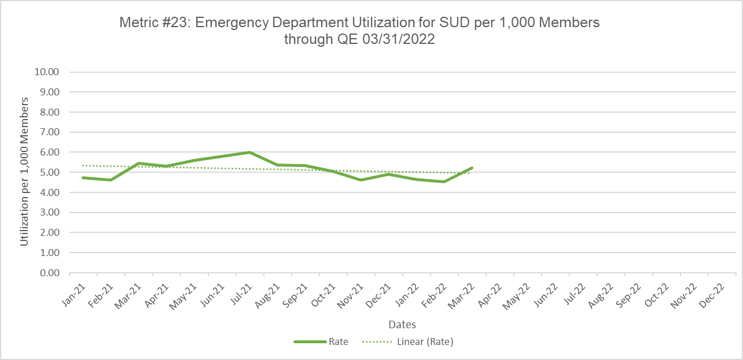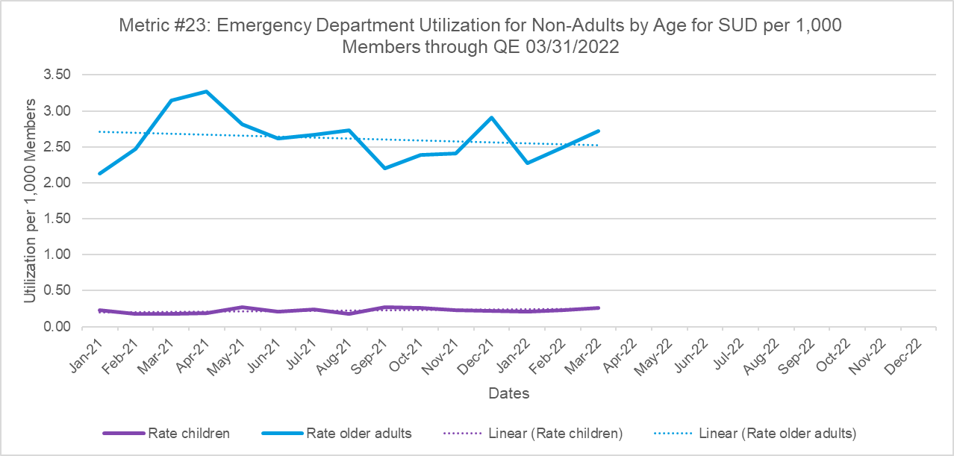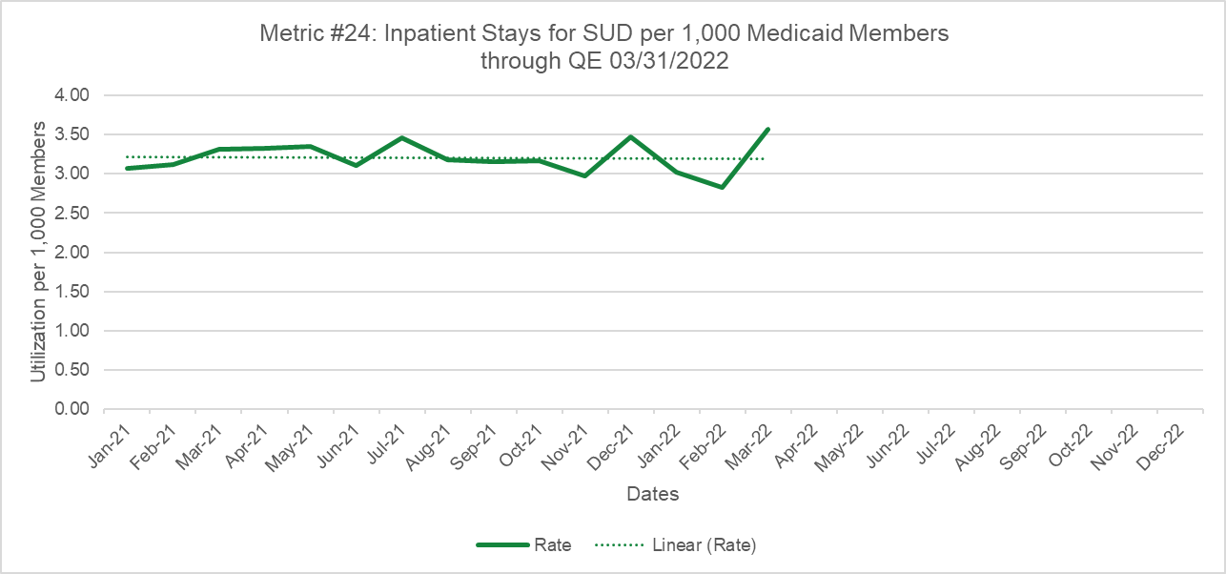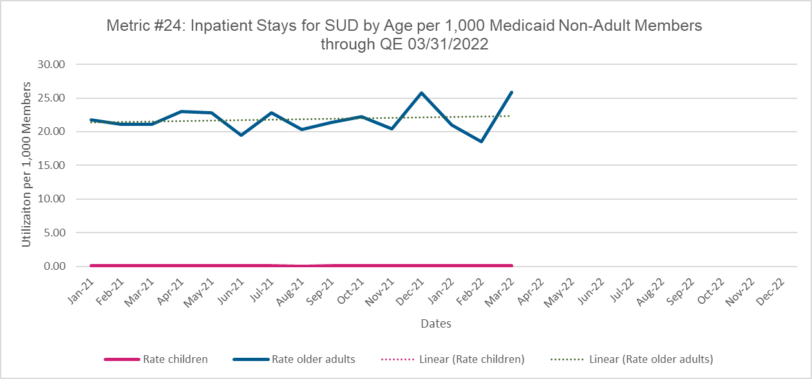

- Annual Metrics
SUD health information technology (health IT)
Questions | Year | Dates | Values
Q1: Total Number of PDMP Users | Year | 01/01/2021-12/31/2021 | 45,230
Q2: Number of Opioid Prescriptions in PDMP | Year | 01/01/2021-12/31/2021 | 2,953,884
Q3: Tracking MAT with Use of Counseling and Behavioral Therapies | Year | 01/01/2021-12/31/2021 | 3,213

- Calendar Year Metrics (National stewards)
CY 2019 metrics |  | Date | Denominator | Numerator | Rate
15. Percentage of beneficiaries age 18 and older with a new episode of alcohol or other drug (AOD) abuse or dependence who received the following:  • Initiation of AOD Treatment—percentage of beneficiaries who initiate treatment through an inpatient AOD admission, outpatient visit, intensive outpatient encounter or partial hospitalization, telehealth, or medication treatment within 14 days of the diagnosis  • Engagement of AOD Treatment—percentage of beneficiaries who initiated treatment and who were engaged in ongoing AOD treatment within 34 days of the initiation visit  The following diagnosis cohorts are reported for each rate: (1) Alcohol abuse or dependence, (2) Opioid abuse or dependence, (3) Other drug abuse or dependence, and (4) Total AOD abuse or dependence. A total of 8 separate rates are reported for this measure. | Year
1. Initiation of AOD Treatment - Alcohol abuse or dependence (rate 1, cohort 1) | Alcohol | 01/01/2021-12/31/2021 | 15,730 | 5,314 | 0.3378
2. Initiation of AOD Treatment - Opioid abuse or dependence (rate 1, cohort 2) | Opioid | 01/01/2021-12/31/2021 | 6,019 | 2,446 | 0.4064
3. Initiation of AOD Treatment - Other drug abuse or dependence (rate 1, cohort 3) | Other | 01/01/2021-12/31/2021 | 11,898 | 4,387 | 0.3687
4. Initiation of AOD Treatment - Total AOD abuse of dependence (rate 1, cohort 4) | Total | 01/01/2021-12/31/2021 | 34,204 | 13,379 | 0.3912
5. Engagement of AOD Treatment - Alcohol abuse or dependence (rate 2, cohort 1) | Alcohol | 01/01/2021-12/31/2021 | 5,314 | 3,575 | 0.6728
6. Engagement of AOD Treatment - Opioid abuse or dependence (rate 2, cohort 2) | Opioid | 01/01/2021-12/31/2021 | 2,446 | 1,733 | 0.7085
7. Engagement of AOD Treatment - Other drug abuse or dependence (rate 2, cohort 3) | Other | 01/01/2021-12/31/2021 | 4,387 | 2,861 | 0.6522
8. Engagement of AOD Treatment - Total AOD abuse of dependence (rate 2, cohort 4) | Total | 01/01/2021-12/31/2021 | 13,379 | 8,087 | 0.6045
17(1) Percentage of emergency department (ED) visits for beneficiaries age 18 and older with a principal diagnosis of alcohol or other drug (AOD) abuse or dependence who had a follow-up visit for AOD abuse or dependence. Two rates are reported: | Year
• Percentage of ED visits for which the beneficiary received follow-up within 30 days of the ED visit (31 total days). | <30 days | 01/01/2021-12/31/2021 | 9,879 | 829 | 0.0839
• Percentage of ED visits for which the beneficiary received follow-up within 7 days of the ED visit (8 total days). | <7 days | 01/01/2021-12/31/2021 | 9,879 | 377 | 0.0382
17(2)Percentage of emergency department (ED) visits for beneficiaries age 18 and older with a principal diagnosis of mental illness or intentional self-harm and who had a follow-up visit for mental illness. Two rates are reported: | Year
• Percentage of ED visits for mental illness for which the beneficiary received follow-up within 30 days of the ED visit (31 total days) | <30 days | 01/01/2021-12/31/2021 | 2,519 | 535 | 0.2124
• Percentage of ED visits for mental illness for which the beneficiary received follow-up within 7 days of the ED visit (8 total days). | <7 days | 01/01/2021-12/31/2021 | 2,519 | 330 | 0.1310
18 | Year | 01/01/2021-12/31/2021 | 18,336 | 1,649 | 0.0899
21 | Year | 01/01/2021-12/31/2021 | 18,339 | 2,419 | 0.1319
22 | Year | 01/01/2021-12/31/2021 | 3,036 | 1,108 | 0.3650
32 | Year | 01/01/2021-12/31/2021 | 74,474 | 64,047 | 0.8600

- Demonstration Year Metrics (CMS steward)
2021 DY Metrics reported to CMS DY1Q1 Q4 |  | Dates | Denominator | Numerator | Rates
4 | Year | 01/01/2021-12/31/2021 |  | 81,928
5 | Year | 01/01/2021-12/31/2021 |  | 652
13 | Year | 01/01/2021-12/31/2021 |  | 3,121
14 | Year | 01/01/2021-12/31/2021 |  | 277
25 | Year | 01/01/2021-12/31/2021 | 31,677 | 5,940 | 0.1875
26 | Year | 01/01/2021-12/31/2021 |  | 11,069
 | <18 |  | 522,941 | 157 | 0.3002
 | 18-64 |  | 751,690 | 5,574 | 7.4153
 | 65+ |  | 59,199 | 5,338 | 90.1704
 | OUD |  | 538 | 538 | 1000.0000
 | No OUD |  | 1,333,292 | 10,531 | 7.8985
27 | Year | 01/01/2021-12/31/2021 | 1,333,830 | 11,069 | 8.2987
36 | Year | 01/01/2021-12/31/2021 | 131 | 3,113 | 23.7634
 | OUD |  | 61 | 1,663 | 27.2623
 | No OUD |  | 70 | 1,450 | 20.7143

