MINUTES
State Medical Assistance & Services Advisory Council
Virtual Meeting
May 26, 2021: 6:00 P.M. – 7:30 P.M.
Virtual Meeting via Google: https://meet.google.com/bxb-dntm-wsg
Call-In Number: 1-530-500-4073 Pin: 740412416#

- 6:00 Call to Order

Chris Newman

Roll Call: MEDICAL ASSISTANCE & SERVICES ADVISORY COUNCIL MEMBERS

Members Excused: Kim Jackson, Janet Puglisi & Leah Schulz

Members Present:

Jill Atkinson Margaret Tomcho J. Ron DeVries

Heather Gitchell Christopher Newman Katya Mauritson

Peter McNally Erika Alexander Jasmine White

Theresa Buxton Josina Romero O’Connell

- Minutes Approval

Chris Newman – March 24, 2021 Minutes approved

- Eligibility Contracts & Site Relations Update

Valerie Gallegos
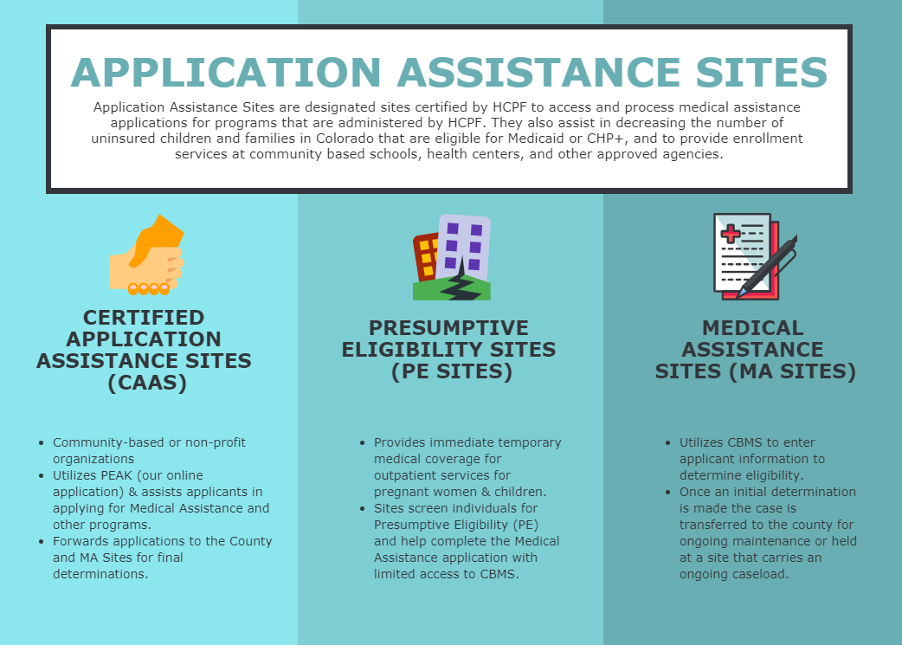

- Certified Application Assistance Sites (CAAS): Assists individuals who want to apply for medical assistance by helping complete the application, and submitting it to the county or nearest MA Site
  - Many types of agencies can become an CAAS
    - Community-based organization or non-profit organization
  - Identified in the Mapping Tool
- Presumptive Eligibility Sites (PE Sites)
  - Gives pregnant women and children under age 19 temporary medical coverage right away
  - Clinics, health centers, and community resource centers
  - Identified in the Mapping Tool
- MA vs EAP Sites
  - Medical Assistance (MA) Sites
    - Governmental agencies with merit based employees can assist with all eligibility activities
      - Connect for Health Colorado (C4HCO)
        - Processes mixed household (Parents with tax credits and children on CHP+)
      - Denver Health Medical Assistance Site
      - Colorado Medical Assistance Partner at Denver Health (CMAP)
        - Takes phone applications
        - CHP+
        - Buy-in Program
  - Eligibility Application Partners (EAP)
    - Formerly known as “Other MA Sites”
    - Sites who are not merit based, governmental agencies are transitioning to working new applications from an intake perspective
    - Located throughout various counties
    - Another access point for Coloradans to receive assistance with applying for Medicaid
    - Currently helps with clients applying for all Medical Assistance Programs

    - Transitioning to only accepting new applications and not doing any case management activities
    - EAP Sites
      - Colorado Access
      - Express Eligibility Connections
      - Parkview Medical Center
      - Pueblo Step-up
      - Kemberton (formerly Advanced Patient Advocacy)
      - Denver Indian Health Services
      - NW Visiting Nurses Association
- Locate a Site: https://apps.Colorado.gov/apps/maps/hcpf.map

- Public Health Emergency
  - Currently we have approximately 375,000 members locked-in to Medical Assistance programs
  - Anticipate that number to continue growing until the end of the PHE
  - Eligibility review at the end of the PHE
    - details are still being worked through

​
- Substance Use Disorder (SUD) Benefit Expansion

Victoria Laskey

- Background: Benefit Expansion
  - House Bill 18-1136
    - Corresponded with the Centers for Medicare and Medicaid Services (CMS) to determine path to open coverage of residential and inpatient SUD treatment and withdrawal management (WM) services
    - Summer 2019 - Spring 2020: Statewide process to inform and engage partners, stakeholders, and public
    - November 2020
      - Medicaid State Plan Amendment (for coverage in non-IMDs) approved
      - Section 1115 SUD demonstration waiver application (for coverage of SUD stays in IMDs) approved
    - SUD benefit expansion implemented – January 1, 2021
- Coverage of the SUD continuum

- American Society of Addiction Medicine(ASAM) SUD treatment Continuum

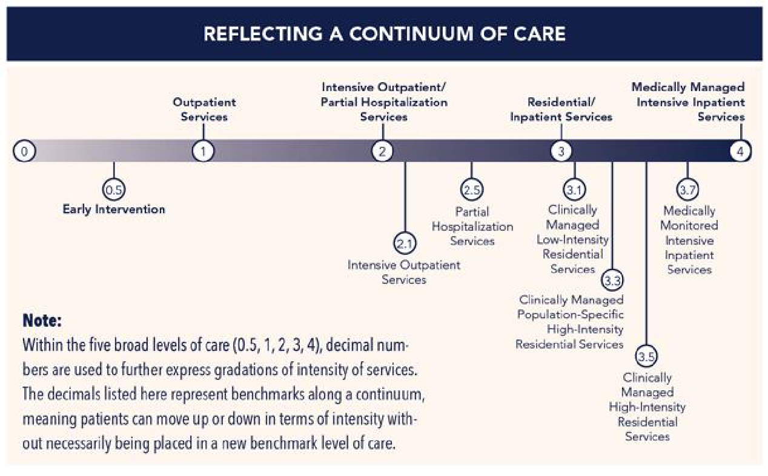

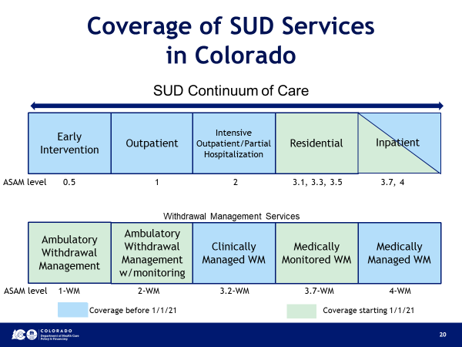

- Delivery System
  - Regional Accountable Entities (RAEs) manage services
    - RAE Responsibilities
      - Network development across SUD continuum
      - Administer covered services
      - Utilization management
      - Care Coordination
      - Integrate care services across the spectrum of behavioral and physical health care
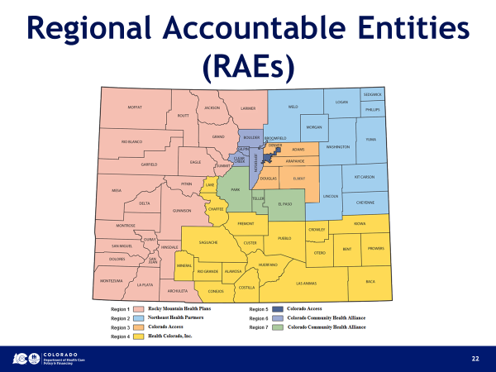

- Benefit Policies
  - Coverage requires SUD primary diagnosis and medical necessity
  - Medical necessity based on ASAM Criteria
  - Length of stay is determined by medical necessity
    - No limit to stay as long as medical necessity is demonstrated
  - Prior authorization is required from treatment services
  - Prior authorization is not required for withdrawal management (detox) services
  - No co-pays for Health First Colorado members
- Special Connections
  - Specialized, gender responsive SUD treatment for individuals who are pregnant or up to one year postpartum
    - Includes childcare, parents can bring children into treatment
  - Previously, only residential SUD benefit covered with Health First Colorado
  - Now managed by the RAEs under the benefit expansion
- ASAM and Medical Necessity
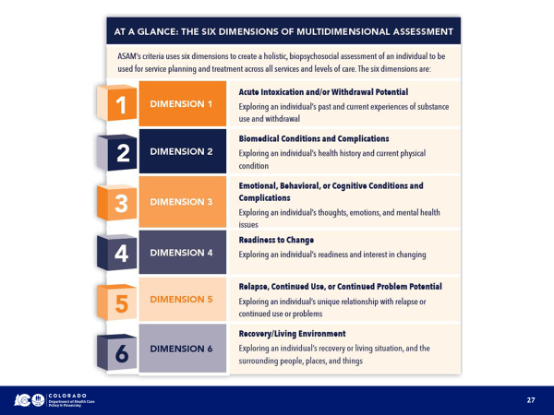

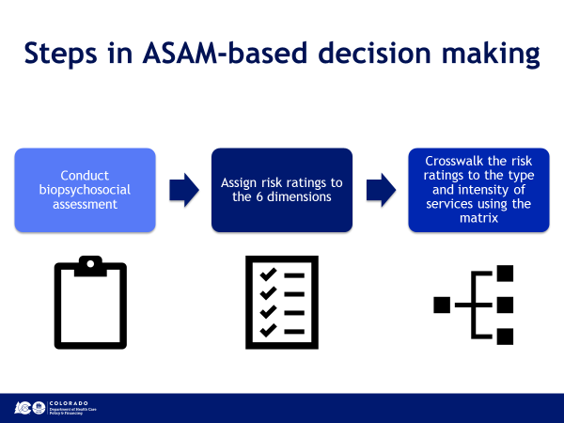

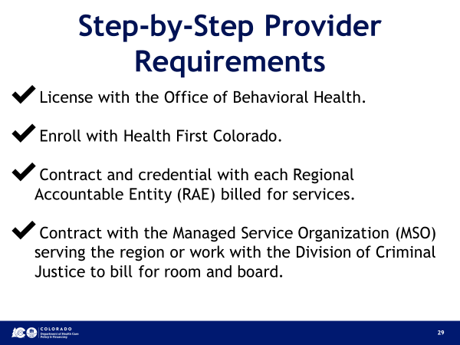

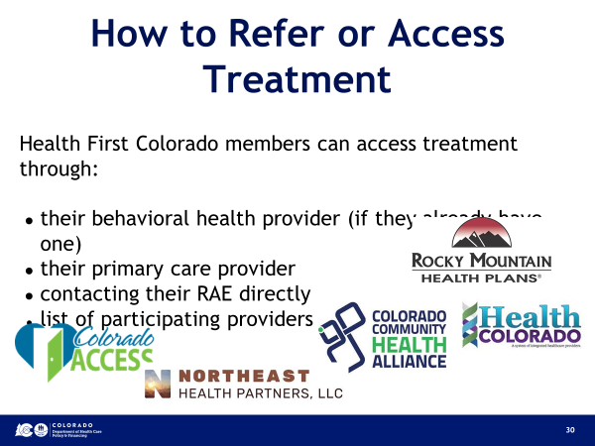

- Ongoing Implementation Efforts
  - SUD Provider Forum every 1st and 3rd Wednesday
    - HCPF, OBH, RAEs, MSOs, SUD providers
    - Discuss policies and provide technical assistance
- Federal Monitoring and Evaluation
  - Working with 3rd party evaluator to gather data and report on this benefit in accordance with 1115 waiver requirements
- RAE Process Enhancements
- HCPF Policy Revisions

- 1115 SUD Waiver Amendment

  - The current SUD benefit enabled by the 1115 waiver does not include Medicaid members under 21 (MCHIP).
  - The Department intends to amend 1115 SUD waiver so that MCHIP may receive inpatient/residential SUD services at facilities that qualify as an IMD.
- Public Forum and Review
  - A formal notice, a copy of the waiver amendment application, and the location to provide comments regarding the amendment will be made available on the Department’s website:
  - https://hcpf.colorado.gov/ensuring-full-continuum-sud-benefits
  - The Department will also host two virtual forums to answer questions and receive feedback about the amendment.
  - The comment period will be open from June 1st until July 1st.

- Round Robin

Chris Newman

- Adjournment

Next Meeting will be held on July 28th from 6pm-7:30pm

Reasonable accommodations will be provided upon request for persons with disabilities. Please notify the Board Coordinator at 303-866-5965 or mary.hoatam-belnay@state.co.us or the 504/ADA Coordinator hcpf504ada@state.co.us at least one week prior to the meeting to make arrangements.

